Project Workspace: Capstone Management System with Plagiarism Checker

A Capstone Project by

Añedez, Patrick Josh
Antipuesto, Throylan
Bautista, Steven Joe
Canoy, Chijay

Submitted to the Information Technology Department, College of Technologies
Bukidnon State University

In Partial Fulfillment
of the Requirements for the Degree
IT136 - Capstone Project and Research 1

<Month and year of degree conferral, not date of submission>

APPROVAL SHEET
This capstone project entitled <Title>, prepared and submitted by <Name 1>, <Name 2>, <Name 3>, <Name 4> in partial fulfillment of the requirements for the degree <Degree> is hereby accepted.

GLAIZA MAE A. LIBE
Capstone Project Adviser
LOUIE JAY S. LABASTIDA
Chair, Defense Panel
RAUL D. LECAROS | JOSEPH L. ABELLA
Panel Member | Panel Member

Accepted and approved for the conferral of the degree Bachelor of Science in Information Technology

SALES G. ARIBE JR., DIT MARILOU O. ESPINA, DIT
Department Head, Information Technology Dean, College of Technologies

DEDICATION
This portion is optional but perhaps you have someone or some people who have inspired you to push on with your studies. A dedication would be a fitting way to acknowledge their impact on your success.

ACKNOWLEDGMENTS
The road to this point in your studies couldn’t have been travelled alone. Along the way, someone somewhere helped you. This is your chance to thank them.
By the way, exercise the liberty to be personal to reflect the sincerity of your gratitude.

TABLE OF CONTENTS
INTRODUCTION 1
1.1 Background of the Study 1
1.2 Objectives of the Study 4
1.3 Significance of the Study 5
1.4 Scope and Delimitations 6
2 REVIEW OF RELATED LITERATURE 8
2.1 Related Literature 8
2.1.1 Capstone Management and Academic Integrity challenges 8
2.1.2 Online Document Submission 9
2.3 Concept of the Study 20
2.4 Definition of Terms 21
3 METHODOLOGY 23
3.1 Materials 23
3.1.1 Software 23
3.1.2 Hardware 26
3.1.3 Data 28
3.2 Methods 29
3.2.1 Research Design 29
3.2.2 Process Model 30
3.2.3 Development Phases 31
4 RESULTS AND DISCUSSION 40
4.1 Results by phase of study 40
4.2 Verification studies 40
5 SUMMARY, CONCLUSIONS, AND RECOMMENDATIONS 41
5.1 Summary 41
5.2 Conclusions 41
5.3 Recommendations 41

LIST OF TABLES
Table 1-1. ML approaches in forecasting HIV. 1
Table 2-1. From "References" > Insert Caption > Table 4

LIST OF FIGURES
Insert the List of Tables using the “References” tab > “Insert Table of Figures” > Figures
Figure 2-1. From "References" > Insert caption > Figure 5
Figure 3-1. Golf course tricks. 7
Figure 1. Conceptual Framework of Capstone Management System 20
Figure 2. Developmental-evaluative method flowchart 29
Figure 2.1. Agile-Scrum Development Process Model 30

ABSTRACT
This paper presents Project Workspace: Capstone Management System (BukSU CMS-V2), a specialized web-based platform tailored for the Information Technology Department at Bukidnon State University. Built on Express 5 modular architecture and React.js, the system replaces manual capstone workflows with end-to-end digital manuscript tracking from Chapter 1 through Chapter 5. Document originality is enforced using an on-premise, in-house Python FastAPI plagiarism microservice (cms-plagiarism-api) integrated via asynchronous Celery workers, Redis message brokers, MinIO object storage, and ChromaDB HNSW vector stores. The engine performs hybrid similarity analysis combining lexical winnowing (Rabin-Karp n-gram rolling hashes) and dense semantic vector similarity (Sentence-Transformers all-MiniLM-L6-v2) evaluated through S_hybrid = 0.65 * S_winnowing + 0.35 * S_semantic under a strict institutional threshold of S_hybrid <= 25%. System concurrency and session security are governed by MongoDB atomic conditional updates and HTTP-only JWT refresh token family rotation, while real-time Socket.IO web sockets and BullMQ email queues provide multi-tiered notifications.

INTRODUCTION

Background of the Study
The management of capstone projects in many academic institutions remains heavily reliant on manual, paper-based processes, a traditional approach that increasingly fails to meet the demands of modern technical education. These conventional methods create significant administrative bottlenecks, including the difficulty of tracking multi-stage submissions, limited accessibility of historical records, and the constant risk of physical document degradation or loss. As the volume of capstone projects within the BSIT and BSEMC programs grows each academic year, the lack of a centralized digital infrastructure leads to asymmetrical feedback loops, where the absence of a transparent audit trail hinders the collaborative relationship between students, advisers, and panel members. Furthermore, maintaining academic integrity becomes a labor-intensive challenge without automated tools to verify originality against internal departmental archives and global web sources. Consequently, there is an urgent need for a systematic, MERN-based approach—realized through the Project Workspace: Capstone Management System (BukSU CMS)to transition the department toward a reliable, accessible, and digitally archived workflow that ensures the long-term preservation and integrity of scholarly work.(Raju, 2025)
Learning Management Systems (LMS) like Moodle and Google Classroom offer central submission and communication but have no bespoke facilities to suit capstone workflows, version-controlled draft tracking, or institutional originality checking. While some universities maintain local repositories of theses to reduce duplication in capstone titles, these are often stand-alone archives without automated similarity detection or active monitoring functions (Arafat, 2024). Commercial plagiarism checking platforms present prohibitive recurring licensing costs and lack interactive monitoring between advisers and students. These disadvantages reveal the opportunity for an efficient, centralized capstone administration system that integrates communication, document submission, and an in-house Python FastAPI similarity detection microservice (cms-plagiarism-api) tailored to institutional needs.
For many years, universities have relied on stand-alone systems to manage and monitor capstone or research projects. These platforms help streamline tasks submitting requirements, and keeping track of project milestones. While they play a valuable role in maintaining organization, their capabilities remain limited. Most lack built-in tools for checking the originality of student outputs or identifying reused content from previous studies. As a result, concerns about plagiarism and content redundancy often go unnoticed, leaving a gap in ensuring academic honesty.
While there are plagiarism detection tools available, most academic users find them too generic. Previous studies emphasize that stand-alone project management systems used in academic settings help organize submissions and deadlines but often lack built-in mechanisms for academic integrity verification (Setu et al., 2025). This study focuses on the specific academic context, especially on academic projects like capstones, to address the gaps identified. A capstone project management system with integrated plagiarism checkers and repository tracking and archiving will address the gaps identified in the current study with respect to maintaining and improving academic integrity.
Recognizing these limitations, this work proposes to overcome them through a hybrid approach that integrates two key components: a centralized capstone project management system and an on-premise plagiarism detection microservice for the IT Department of Bukidnon State University. This centralized structure offers immediate benefits by enabling real-time access to crucial project data, significantly improving coordination among stakeholders, and minimizing communication delays. Crucially, the addition of the on-premise cms-plagiarism-api microservice strengthens the platform's capacity to detect duplicated or repurposed academic work, thereby effectively upholding academic integrity. This integrated model is particularly valuable for institutions seeking to avoid expensive commercial licensing fees while maintaining complete data privacy (Setu et al., 2025).
This paper highlights the role of plagiarism detection tools on the research process to uphold academic integrity, discourage unethical practices, promote originality, and foster a culture of transparency. Plagiarism is a pervasive unethical practice within scholarly work that compromises academic and scientific integrity and credibility. Furthermore, as research becomes increasingly digitized and information readily accessible, the unethical practice of plagiarism grows, thus creating a demand for plagiarism detection tools.
Technological advances analyzing machine learning and artificial intelligence aid in plagiarism detection and address challenges posed by paraphrasing and non-textual formats. In BukSU CMS-V2, document text is extracted and evaluated by an internal Python FastAPI microservice using a hybrid two-tier engine. Lexical winnowing via Rabin-Karp rolling hashes and dense semantic vector embeddings via Sentence-Transformers (all-MiniLM-L6-v2, 384 dimensions) are combined mathematically into S_hybrid = 0.65 * S_winnowing + 0.35 * S_semantic to enforce an institutional clearance threshold of S_hybrid <= 25%. Research and plagiarism detection tools are fundamental to maintaining scientific integrity by fostering research openness and moral scholarship (Mane, 2024).

Objectives of the Study
The objective and scope of this study is to design, develop, and implement a system that enhances the existing university capstone project management framework by digitizing the current manual, paper-based process and centralized digital archiving and management platform. The research will refine its approach at each stage to achieve the following objectives:
Specific Objectives
- Gather and analyze the existing capstone project management framework, policies, and procedures of the university to identify requirements, gaps, and inefficiencies in the current manual process.
- Design a system architecture and workflow model that aligns with the university’s established capstone management process, ensuring that all institutional requirements, roles, and documentation flows are accurately represented in a digital environment.

Develop a capstone project management and archiving system based on the approved design.

Test the developed system in terms of technical functionality and reliability to ensure it meets the design specifications and performs as intended.
- Evaluate the system’s usability and user satisfaction through surveys and feedback from participants for areas of improvement based on actual end user feedback.

1.3 Significance of the Study
Project Workspace aims to deliver streamlined communications and operational efficiency for all parties involved. By centralizing paper submissions, reviews, and scheduling processes into a web-based system, it solves many pain points of the traditional capstone workflow. The plagiarism detection functionality operates through an in-house Python FastAPI microservice (cms-plagiarism-api) backed by a Celery worker (cms-plagiarism-worker) and Redis (cms-plagiarism-redis), which compares uploaded documents against two primary sources: internal document vaults stored in MinIO object storage with presigned URLs, and ChromaDB vector stores housing previous capstone manuscripts with zero external API licensing costs. Self-hosting MinIO object storage on campus infrastructure provides complete Institutional Data Sovereignty in full compliance with the Philippine Data Privacy Act of 2012 (Republic Act No. 10173) by ensuring sensitive student manuscripts never leave institutional control, eliminates recurring cloud infrastructure storage fees to achieve Zero Recurring Infrastructure Cost, and delivers S3 Compatibility with Campus Offline Resilience to guarantee uninterrupted document access during external network outages. When a document is submitted, the system extracts its textual content, transmits it to the internal microservice for hybrid analysis—combining lexical winnowing (Rabin-Karp n-gram fingerprinting with Mersenne prime modulus) and dense semantic vector similarity using PyTorch Sentence-Transformers (all-MiniLM-L6-v2) with ChromaDB (HNSW index) computed via S_hybrid = 0.65 * S_winnowing + 0.35 * S_semantic—and generates a comprehensive similarity report enforcing an institutional clearance threshold of S_hybrid <= 25%. Real-time Socket.IO web socket alerts and asynchronous BullMQ SMTP email dispatches immediately notify advisers and instructors upon threshold breach detection.
Students (3rd and 4th Year): The study will help students manage their research work more efficiently by reducing the confusion and stress caused by misplaced documents and inconsistent feedback. It will also promote academic integrity by helping them identify and avoid unintentional plagiarism. It helps empower students to take responsibility for their work and become more organized and confident researchers.
Panel, Advisers, and Secretary: Searching through numerous emails or hard copies of research wastes time. To make things easier and convenient, advisers and panel members can just access the web system application to view the most recent copy and provide their feedback, saving their time and minimizing confusion. Additionally, the technology mentioned will indicate any content that may be similar, which allows academic fairness in research, making the clear similarity reports easier for advisers.
Instructors: To make sure nothing is overlooked, capstone course supervisors can keep an eye on which students have finished their work and which ones still require changes. Demonstrating adherence to university research norms is also made simpler by the transparency test, particularly audit logs and similarity reports. Overall, the advantages include: simplifying monitoring; assisting Instructors in determining the extent of plagiarism in a paper; and lowering administrative burden for effective time management.
Bukidnon State University: Institutionally, this project delivers greater efficiency, sustainability, and integrity. By going paperless and replacing it with a web system, BukSU reduces physical waste and paper-handling costs, yielding a more sustainable, environment-friendly process. The integrated plagiarism checker provides an in-house solution so the university need not invest in expensive external licenses.
Future Researchers: This research will serve as a valuable reference for future studies, in improving capstone management systems or integrating AI-driven plagiarism detection tools. It can guide future innovations that further improve transparency, academic honesty, and digital change in higher education research administration.

1.4 Scope and Delimitations
This phase focuses on gathering and analyzing the university's current capstone project management framework, policies, and procedures to define system requirements. The scope includes reviewing documents and consulting with advisers and panel to identify process gaps and functional requirements. Delimitations strictly confine the analysis to current departmental practices, excluding comparative studies, policy redesign, performance assessment, and all subsequent technical phases (design, development, testing, and evaluation).

This study focuses on creating a web-based Capstone Management System with Plagiarism Checker for the IT Department at Bukidnon State University. The system will support the end‑to‑end capstone submission workflow from Chapter 1 to Chapter 5, covering document uploads for proposal, pre‑oral/pre‑final, and final manuscript versions. Students can submit and update their chapter drafts during the proposal stage (Chapters 1–3), development and presentation stage (Chapters 4–5), and prior to scheduled defenses, while advisers and panel members can review, comment, and request revisions within the same platform. For similarity checking, the scope focuses on pre‑final and final submissions per chapter and on the complete final manuscript, where each uploaded version is automatically scanned through the in-house Python FastAPI plagiarism detection engine and the IT Department’s repository before endorsement for defense or final binding.
The study encompasses the analysis of the current manual capstone project workflow, policies, and procedures within the IT Department. Data is gathered through document analysis, key informant interviews (students, advisers, panel, instructor), and structured surveys (with 3rd and 4th-year BSIT/BSEMC students) to identify functional and non-functional requirements.
Data gathering is confined strictly to the processes and personnel of the IT Department at Bukidnon State University. The study does not analyze the capstone management processes of other colleges or external academic institutions.
This phase includes the detailed design of the system's architecture (Express 5 modular service layer, React.js frontend, MongoDB database), the database schema, and RESTful API endpoints. The design specifically incorporates role-based dashboards, document flow management (Chapter 1 to 5), and the technical workflow for integrating the in-house Python FastAPI plagiarism detection microservice for similarity checking, presigned MinIO URLs for document access, and Google Docs API integration for live editing.
The design is tailored exclusively to align with the capstone management process and institutional requirements of the IT Department. The design of the plagiarism detection feature is based on the deployment and configuration of an in-house Python FastAPI microservice utilizing a hybrid two-tier engine (lexical winnowing and sentence-transformer vector embeddings with ChromaDB), eliminating external commercial dependencies.
Development involves the full implementation of the web-based system, including all functional requirements (e.g., user authentication, group management, submission history, deadline setting) and non-functional requirements (e.g., web-based compatibility, security, performance). It includes developing the IT Repository for secure storage in MinIO and the automated mechanism to trigger similarity checking for pre-final and final submissions using the in-house Python FastAPI plagiarism microservice (cms-plagiarism-api) against web sources and the internal repository.
The system is developed exclusively as a web-based application, excluding any native mobile app or offline submission capabilities. It will only be used by the IT Department and will not cover other colleges' research. Commercial plagiarism systems like Turnitin are excluded due to cost, with the on-premise Python FastAPI microservice used as the sole similarity checker, ensuring zero external API licensing fees.
The testing phase includes a comprehensive suite of methods: Unit Testing, Integration Testing, System/Functional Testing (Black-box), and Plagiarism Detection Testing. Testing validates all core system functionalities, data integrity (using MongoDB Compass), API routes (using Postman), and user interface rendering across modern browsers. The plagiarism checker is validated against a controlled corpus of original and manipulated texts.
Testing is limited to the technical performance and reliability against the design specifications within a controlled environment. Long-term performance monitoring and scalability testing beyond the initial User Acceptance Testing (UAT) load are not included in this study.
Evaluation is based on User Acceptance Testing (UAT) and a structured survey using a 5-point Likert Scale. The evaluation instrument assesses quality characteristics based on the ISO 25010 System Quality Model (Functionality, Usability, Performance, Compatibility, Evaluation). The evaluators are a select group of target users (30 Students, 5 Panel Members, and 2 Instructors) from the IT Department.
The evaluation is limited to the perspective of the 37 selected respondents from the IT Department. The study does not include a comparative satisfaction assessment against the previous manual system, and the interpretation of results is based on the predetermined weighted mean scale.

The plagiarism detection component analyzes submitted documents and generates detailed similarity reports displaying the percentage of matched content, specific flagged passages, and source attribution, enabling advisers and instructors to make informed decisions about originality and academic integrity. It will also include tools for adviser feedback, version control (via Google Docs API), and a plagiarism checker that compares documents with online sources and past university projects through the university’s repository.

The plagiarism checker will analyze text similarity by extracting and processing document content, then matching it against public web sources and stored IT Department repositories to generate a similarity percentage. The system is designed exclusively for use by the IT Department. The main users of the system are 3rd and 4th year students from BSIT and BSEMC, advisers, and panel members. The system manages capstone outputs at the group level while maintaining individual user accounts for all members. Each student has a personal login, but one designated group leader submits chapter drafts and final manuscripts on behalf of the group, with all members automatically linked to the same project record. Advisers and panel members can view the group submission as a single output, track its status and history, and still see the list of individual members associated with that capstone. Individual activities logins, comments, and file uploads are recorded per user, while evaluation and similarity checking are applied at the group document level.

This study does not include the use of commercial plagiarism systems Turnitin because of cost and licensing issues; instead , we will be using an in-house Python FastAPI plagiarism detection microservice (cms-plagiarism-api). It will only be developed as a web-based system. Offline submission of documents will not be part of the study since the system is designed for online use. The project is limited to the IT Department only and it will not cover other college’s research in the university. Research outputs from outside the IT Department are also not included in the plagiarism checking process. Only documents stored within the IT Department’s repository and publicly accessible online sources will be compared by the system.

REVIEW OF RELATED LITERATURE

Related Literature
This section presents the review of related literature and studies relevant to the development of the Capstone Management System with Plagiarism Checker. It will discuss previous works related to online document submission, integrity and credibility of research, ethical research, and proper academic paper citation.

2.1.1 Capstone Management and Academic Integrity Challenges
Capstone projects provide a comprehensive academic experience for undergraduate students, requiring the application of acquired knowledge and skills to solve authentic problems and encouraging critical thinking, collaboration, and career preparedness (Sozon et al., 2024). The project grants a relatively large number of academic credits and requires considerable effort from both the students and the academic institution regarding logistics, time, and means (Shurin et al., 2021). However, the difficulty and integrative nature of these projects gives significant challenges for students, advisers, and panel, especially on monitoring progress and maintaining communication (Contributors, 2023).
Students often struggle to balance capstone demands with other academic and personal commitments, and how inadequate guidance from supervisors further intensifies these issues (Shurin et al, 2023). AI writing tools become increasingly rampant among students, new concerns about academic dishonesty and the ethical use of AI and digital resources emerge (Filson & Atuase, 2025). Instructors and advisers play a crucial role in supporting students to maintain integrity and use tools responsibly. Tenhunen et al. (2023) suggest that digital management platforms, systematic communication tools, and adaptive assessment systems can improve transparency, accountability, and student success in capstone courses.

2.1.2 Online Document Submission
In today’s world, where technology is prevalent, handling large amounts of files and maintaining document integrity is a big challenge. This section discusses the creation of a web-based system with a built-in plagiarism checker to offer a complete solution for the storing, retrieval, and verifying uniqueness of documents.
In the study of A. Adegbola et al. (2024), there is a need for an integrated solution that not only provides secure and efficient document storage but also includes a built-in plagiarism detection tool to ensure the originality of the content. This system would streamline workflows, enhance document management, and improve the verification of document authenticity. Thus, the development of a web-based document repository with a plagiarism checker aims to address these challenges by providing a centralized platform that simplifies document management and upholds content integrity. (A. Adegbola et al.,2024).
2.1.3 Addressing Plagiarism and Similarity Issues in Research
According to the University of Pittsburg (2023), A citation is a way of giving credit to individuals for their creative and intellectual works that you utilized to support your research, It can also be used to locate particular sources and combat plagiarism. Ensuring the authenticity, originality, and value of an academic work, ethical components also need to be considered. Similarity refers to likeness that implies the literature, content, thought, or contributions of a paper or write-up are merely somewhat alike. The state of the literature or the contributory facts of a write-up seem to be identical to a previous write-up of the same author or some others’ contributions.
Differentiating between “plagiarism” and “similarity” is crucial for academics. Similarities to other intellectual properties do not necessarily mean the paper is plagiarized. It simply means that the respective contents seem to be like the other intellectual contributions or author(s)’ previously published works. Whether the paper is plagiarized or not depends on whether it is appropriately cited or not. But even if it is appropriately cited, if the percentage of similarity of a paper exceeds the institution’s accepted margin, the paper falls under ethical concern and thus would be treated as plagiarized. Such an instance, however, does not invite disciplinary action but, of course, rejection.
2.1.4 Hybrid System for Capstone Management and Integrity
Existing literature increasingly points toward a hybrid approach as the necessary evolution beyond isolated plagiarism tools and generic Learning Management Systems (LMS). This strategy involves integrating specialized project management functionalities directly with originality verification mechanisms (Setu et al., 2025). Studies have shown that dedicated project management platforms significantly improve educational outcomes by establishing clear milestones and accountability (Bui & Hiep, 2023).The combination is highly effective: a centralized system provides administrative efficiency, giving all stakeholders real-time access to project data, which fundamentally improves coordination and cuts down on communication delays (Al-Zahrani & Al-Shamri, 2022)
Furthermore, embedding a plagiarism checker allows for the robust detection of content that has been duplicated or repurposed, thereby strongly upholding academic integrity (Mane, 2024) This unified model offers a significant advantage, particularly for institutions that cannot afford expensive commercial licenses, providing a tailored, cost-effective in-house solution to handle both workflow management and content originality checking in a single platform (Setu et al., 2025).
2.1.5 Plagiarism Detection Tool in Maintaining Academic Integrity
Plagiarism detection tools play a significant role in promoting academic integrity and promoting transparency in the capstone process. In modern digital generation, access to online information is easier for students and researchers to unintentionally and consciously commit plagiarism. Higher education institutions adopt technological interventions to check, detect and prevent such practices (Sozon et al., 2024). Recognizing these limitations, this work proposes to overcome them through a hybrid approach that integrates two key components: a central capstone management system and an embedded plagiarism and similarity indicator (Setu et al., 2025)
Plagiarism evolved from simple textual copying to complex academic dishonesty involving paraphrasing and the use of generative AI tools (Sozon et al., 2024). These advancements led educators to rely and utilize the plagiarism detection tools to cultivate academic integrity and encourage ethical practices to students. Plagiarism detection tools not only help to check copied or paraphrased content but also promote students to focus and engage deeply with their writing and maximizing their capabilities. (Eaton, 2023) described this as a “technological arms race” between academic integrity advocates and unethical users of AI text generators.
Plagiarism detection tools become most effective when combined with clear guidance on proper citation and paraphrasing (Angwaomaodoko, 2025). Similarly, (Evangelista, 2025) argued that academic institutions should complement technological solutions with reformed assessment frameworks to reduce plagiarism temptations and encourage creativity in the era of ChatGPT.
2.1.6 Enhancing Through Integrated Plagiarism Detection Systems
The proliferation of digital technology has significantly facilitated access to information, making it easier for individuals to copy and replicate content. While the internet offers a vast repository of resources for research, it also presents a temptation for students to engage in plagiarism. The ease of copying and pasting text, coupled with the vast amount of information available online,can make it challenging for students to resist the urge to use someone else's work without proper citation. Furthermore, the attitude of students towards plagiarism is a critical aspect of this problem. Some students may not perceive plagiarism as a serious offense, viewing it as a minor transgression or a necessary evil to achieve their academic objectives. (Ahmad & Fauzi, 2024)

1. Turnitin Originality Check
One of the most widely used plagiarism detection platforms in higher education, as it employs a deep-learning algorithm to compare submitted documents against its extensive database that contains over 70 billion web pages, 200 million student papers, and 180 million scholarly publications (Johnson, 2025). The system provides a detailed similarity report with color-coded matches that indicate whether a specific phrase is plagiarized, source is identified, and percentage indicators enable educators to assess originality effectively (Turnitin Similarity | Comprehensive Plagiarism Detection, n.d.). However, as mentioned in the background of the study, Turnitin lacks the element of monitoring and interactive elements necessary for continuous communication between advisers and students throughout the capstone development process. In addition, licensing costs make it hard, especially for financially challenged institutions, particularly smaller universities and departments with limited budgets.
2. Grammarly Plagiarism Detector
Utilizing Natural Language Processing models, Grammarly also uses proprietary plagiarism detection technology, comparing users' documents with over 16 billion documents and web pages, along with the academic papers stored in ProQuest (How To Check Your Work for Plagiarism | Grammarly Spotlight, 2019). Users have access to real-time plagiarism detection and detailed reports explaining the documents with which the users' documents have been compared, the document's score for originality, probable sections that should be cited, and reports that provide citation suggestions (How To Check Your Work for Plagiarism | Grammarly Spotlight, 2019). Grammarly also provides citations in APA, MLA, Chicago, and other styles, which helps in proper attribution (Can Grammarly Help with Citations?, n.d.). Even with these features, Grammarly is still mostly a standalone writing assistance with a limited ability to integrate with institutional learning management systems, and lacks project management to control versioning systems needed in the supervision of capstone projects (Dong & Shi, 2021).
3. Copyleaks
An on-premise Python FastAPI Plagiarism Detection Engine (cms-plagiarism-api) was specifically designed for academic institutions, utilizing a two-tier hybrid architecture combining lexical winnowing (Rabin-Karp n-gram rolling hashes with Mersenne prime modulus) and dense semantic vector embeddings (PyTorch Sentence-Transformers all-MiniLM-L6-v2, 384 dimensions) with a ChromaDB HNSW vector store to detect various plagiarism types including direct copying, paraphrasing, and synonym-swapped concepts. The system computes a mathematical similarity score according to S_hybrid = 0.65 * S_winnowing + 0.35 * S_semantic, enforcing an institutional clearance threshold of S_hybrid <= 25%. Deployed on-premise as an asynchronous microservice with Celery workers and Redis, it provides full REST API interoperability with the core Express 5 modular gateway while ensuring complete document privacy and zero recurring licensing costs.
In contrast to expensive commercial solutions, the on-premise cms-plagiarism-api eliminates recurring API licensing costs while providing high detection accuracy for both lexical matching and semantic paraphrasing. Comparative analysis demonstrates that hybrid lexical and transformer-based vector similarity models effectively identify manipulated text while minimizing false positives, allowing faculty members to focus on qualitative review rather than manual verification of flagged citations.
Amirzhanov, Turan, and Makhmutova (2025) conducted a systematic survey categorizing plagiarism into distinct types, including verbatim copying, paraphrasing, translation-based plagiarism, and idea appropriation. Their analysis revealed that traditional string-matching methods have been largely superseded by advanced machine learning, natural language processing, and deep learning approaches employing CNNs, LSTMs (Long Short-Term Memory networks), and transformer architectures BERT (Bidirectional Encoder Representations from Transformers) and GPT (Generative Pre-trained Transformer). These deep learning models demonstrate significantly improved detection capabilities for complex plagiarism types, with transformer-based systems achieving 95-99% accuracy compared to 70-85% for traditional methods (Amirzhanov et al., 2025).
Despite the technological sophistication of these deep learning-based detection systems, significant gaps remain in their application to comprehensive capstone project management. As identified in the background of this study, existing plagiarism detection tools operate primarily as standalone services focused exclusively on originality checking without providing integrated features for project supervision, communication facilitation, progress monitoring, or collaborative document management (Arafat, 2024). Most systems require separate platforms for submission management, adviser feedback, milestone tracking, and repository archival, creating fragmented workflows that reduce efficiency and increase administrative burden. Furthermore, cost considerations represent a substantial barrier, with commercial licenses for platforms like Turnitin requiring significant financial investment beyond the reach of many institutions, particularly smaller universities and individual departments (Educational Testing Resources, 2023).
The limitations of existing deep learning-based detection systems highlight the need for integrated solutions that combine plagiarism detection capabilities with comprehensive capstone management features. As Mane (2024) emphasizes, plagiarism detection tools are fundamental to maintaining academic integrity, discouraging unethical practices, promoting originality, and fostering transparency. However, their effectiveness in educational contexts is maximized when embedded within broader systems that support the entire research workflow rather than functioning as isolated checking services. This recognition underscores the significance of developing hybrid platforms that unite project management, communication tools, version control, progress tracking, and originality verification in unified systems tailored to institutional contexts and budgetary constraints.
2.2 Related System

Feature Category | Specific Feature | Standard LMS | Turnitin | Grammarly | cms-plagiarism-api (In-House) | Project Workspace (In-House Winnowing + MiniLM Engine)
Core Project Management | Centralized Document Submission | ✔ | ✘ | ✘ | ✘ | ✔
 | Progress & Milestone Tracking | Limited | ✘ | ✘ | ✘ | ✔
 | Integrated Feedback Tools | Basic | ✘ | ✘ | ✘ | ✔
 | Document Version Control | ✘ | ✘ | ✘ | ✘ | ✔ (Google Docs API)
 | Role-Based Dashboards | ✔ | ✘ | ✘ | ✘ | ✔
Plagiarism Detection | Text Similarity Checking | ✘ | ✔ | ✔ | ✔ | ✔ (Via cms-plagiarism-api Microservice)
 | Comparison vs. Web Sources | ✘ | ✔ | ✔ | ✔ | ✔
 | Comparison vs. Academic Databases | ✘ | ✔ | ✔ | ✔ | ✔
 | Comparison vs. Internal University Repository | ✘ | ✘ | ✘ | ✘ | ✔
 | Cost model | Licensed / Free | Institutional License | Subscription | API Usage (Cost-Effective) | On-Premise / In-House (Zero API License Cost)
 | Integration Capability | Standalone | Limited | Limited | API Available | REST Microservice Interop
Table 1: Similar System Matrix
Table 1 demonstrates that while existing systems excel in specific domains, none provides the comprehensive integration required for effective capstone project management. Standard Learning Management Systems offer submission and basic feedback capabilities but lack specialized plagiarism detection tailored to academic research (Arafat, 2024). Commercial plagiarism detection tools provide similarity analysis but operate as standalone external services without project management features or institutional repository integration (Mane, 2024). Project Workspace addresses these fragmented approaches by unifying project management functionalities—including milestone tracking, version control, and structured feedback mechanisms—with comprehensive plagiarism detection through an in-house Python FastAPI microservice (winnowing + MiniLM engine with ChromaDB HNSW store), creating a cohesive ecosystem specifically designed for capstone project supervision within institutional contexts and budgetary constraints.

2.3 Concept of the Study
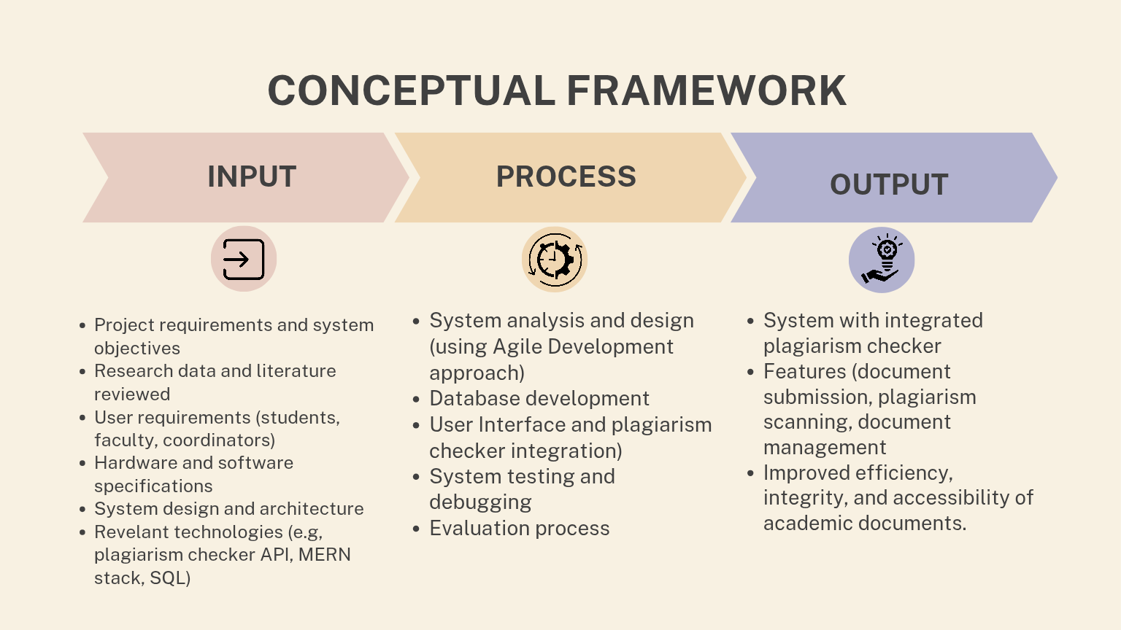
Figure 1. Conceptual Framework of Capstone Management System
The final output of the study is a functional Capstone Management System with an integrated plagiarism checker. The system provides a secure and organized platform for submitting, checking, and archiving academic documents. It aims to promote research integrity, prevent plagiarism, and streamline the overall capstone submission process.

2.4 Definition of Terms
IT Repository - A centralized digital repository within the Capstone Management System that securely stores, organizes, and archives students’ project documents and research outputs for easy retrieval and verification.
Learning Management System(LMS)- Software platforms Moodle and Google Classroom that provide tools for course delivery, assignment submission, and communication but may lack specialized features like version-controlled draft tracking and plagiarism detection tailored for capstone workflows.
Plagiarism- A prevalent issue in academic documents or research that refers to presenting another person’s work, ideas, or expressions as one’s own without proper citation or acknowledgement, including copying, paraphrasing, or use of AI-generated content without attribution.
Plagiarism Detection Tool- A software application integrated within the capstone management system that scans student submissions to identify similarity or duplication of content, helping uphold academic integrity by providing originality reports.
Turnitin- A widely-used plagiarism detection platform employing deep learning algorithms to compare submitted documents against an extensive database of internet pages, student papers, and scholarly publications for originality checking.
In-House Plagiarism Detection Engine - An integrated Python FastAPI microservice employing lexical winnowing (Rabin-Karp) and dense vector embeddings (Sentence-Transformers all-MiniLM-L6-v2) with ChromaDB to provide automated, privacy-preserving detection of copied and paraphrased academic content.

METHODOLOGY

Materials
The following section outlines the software, hardware, and data requirements needed to develop and implement the Capstone Management System with Plagiarism Checker. The choice of these materials has been informed by the general aims of creating a scalable, efficient, and institutionally-adaptable web application that combines effective project management with high-quality plagiarism-detecting functions.

Software
 | Component / Tool | Description / Justification
Software | Frontend Development | React.js (component-based, dynamic UI, virtual DOM for efficiency)
 | Backend Development | Node.js with Express 5 modular service layer & BullMQ job queues
 | Database | MongoDB (NoSQL, schema-free, document-based, horizontally scalable)
 | Version Control Integration | Google Docs API (real-time collaborative editing, version history)
 | Version Control Tools | Git / GitHub (source code management, collaboration, history tracking)
 | API Testing | Postman (tests backend functions before frontend implementation)
 | UI/UX Design | Figma (wireframes and prototypes for user-friendly design)
Table 2. Software Components
In essence, we took a dive and chose all the options and stacked them in a pile that makes the app up-to-date, easy to maintain, and loaded. The reason we chose the tech was because it is the fastest, scales well, the hype in the community, and the fact that it matches well with the functionalities we need.
Hardware
The architecture emphasizes user accessibility and eliminates overhead with physical hardware.
 | Component / Tool | Description
Hardware | Development Environment | Multi-core PCs (AMD Ryzen 7, 8–16GB RAM, SSD storage)
 | Minimum User Requirements | - Processor: Dual-core 2.0 GHz or higher  - RAM: 8 GB minimum  - Storage: 500 MB free space  - Modem: Stable internet connection (≥5 Mbps)
Table 2.1 Hardware Components
The hardware architecture of the system is structured to support a high-performance development lifecycle while ensuring that the final application remains lightweight and accessible to all stakeholders. This is achieved through a Decentralized Hardware Strategy, where the heavy computational lifting is shifted away from the end-user and onto robust development and cloud-based environments.

Frontend Development: React.js using Node.js
Justification: React.js was the primary frontend library that was selected due to its component-based nature, allowing for the reuse of code and creating a dynamic user interface easily. React has achieved high efficiency in the virtual DOM, making the app fast enough, as it is critical in real-time document management and feedback. Node.js for the backend, so the entire stack remains in JavaScript to simplify development and allows us to utilize the enormous npm ecosystem for packages.
JavaScript Backend Development: Express.js
We selected Express 5 with a modular service layer as the backend framework due to its lightweight routing, improved error handling, and adaptability for enterprise API development. It handles HTTP requests, user authentication via HTTP-only cookies with JWT refresh token family rotation, file uploads, presigned MinIO S3 object storage URLs, and asynchronous background tasks via BullMQ and Redis. Express 5 provides a structured approach to server-side logic, making the application scalable and robust.
Database: MongoDB
MongoDB is a NoSQL document database selected as the primary data store. First, its flexible schema accommodates evolving data models in capstone management, including submission metadata, version histories, and dynamic feedback threads. Second, MongoDB atomic conditional updates are leveraged to prevent Time-of-Check to Time-of-Use (TOCTOU) race conditions during concurrent submission clicks, returning HTTP 409 Conflict whenever lock contention occurs. Lastly, it scales horizontally to handle expanding academic archives.
Version Control Integration: Google Docs API
Reason: To achieve the version control features as outlined in the scope of the project (Section 1.4), the Google Docs API has been chosen. This choice builds upon a proven and widely used platform that enables real-time collaborative editing and has a full version history. The usage of Google Docs API provides a more comprehensive and user-friendly system of keeping track of document changes and facilitating the work of advisors and students than creating a versioning system on its own, and, therefore, it serves to complement the collaborative aspect of the capstone supervision process.
Tools that aid the development process and project management:
Git/GitHub Tools:
It has been utilized for version control purposes to manage the entire source code and allow collaboration among various developers. Additionally, it has been used to create an entire history related to
Postman: Used for testing backend-side function APIs to ensure that they are functioning properly before implementing them on the frontend side.
Figma: We used to design the user interface (UI) and user experience (UX) with the use of wireframes and prototypes. The end product has to be user-friendly.
Development Environment:
The development environment comprised standard development PCs with multi-core processors (AMD Ryzen 7), with 8GB RAM (16GB recommended), and Solid-State Drive (SSD) storage to facilitate smooth development on integrated development environments (IDEs), development servers, and database environments.
Universal Accessibility
It allows students, advisers, panel, and instructors to use the system on any device that is connected to the internet; this is integral to any learning process.
Elastic Scalability: The cloud services possess the ability to dynamically provision resources to meet more variable workloads that change over time due to factors peak document submissions.
Institutional Cost Efficiency
It follows the pay-as-you-go method; therefore, there are no investments in servers that require maintenance.

Data
The data requirements that the system needs to meet are outlined below with due adherence to ethical considerations that ensure data acquisition and privacy are upheld.

Institutional Data
This consists of anonymous data involving the user roles (Student, Adviser, Instructor), codes for courses, as well as capstone project names that will be obtained from the Information Technology side of Bukidnon State University. The collection process will be carried out with appropriate requests to ensure permission has been sought and data governance requirements are followed.
Repository
The initial operational data would be derived from capstone documents with supported formats (docx, pdf, txt) will then be submitted to the instructor for review, then to repository These documents shall be housed within the secure repository maintained by the IT Department to enable plagiarism detection during other projects.

Methods

Research Design
This project will be utilizing the developmental-evaluative research design, which involves designing, building, and evaluating the Capstone Management System with an in-house plagiarism checker powered by a Python FastAPI microservice (cms-plagiarism-api). The developmental aspect focused on creating the system, while the evaluative component assessed its functionality and user acceptance.
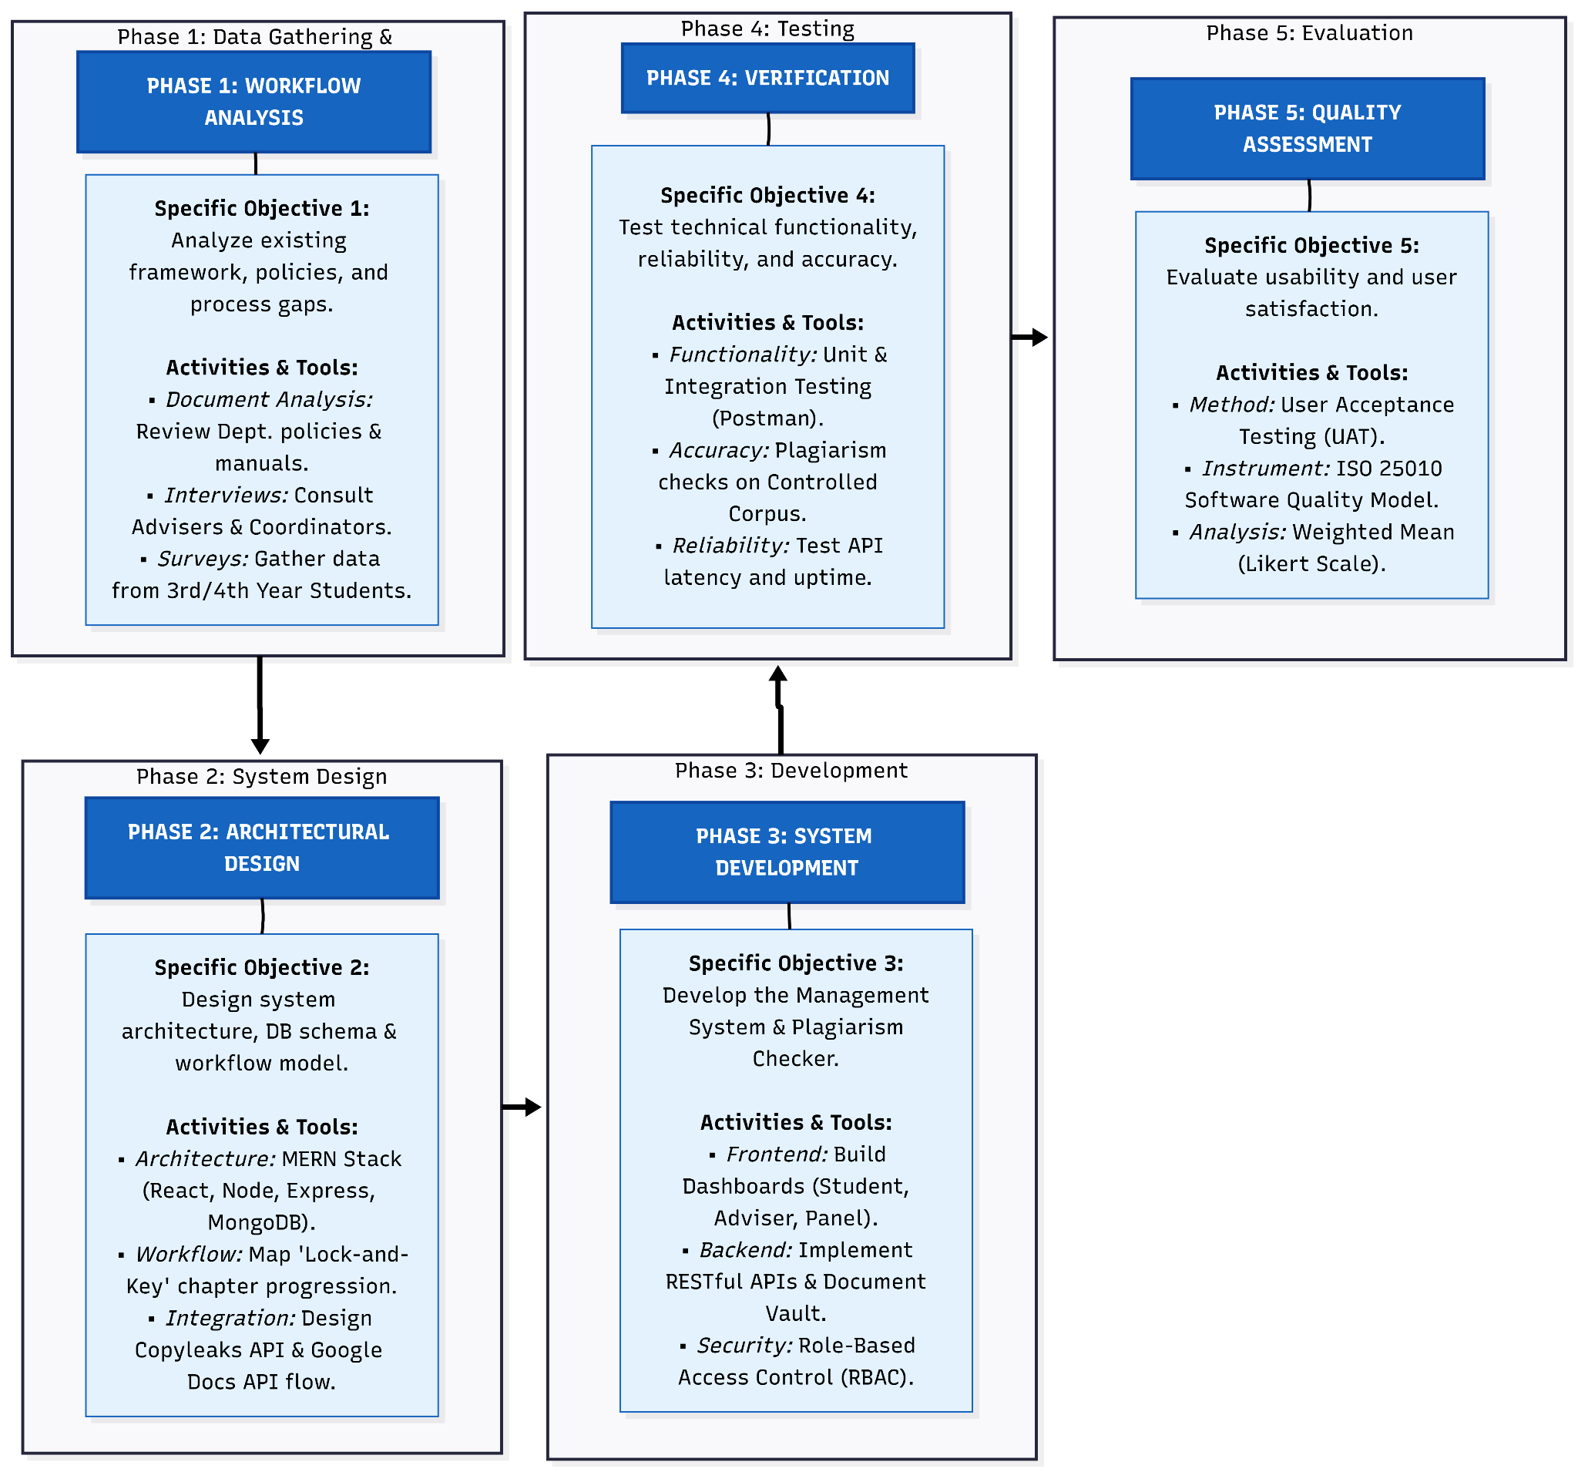
Figure 2. Developmental-evaluative method flowchart

Process Model
For this study, the researchers will utilize the Agile Scrum methodology, enabling iterative development of the system and the integration of continuous user feedback for ongoing improvement, particularly in the refinement of the plagiarism checker.

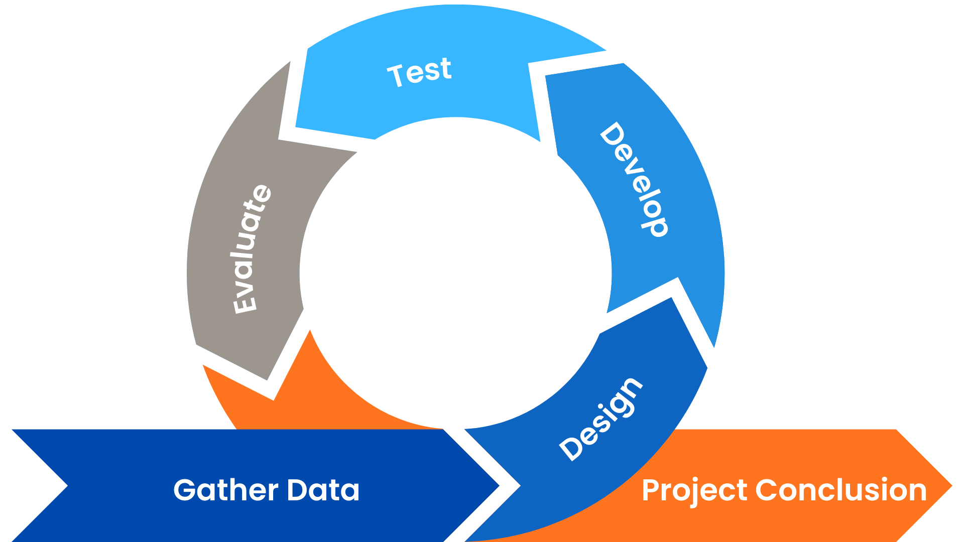
Figure 2.1. Agile-Scrum Development Process Model

3.2.3 Development Phases

Phase 1: Data Gathering

Objective 1: The researchers will gather data using document analysis, key informant interviews, and surveys.
Document analysis: The researchers will collect and review existing capstone-related documents, university and department policies, capstone guidelines, process manuals, and memorandum orders of the IT Department of Bukidnon State University. ​ The documents will be examined to map the current manual capstone workflow, including roles, steps, required forms, submission schedules, and approval processes that the proposed digital system will replace.
Key informant interviews: Interviews will be conducted with selected advisers, panel members, and capstone instructors involved in capstone management. The interviews will focus on identifying specific problems in the manual process and determining the features and controls they expect from the digital Capstone Management System with Plagiarism Checker.
The study will employ Stratified Random Sampling to select respondents from the 3rd and 4th year students of the BS Information Technology (IT) and EMC programs under the IT Department of Bukidnon State University. The population will be divided into four strata based on program and year level. A proportional allocation method will be used to determine the number of respondents per stratum. A total of 71 students will be randomly selected to participate in the study.
Surveys: Structured questionnaires will be administered to 3rd and 4th year BSIT and BSEMC students, advisers, and panel members who use the current manual capstone process.
Participation in this study involves minimal risk to the respondents. Potential risks include minor inconvenience or time spent completing the survey questionnaire, as well as possible discomfort in answering questions if a participant feels unsure about certain items. To minimize these risks, all participants will be informed that their involvement is voluntary and that they may withdraw from the study at any time without any penalty or consequence. Moreover, all responses will be treated with strict confidentiality and used solely for research purposes.
Participation in the study also provides several benefits. Directly, respondents may gain a better understanding of the system or processes being evaluated, such as the software or tools used in the IT and EMC programs. Indirectly, the study may offer valuable insights for the improvement of these programs at Bukidnon State University, contributing to enhanced curriculum design, more effective technological processes, and future research initiatives. By participating, students play a vital role in helping the department improve learning experiences and IT-related systems for current and future students.
System Requirements Specification
This System Requirements Specification (SRS) defines the Project Workspace: Capstone Management System with Plagiarism Checker, a centralized web-based platform tailored for the Bukidnon State University IT Department. Adhering to the ISO/IEC/IEEE 29148:2018 standard for requirements engineering and incorporating modern user-centered methodologies (Báez & Brunner, 2026), the system digitalized the end-to-end capstone workflow from Chapter 1 to 5 through MERN stack architecture. It integrates an in-house Python FastAPI plagiarism microservice and Google Docs APIs to facilitate online submissions, real-time similarity checking against a secure repository, and collaborative feedback loops. The system serves five primary user classes—Students (uploading chapters, tracking milestones), Advisers (reviewing manuscripts, providing approvals), Panel (evaluating defense documents), Instructors (monitoring batch progress, configuring deadlines), and Instructor (managing accounts and overseer of entire capstone project research). Operating via HTTPS with a reliable uptime commitment and mobile-responsive interfaces, the platform ensures academic integrity through permanent read-only archiving and strictly controlled role-based access.
Student Functional Requirements
Category | Requirement ID | Requirement Description
Authentication & Profile | FR-01 | Allows students to register, verify their email via a 6-digit OTP, and log in with a JWT token valid for 30 days.
 | FR-02 | Provide options for the student to reset their password and update their profile.
Team Management | FR-03 | Allow a student to create a team, becoming the Team Leader, or join an existing team via invitation.
 | FR-04 | The Team Leader shall be able to invite up to 3 members via email and lock the team once the roster is finalized.
Project Initiation | FR-05 | The system shall allow students to create a project title and description, which undergoes an automated Title Similarity Check (Levenshtein Distance).
 | FR-06 | The system shall allow students to revise a title or submit a Title Change Request if high similarity is detected.
Capstone 1 (Proposal) | FR-07 | The system shall provide an auto-template for Google Docs collaborative drafting (Chapters 1-3).
 | FR-08 | The system shall allow students to upload chapter documents (DOCX/PDF/TXT, max 25MB) via Google Drive integration.
 | FR-09 | The system shall require a late justification note if the submission is made past the deadline.
Capstone 2 (Development) | FR-10 | The system shall track the status of system development (Design, Build, Test Modules).
 | FR-11 | The system shall allow students to upload source code, system design documents, and test results for adviser review.
Revision & Defense | FR-12 | The system shall allow students to view adviser/panel feedback and submit revised versions of their work.
 | FR-13 | The system shall track the project status through phases: Proposed, Review, Approved for Defense, and Defended.
Concurrency & Integrity | FR-14 | The system shall implement concurrency control to prevent duplicate submissions from different teammates at the same time (HTTP 409 Conflict).
 | FR-15 | The system shall provide a Plagiarism Report showing similarity scores, matched passages, and source links.
Monitoring & Logs | FR-16 | The system shall allow students to view a Project Progress Report, Submission History (with versioning), and a full Audit Trail/Logs.
 | FR-17 | The system shall notify students of deadline alerts, approvals, revisions, and comments.
Table 3. Student Functional Requirements

Student Non - Functional Requirements
Req ID | Non-Functional Requirement (System shall…) | Category
NFR01 | The system shall implement JWT (JSON Web Token) authentication with a session persistence of 30 days. | Security
NFR02 | Email verification must utilize a 6-digit OTP with a strict expiration window of 10 minutes. | Security
NFR03 | The system must utilize Atomic Status Transitions and Atomic Writes to the database to prevent data corruption during concurrent clicks. | Data Integrity
NFR04 | The system must handle concurrency conflicts (HTTP 409) by preventing teammates from triggering simultaneous submissions for the same project. | Availability
NFR05 | The Title Similarity Check must utilize the Levenshtein Distance algorithm to provide real-time feedback on project uniqueness. | Performance
NFR06 | The system must support document uploads through Google Drive integration with a defined file size limit of 25MB per upload. | Scalability/Storage
NFR07 | The system must maintain a Full Audit Trail and version history, ensuring every change is logged with a timestamp and the user ID of the uploader. | Reliability
NFR08 | The system shall provide automated document templates (Auto-template) for Capstone chapters to ensure formatting consistency. | Usability
Table 3.1. Student Non-functional Requirements
Adviser Functional Requirements
Category | Requirement ID | Requirement Description
Authentication | FR-AD-01 | The system shall allow advisers to log in and log out securely.
Project Supervision | FR-AD-02 | The system shall allow advisers to view assigned students and their submitted projects.
Document Access | FR-AD-03 | Allow a student to create a team, becoming the Team Leader, or join an existing team via invitation.
Plagiarism Review | FR-AD-04 | The Team Leader shall be able to invite up to 3 members via email and lock the team once the roster is finalized.
Evaluation | FR-AD-05 | The system shall allow advisers to provide comments and request revisions.
 | FR-AD-06 | The system shall allow advisers to approve or reject submissions.
Monitoring | FR-AD-07 | The system shall notify advisers when students submit or resubmit documents.
Table 4. Adviser Functional Requirements
Adviser Non - Functional Requirements
Req ID | Non-Functional Requirement (System shall…) | Category
NFR-AD-01 | allow advisers to access submitted documents without noticeable delay. | Performance
NFR-AD-02 | display plagiarism reports in under 5 seconds after request. | Performance
NFR-AD-03 | restrict advisers to viewing only assigned student projects. | Security
NFR-AD-04 | log adviser actions (approvals, rejections, comments). | Security
NFR-AD-05 | be structured and easy to complete. | Usability
NFR-AD-06 | provide organized viewing of student submissions. | Usability
NFR-AD-07 | be available during academic working hours with minimal downtime. | Availability
Table 4.1. Adviser Non-functional Requirements
Panel Functional Requirements
Category | Requirement ID | Requirement Description
Authentication | FR-PA-01 | The system shall allow panelists to log in and log out securely.
Project Access | FR-PA-02 | The system shall allow panelists to view assigned capstone projects.
Plagiarism Review | FR-PA-03 | The system shall allow panelists to access plagiarism results.
Evaluation | FR-PA-04 | The system shall allow panelists to input evaluation scores based on defined criteria.
 | FR-PA-05 | The system shall allow panelists to provide comments and recommendations.
Final Decision | FR-PA-06 | The system shall allow panelists to mark the project as Passed, Passed with Revisions, or Failed.
Results Submission | FR-PA-07 | The system shall restrict editing after final evaluation submission unless unlocked by the Admin.
Table 5. Panel Functional Requirements
Panel Non - Functional Requirements
Req ID | Non-Functional Requirement (System shall…) | Category
NFR-  PA-01 | load evaluation forms within 3 seconds. | Performance
NFR-  PA-02 | automatically compute evaluation totals without delay. | Performance
NFR-  PA-03 | ensure that panelists can only evaluate assigned projects. | Security
NFR-  PA-04 | prevent modification of submitted evaluation results unless authorized. | Security
NFR-  PA-05 | follow consistent evaluation criteria format. | Usability
NFR-  PA-06 | allow panelists to review comments before final submission. | Usability
NFR-  PA-07 | automatically save evaluation inputs to prevent data loss. | Reliability
Table 5.1. Panel Non-functional Requirements
Instructor Functional Requirements
Category | Requirement ID | Requirement Description
Authentication | FR-INS-01 | The system shall allow the instructor to log in and log out securely.
User Management | FR-INS-02 | The system shall allow the instructor to create, edit, deactivate, and delete user accounts.
Role Management | FR-INS-03 | The system shall allow the instructor to assign roles and permissions.
Project Monitoring | FR-INS-04 | The system shall allow the instructor to view and monitor all submitted projects.
Plagiarism Control | FR-INS-05 | The system shall allow the instructor to set plagiarism threshold percentages.
Reports | FR-INS-06 | The system shall allow the instructor to generate system reports (submissions, evaluations, plagiarism results).
Archive Management | FR-INS-07 | The system shall allow the instructor to archive completed projects.
Table 6. Instructor Functional Requirements

Instructor Non - Functional Requirements
Req ID | Non-Functional Requirement (System shall…) | Category
NFR-  INS-01 | generate system reports within 10 seconds. | Performance
NFR-  INS-02 | support multiple concurrent users without performance degradation. | Performance
NFR-  INS-03 | enforce role-based access control. | Security
NFR-  INS-04 | maintain a secure audit trail of all system activities. | Security
NFR-  INS-05 | protect stored documents using secure storage protocols. | Security
NFR-  INS-06 | perform automatic database backups on a scheduled basis. | Reliability
NFR-  INS-07 | ensure data integrity across all transactions. | Reliability
NFR-  INS-08 | be modular to allow future updates and enhancements. | Maintainability
NFR-  INS-09 | maintain structured logs for troubleshooting and debugging. | Maintainability
Table 6.1. Instructor Non-functional Requirements
Phase 2: Designing
Objective 2: Design a system architecture and workflow model that aligns with the university’s established capstone management process, ensuring that all institutional requirements, roles, and documentation flows are accurately represented in a digital environment .
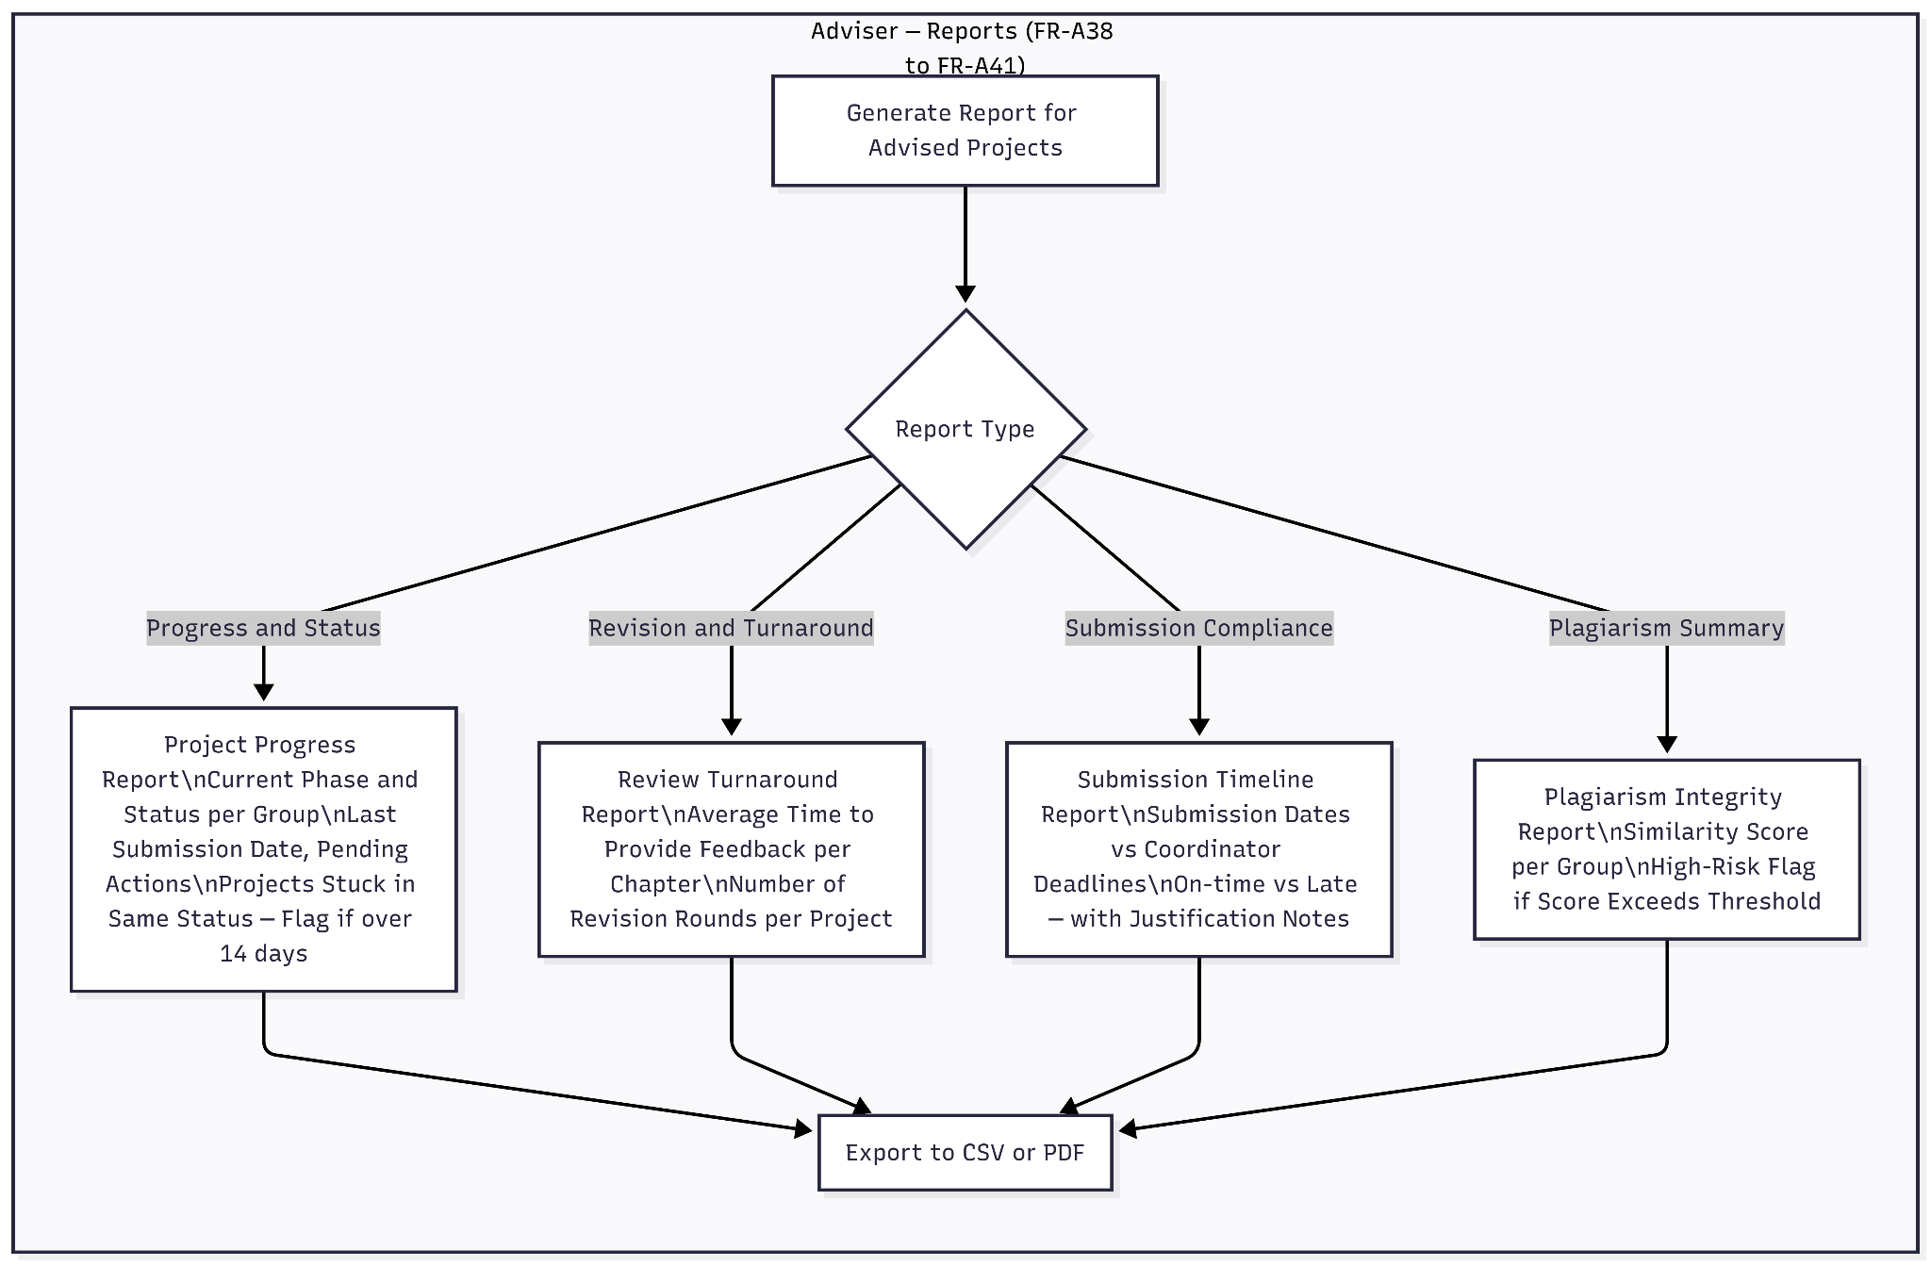
System Architecture Design: Defining the high-level structure, including the client-server model and the interaction between the React.js frontend, Node.js/Express.js backend, and MongoDB database. This lays the groundwork for a centralized and scalable Capstone Management System.

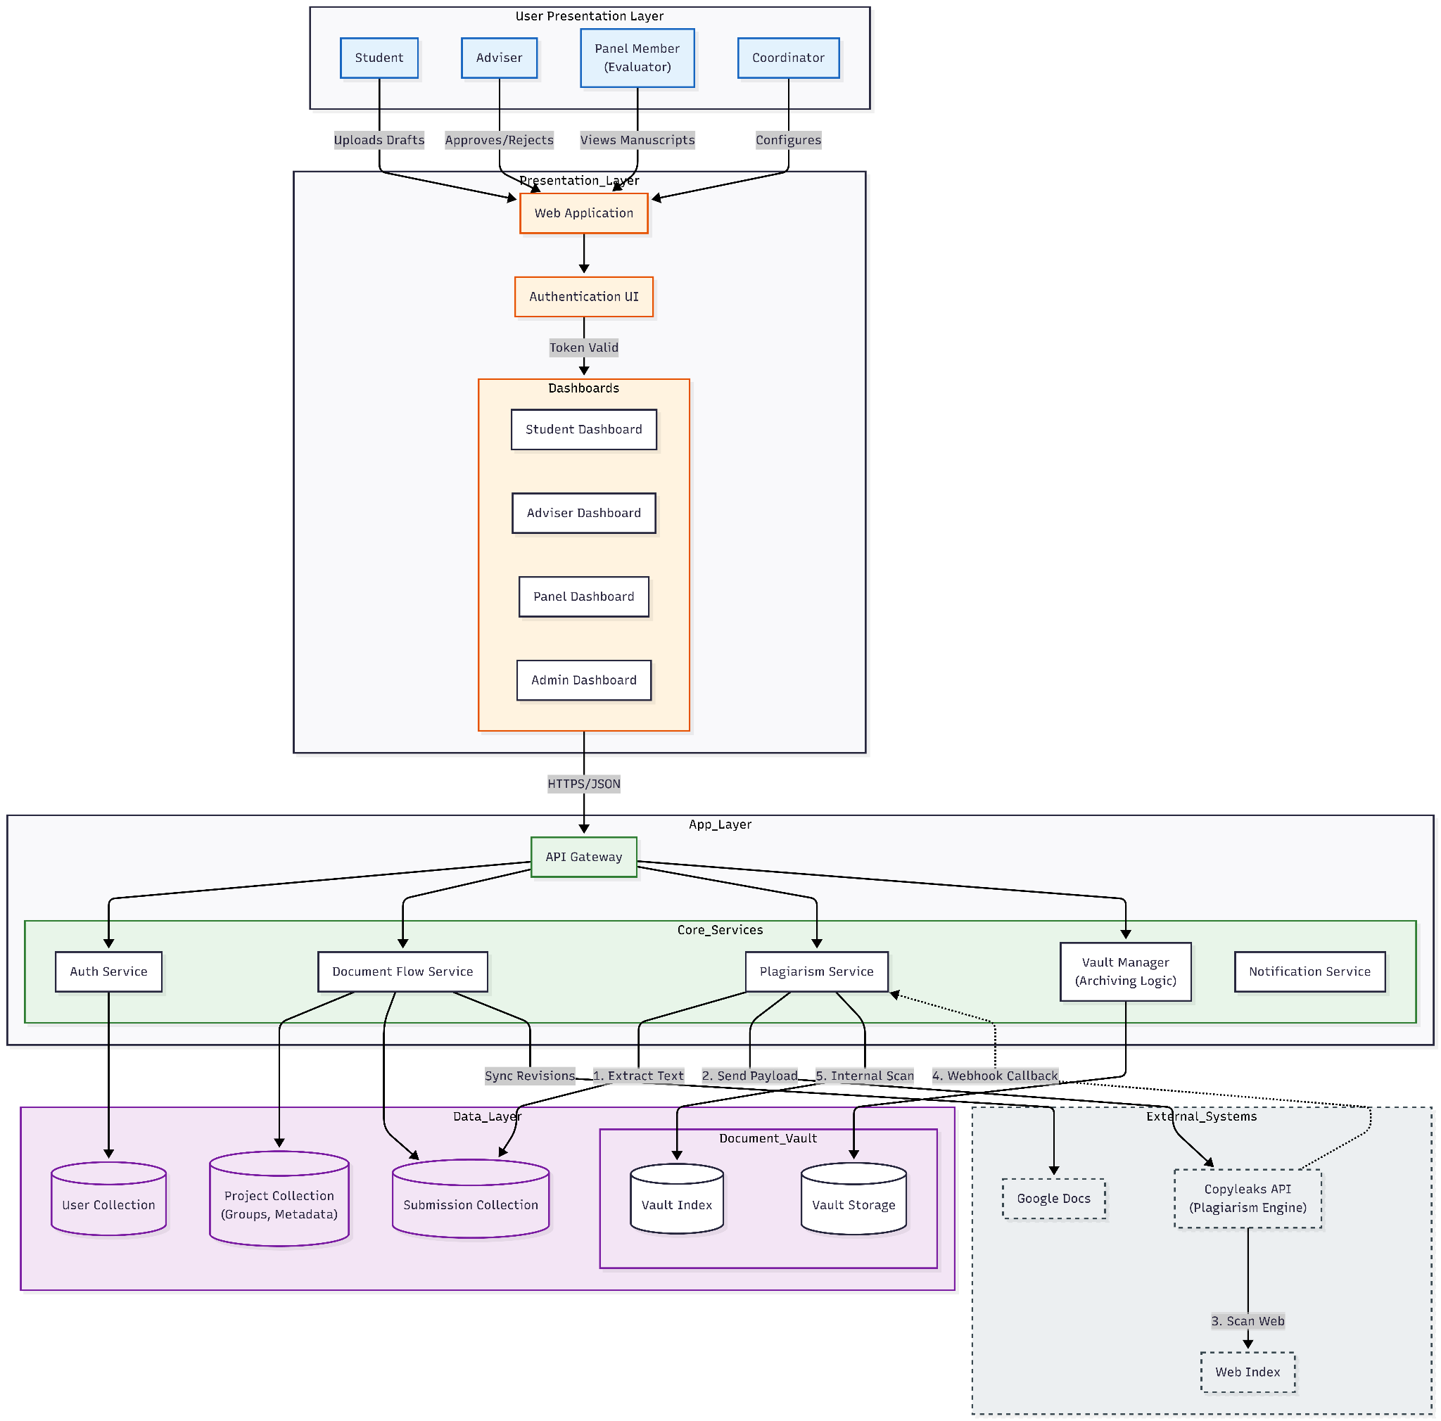
Figure 7.1. System Architectural Design

Database Schema Design: Creating an efficient database schema using MongoDB collections to represent core entities Users, Projects, Submissions, and Feedback, which are essential for document submission, feedback, and progress tracking.
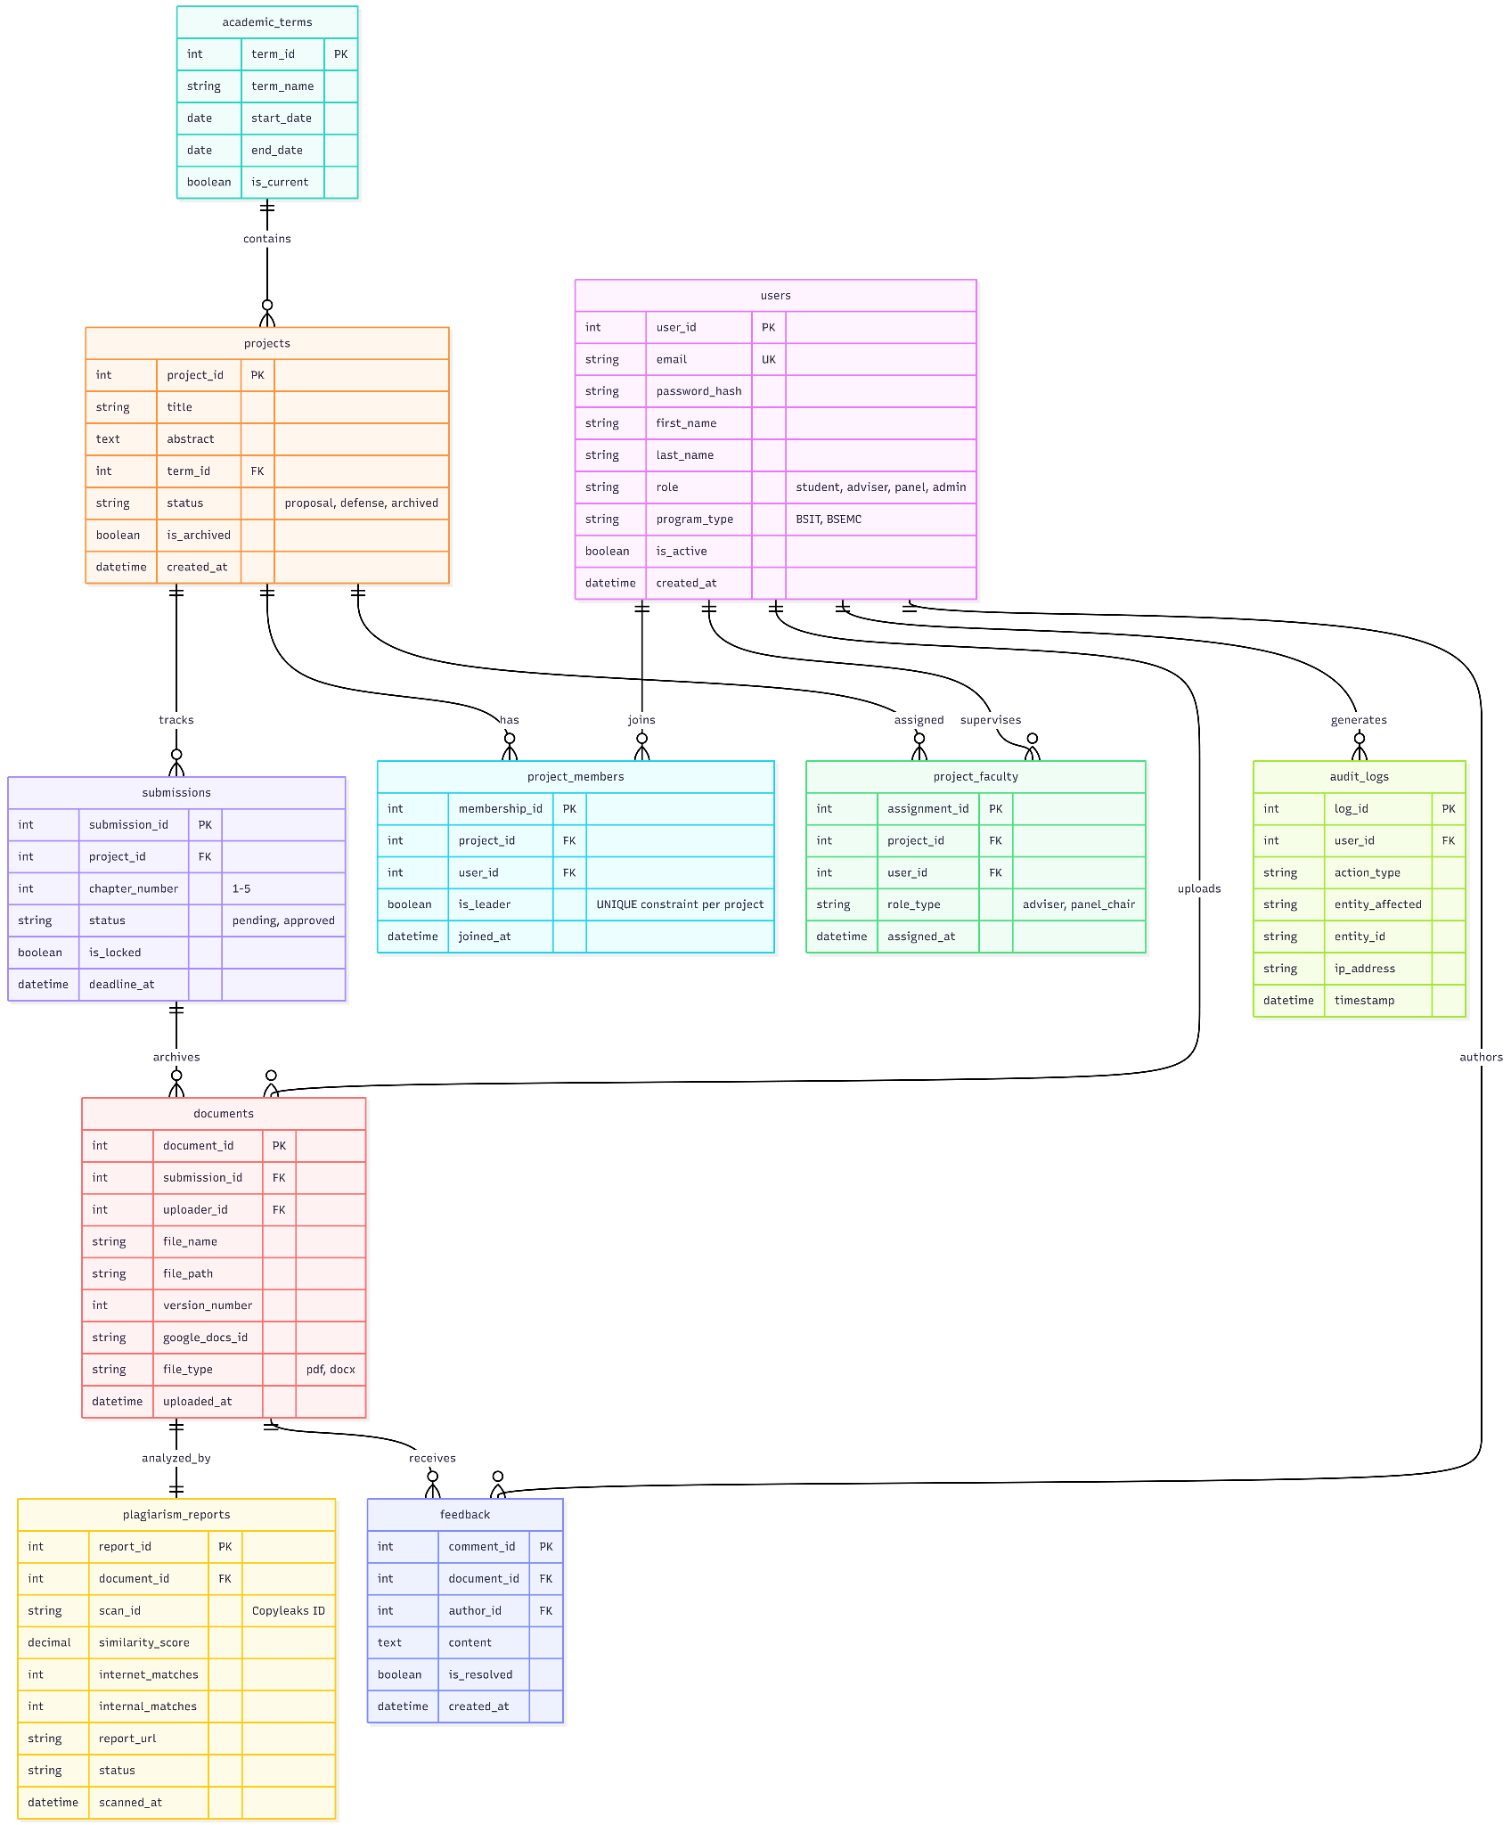
Figure 8.1. Project Workspace Database Schema
API Endpoint Specification: Designing the RESTful API endpoints that will facilitate communication between the frontend and backend for all management features.
Plagiarism Checker Integration Design: Planning the technical workflow for integrating the similarity checker using an in-house Python FastAPI microservice (cms-plagiarism-api). This includes designing the process for document submission via REST API, asynchronous execution using Celery workers (cms-plagiarism-worker) and Redis (cms-plagiarism-redis), executing hybrid winnowing and sentence-transformer vector analysis against MinIO/ChromaDB stores, handling the response, and displaying similarity reports within the system.
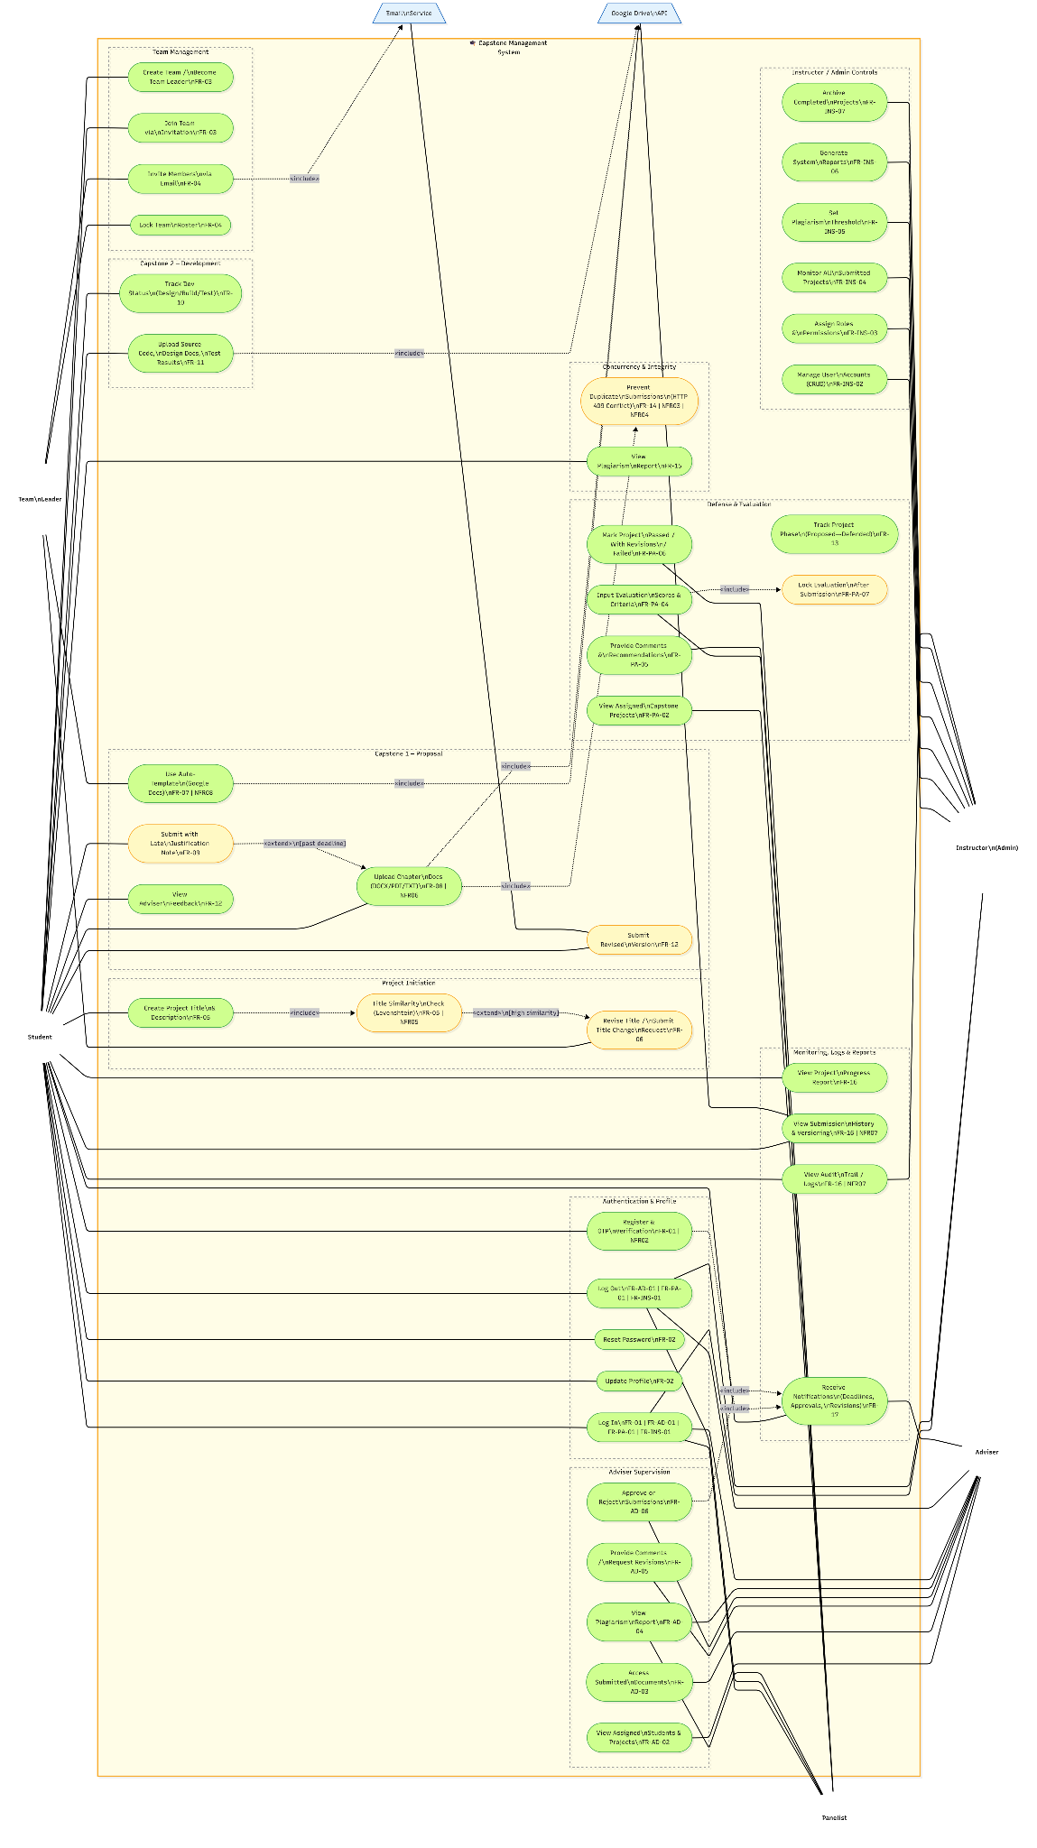
Figure 8.2 Use Case Diagram
Student DFD & Process Flowchart
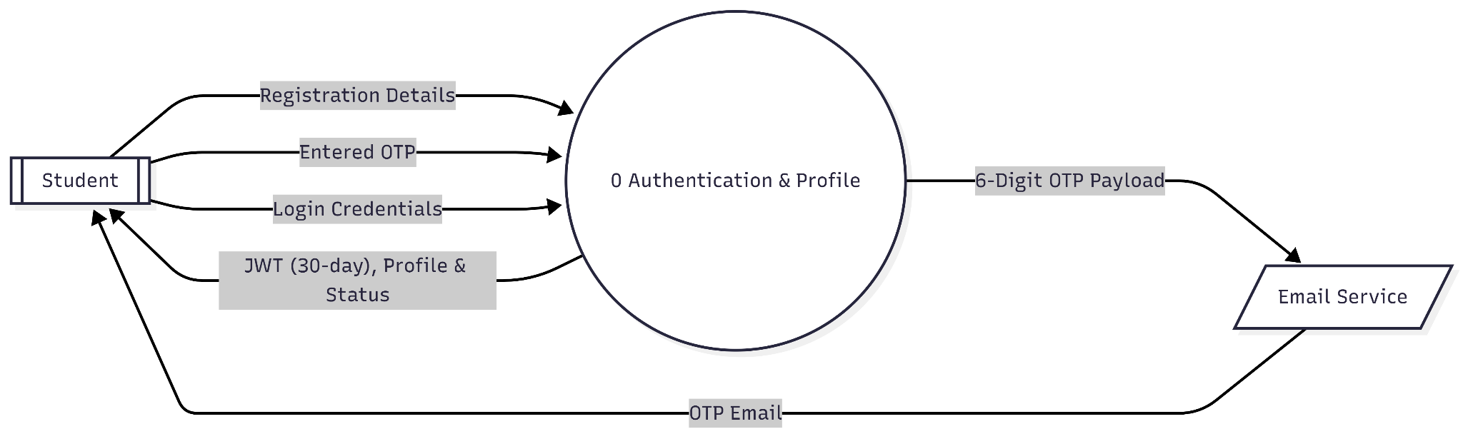
Functional Requirement 1: DFD Student Login
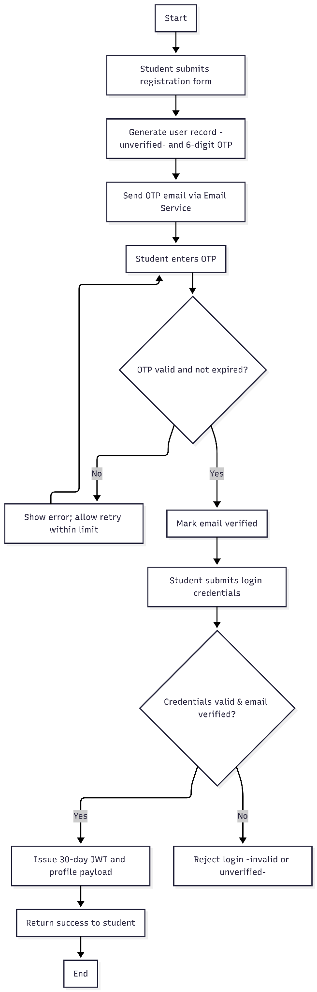
The Authentication & Profile system is a central process managing the exchange of information between the Student and an external Email Service. The Student inputs registration details, prompting the system to generate an OTP payload sent via the Email Service. To complete the process, the Student submits their OTP and login credentials. Successful validation results in the system outputting a 30-day JWT and profile/status data to the Student. Internal data stores are abstracted, treating the system as a "black box" interface.

Functional Requirement 1: Process Flowchart Student Login
The operational lifecycle transitions from a simple data exchange into a sequential logic path. It starts with the Student Registration event, which triggers the system to generate and dispatch an OTP. This leads into a validation loop; the student is prompted to enter the code, and the system monitors for retries. If the validation fails, the loop restarts until a limit is reached or the correct code is provided.
Once the account is marked as Verified, the logic moves to the login phase. Here, the system performs a two-factor check: it validates the user credentials against the verification status. If the account is both verified and the credentials are correct, the system generates a 30-day JWT and bundles it with the profile payload, successfully concluding the authentication session and granting the user access.
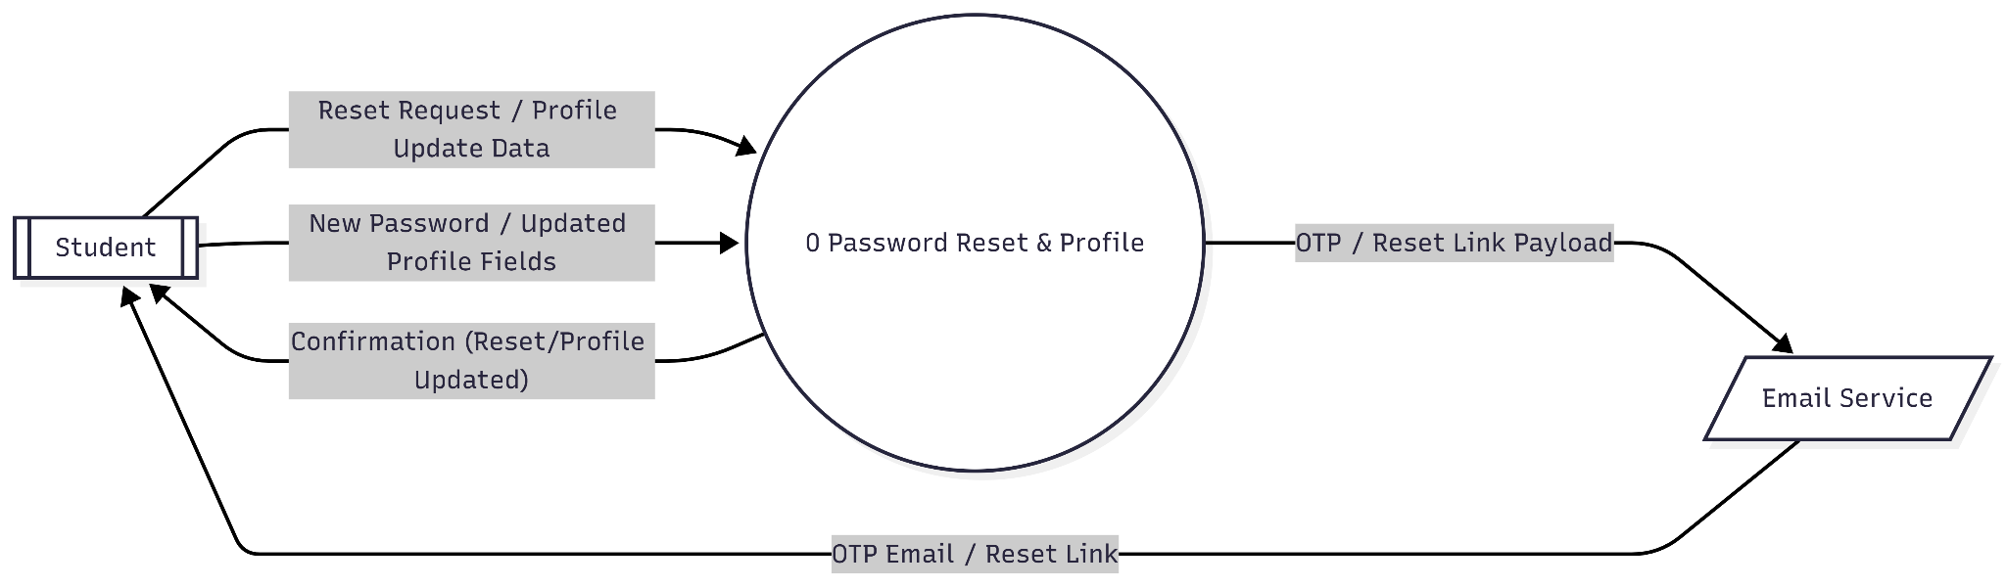
Functional Requirement 2: DFD Student Password Reset
Shows one system process handling both password reset and profile updates. Student sends requests/data; Email Service only relays OTP/reset links; system returns confirmations.

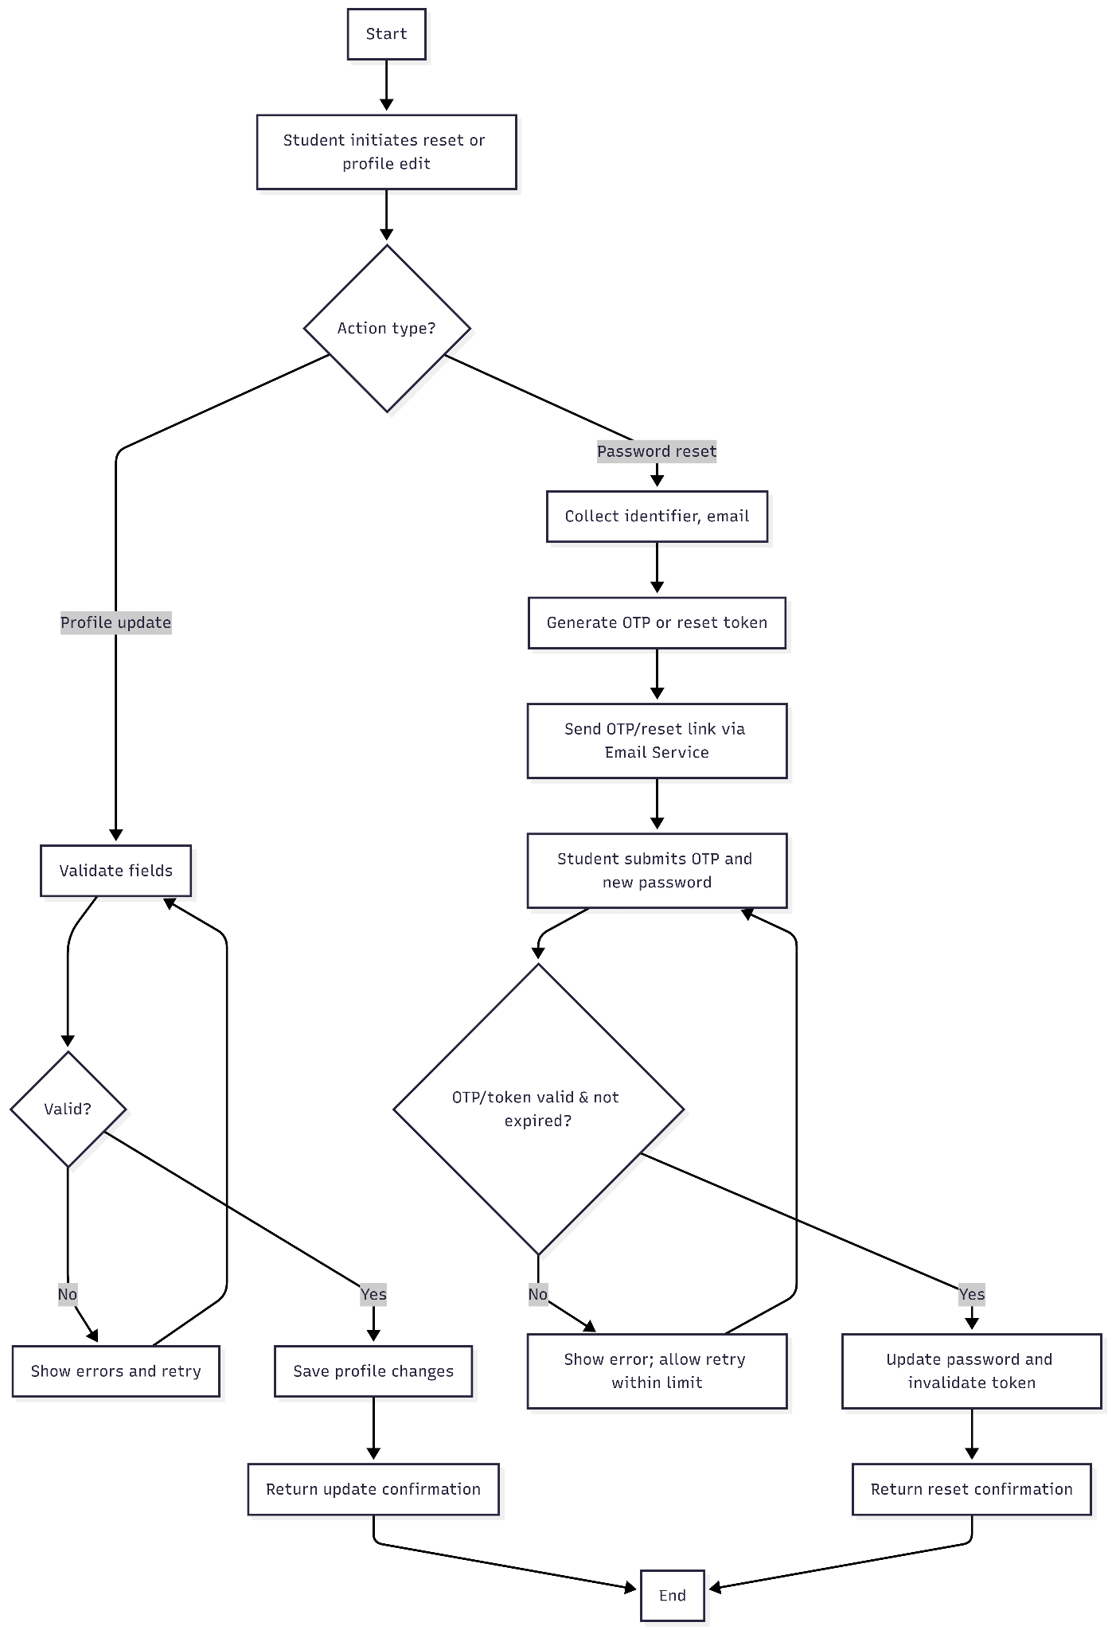
Functional Requirement 2: Process Flowchart Student Password Reset
Flow splits by action: profile updates validate/save fields with immediate confirmation; password reset issues OTP/reset link, validates it, then updates password and confirms.
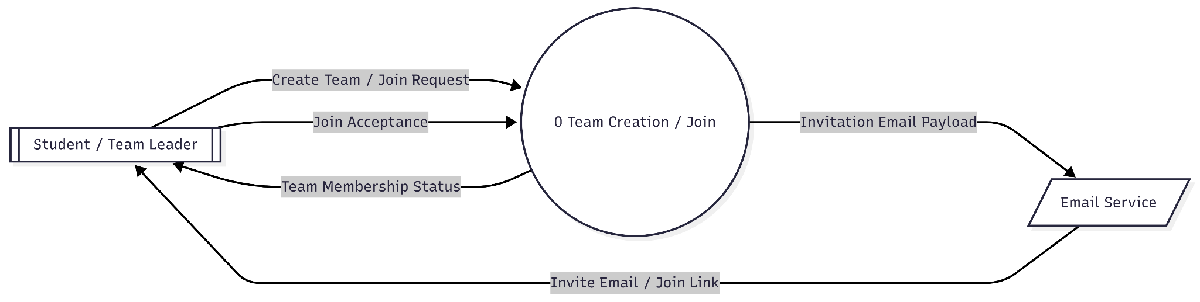
Functional Requirement 3: DFD Student Team Management
The 0 Team Creation / Join process functions as the central logic layer that ingests Student-initiated requests, delegates invitation payloads to an external Email Service for distribution, and asynchronously updates the system state upon receiving a Join Acceptance to provide the finalized Team Membership Status.
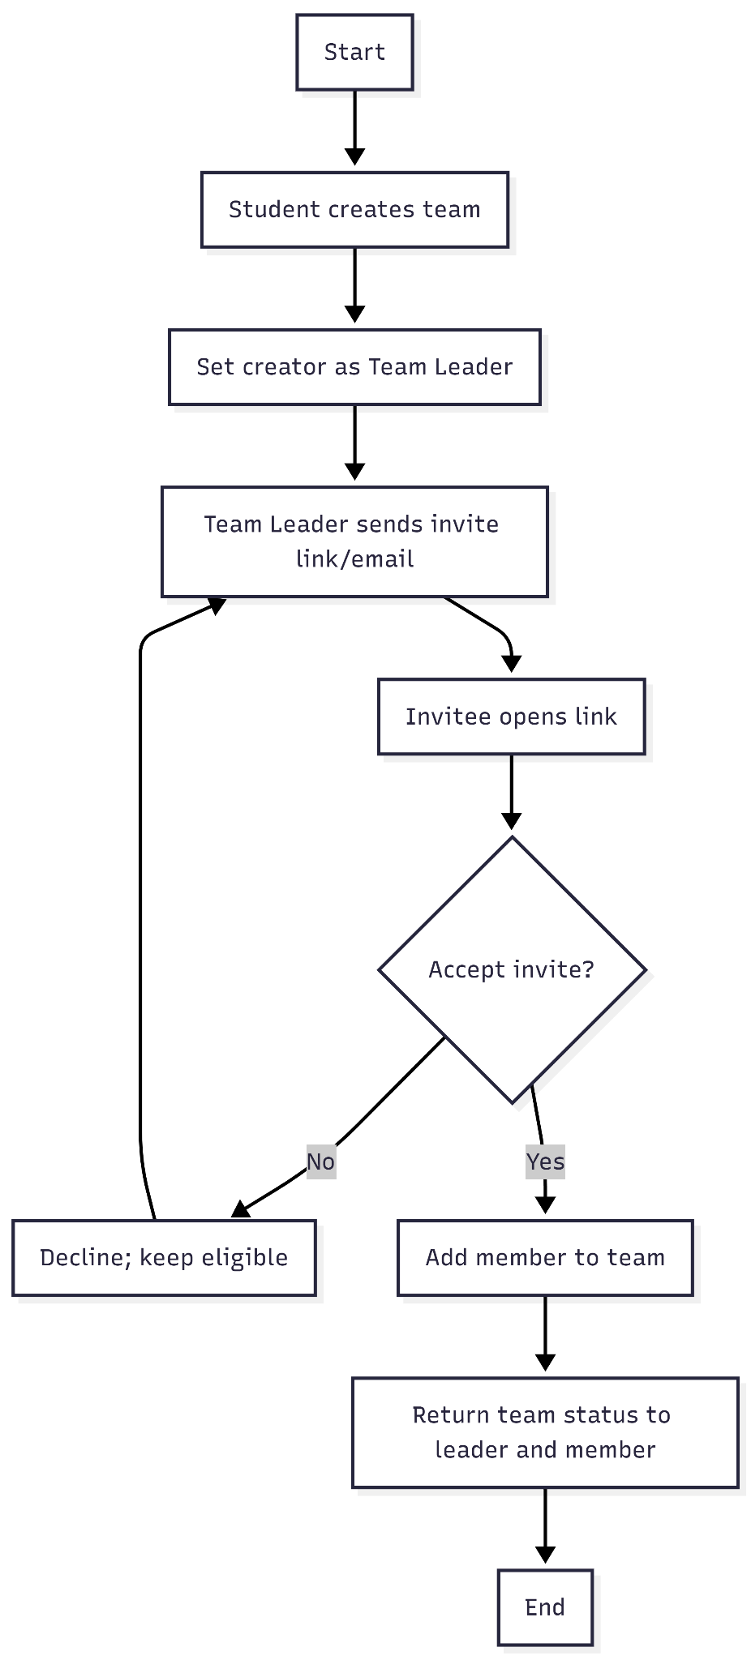
Functional Requirement 3: Process Flowchart Student Team Management
Student creates a team, becomes leader, sends invite links via email; invitees accept/decline; system updates membership and returns team status. Flowchart shows create → invite → accept/decline loop → status.
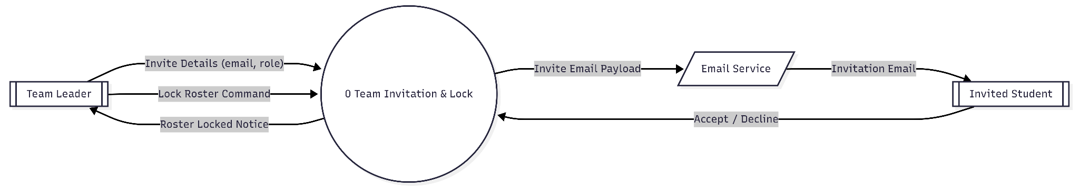
Functional Requirement 4: DFD Student Team Invite
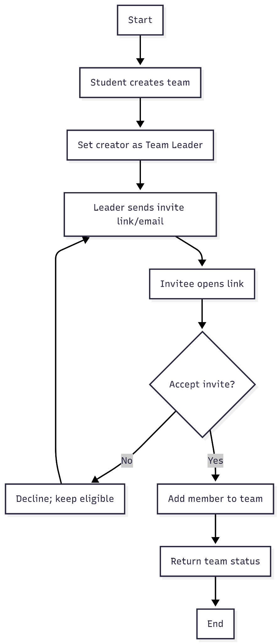
Shows one system process handling team creation and join requests. Student creates or joins; invites are sent via Email Service; acceptance updates membership status returned to the student.
Functional Requirement 4: Process Flowchart Student Team Invite
Loop invites until slots filled or leader decides; accept adds member; decline keeps slot; leader locks to prevent changes.
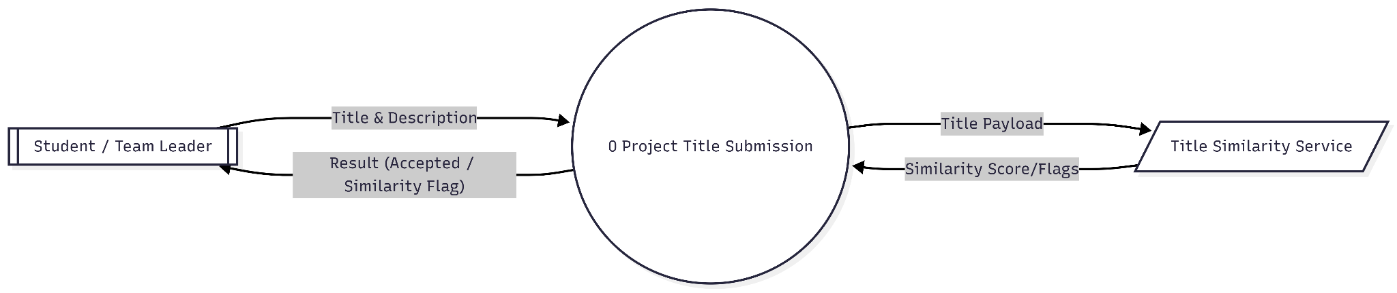

Functional Requirement 5: DFD Student Title Submission + Similarity Check
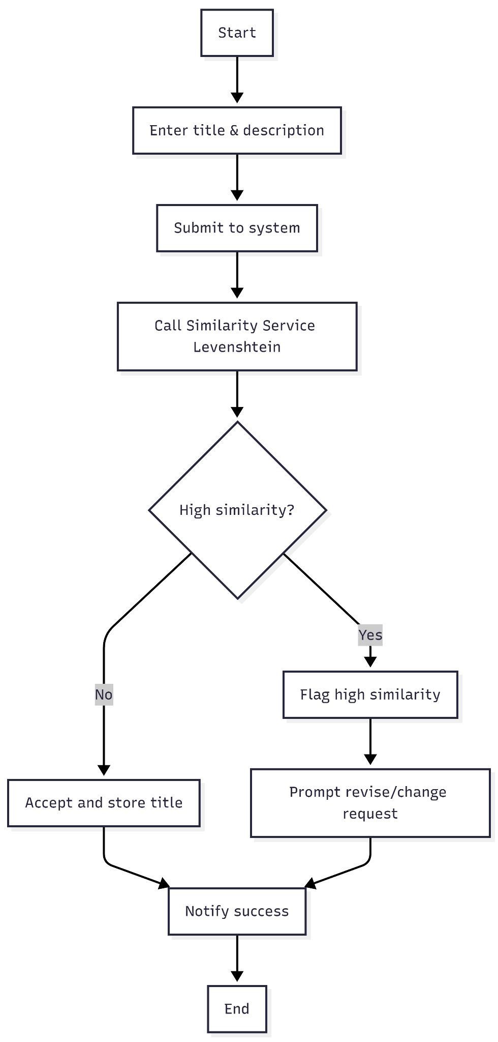
Student submits title/description; system calls similarity service; returns acceptance or high-simil
Functional Requirement 5: Flowchart Student Title Submission
submit → similarity check → accept if low similarity; if high, flag and prompt for revision/change (feeds FR-06).
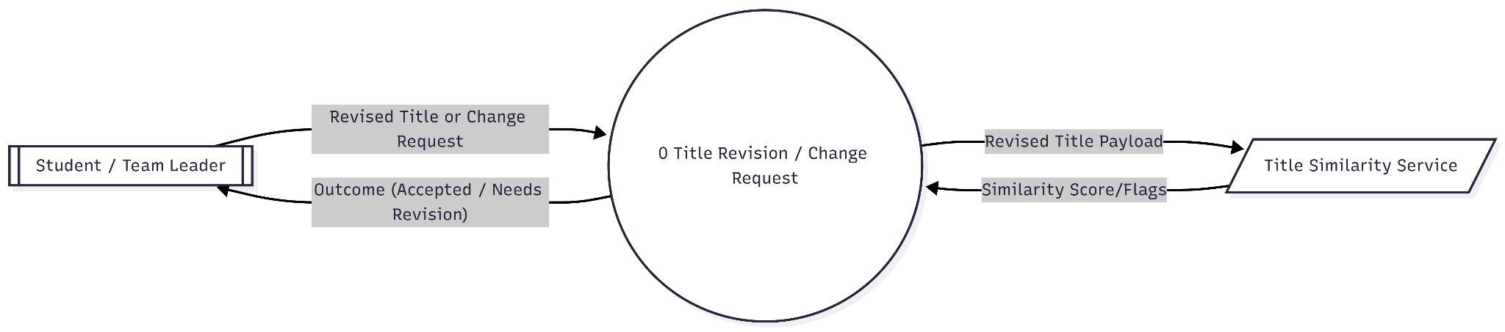
Functional Requirement 6: DFD Student Title Revision / Change Request
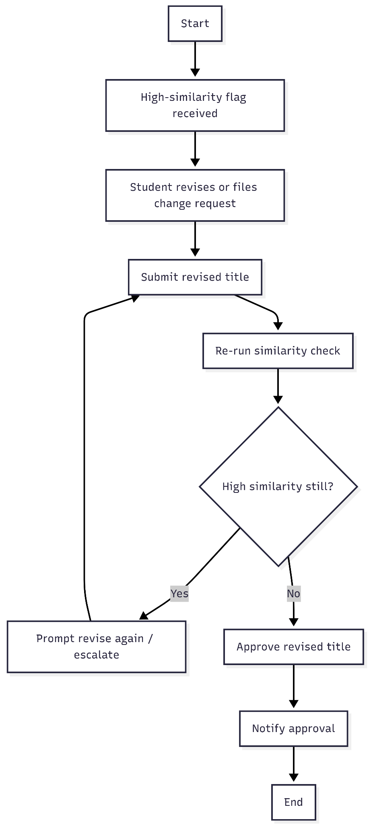
Student submits revised title/change request; system re-checks similarity; returns acceptance or further revision needed.
Functional Requirement 6: Flowchart Student Title Revision / Change Request
Loop revisions until similarity acceptable; then approve and notify.
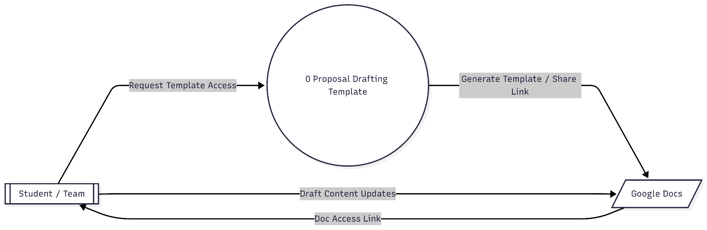
Functional Requirement 7: DFD Student Google Docs Auto-Template (Ch 1–3)
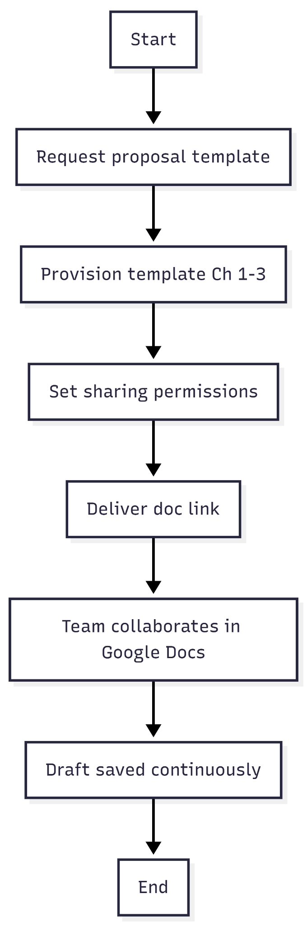
System provisions a Docs template and shares link; students edit directly in Docs; updates stay in Docs.
Functional Requirement 7: Flowchart Student Title Revision / Change Request
Request → provision template → share link → collaborate with live saves.
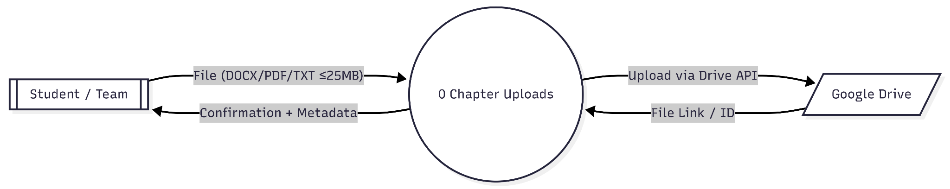
Functional Requirement 8: DFD Student Chapter Uploads via Google Drive
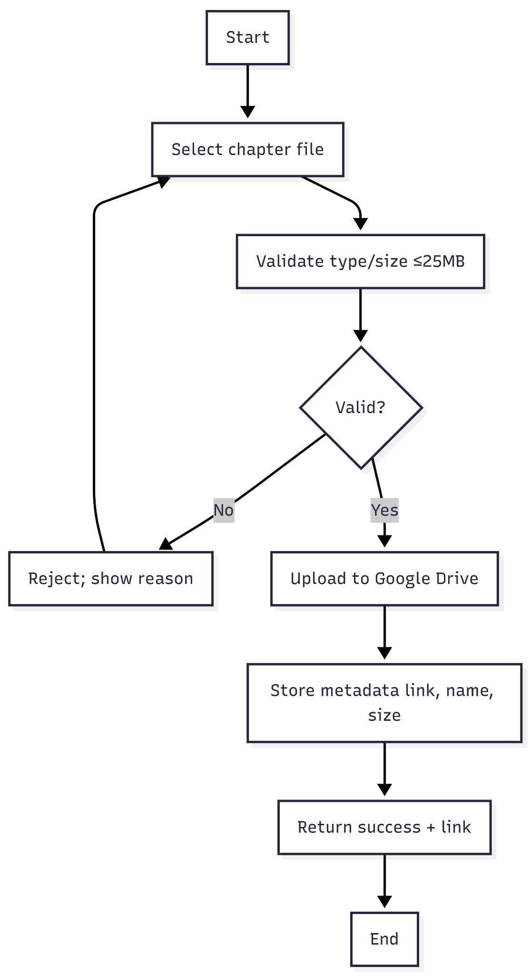
Student uploads validated file; system stores via Drive API; returns link/metadata and confirmation.
Functional Requirement 8: Flowchart Student Chapter Uploads via Google Drive
Validate file → if valid upload & store metadata → return link; else reject and retry.

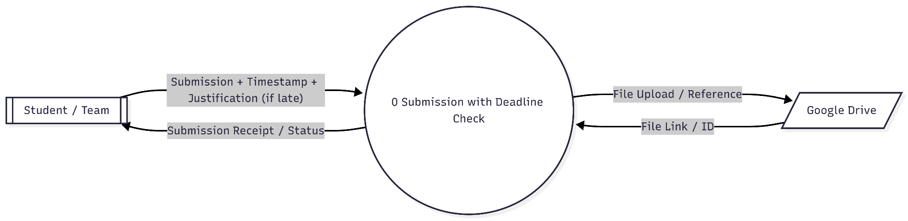
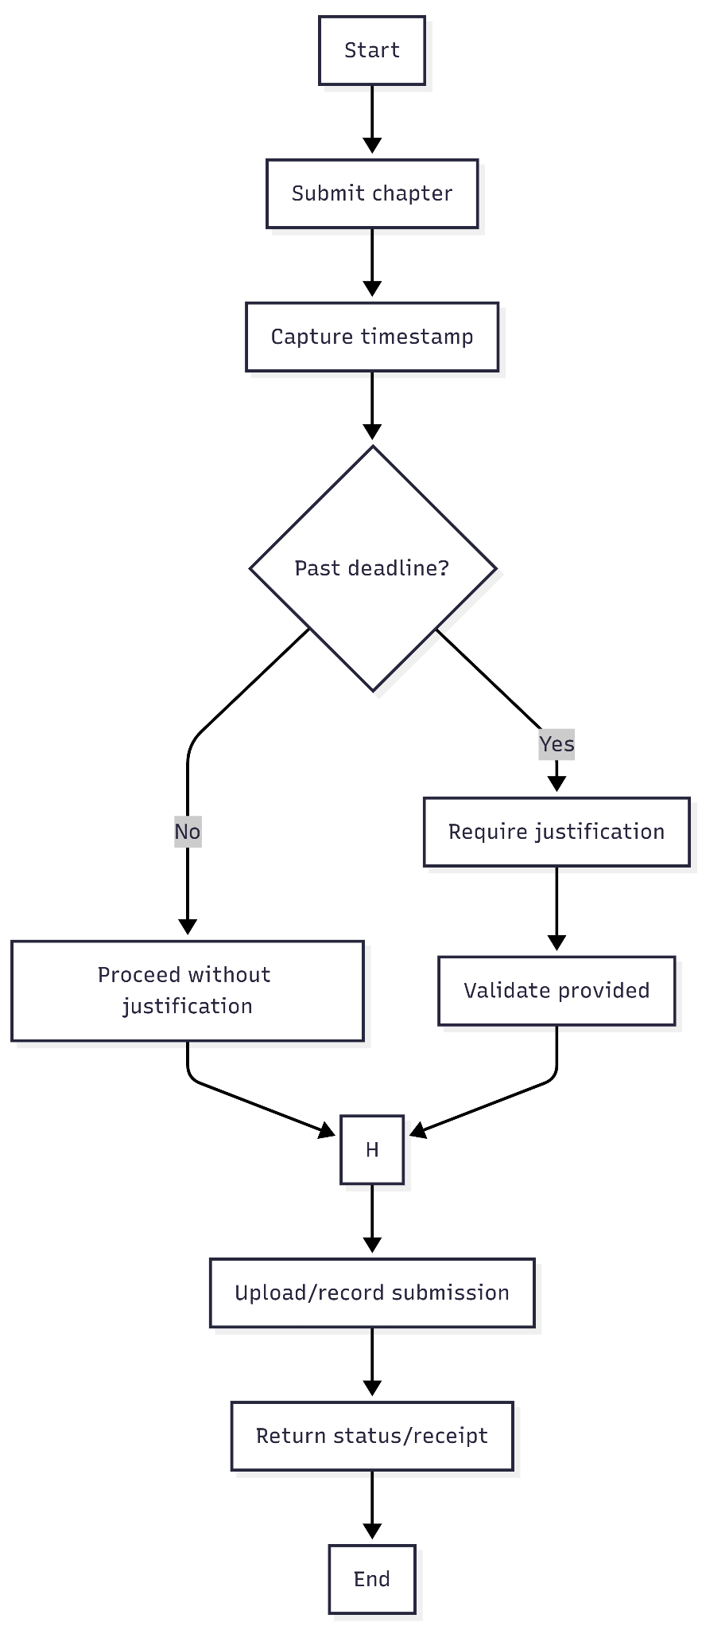
Functional Requirement 9: DFD Student Late Justification for Past-Deadline SubmissionSubmission includes timestamp (and justification if late); system stores file/reference; returns receipt/status.

Functional Requirement 9: Flowchart Student Late Justification for Past-Deadline Submission
To provide an exhaustive summary of the integrated system represented in both diagrams: the workflow functions as a continuous accountability loop that captures critical data at every transition point. It initiates with the student's submission, where the system generates "digital exhaust" through automated timestamping and justification validation to ensure deadline compliance. This data is then ingested by the Project Status Lifecycle process, which acts as the central repository for the project's state. As reviewers submit their Status Decisions, the system translates these inputs into formal Confirmation Records and updates the Status History, which is then served back to the student to maintain transparency. Essentially, the system transforms raw student inputs and faculty evaluations into a permanent, searchable audit trail of the entire project's evolution.
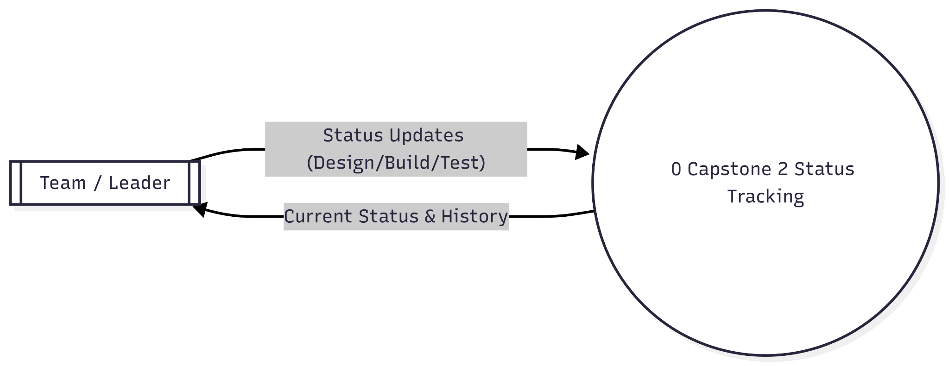
Functional Requirement 10: DFD Student Capstone 2 Status Tracking (Design/Build/Test)
Team submits status updates; system returns current phase and history to the team.

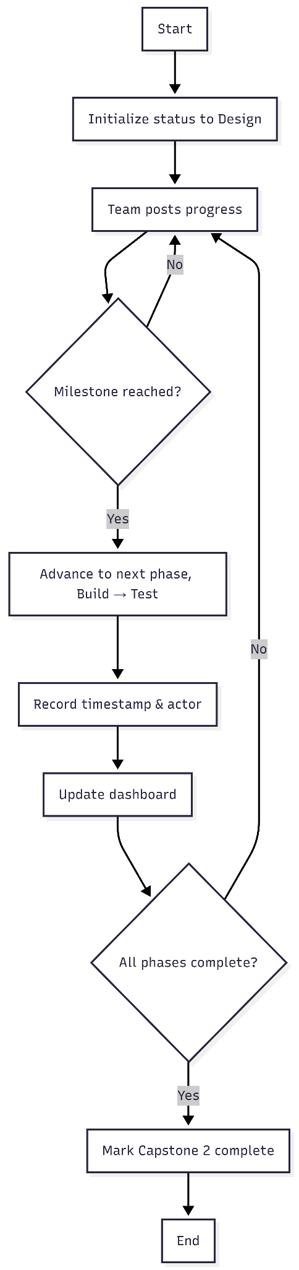
Functional Requirement 10: Flowchart Student Capstone 2 Status Tracking (Design/Build/Test)
Status starts at Design; progress triggers phase advancement to Build then Test; timestamps/actors logged; dashboard updated until completion.- Status starts at Design; progress triggers phase advancement to Build then Test; timestamps/actors logged; dashboard updated until completion.
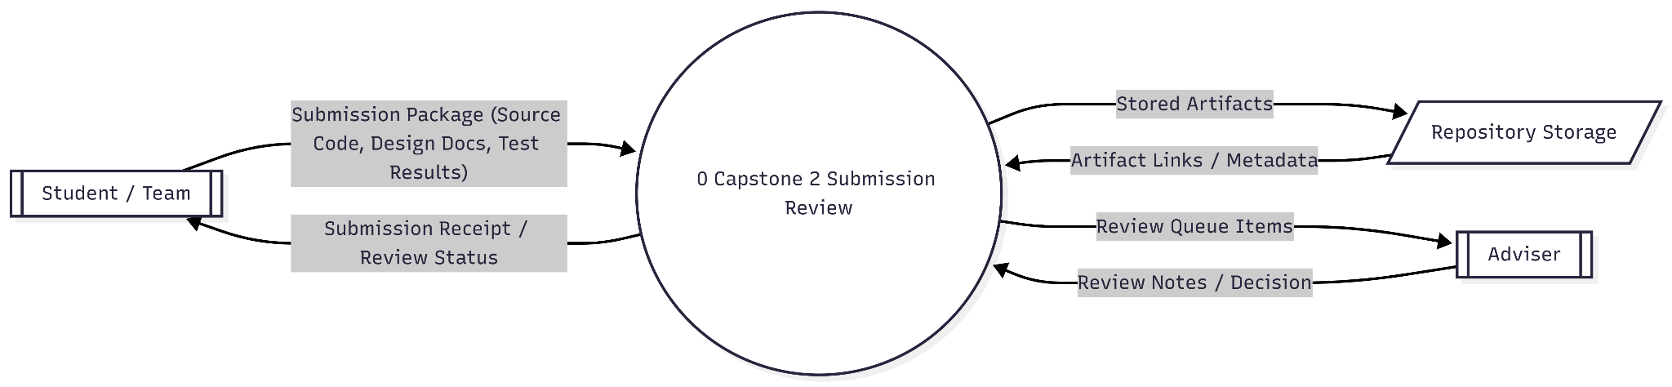
Functional Requirement 11: DFD Student Upload source code, design documents, and test results for adviser review.
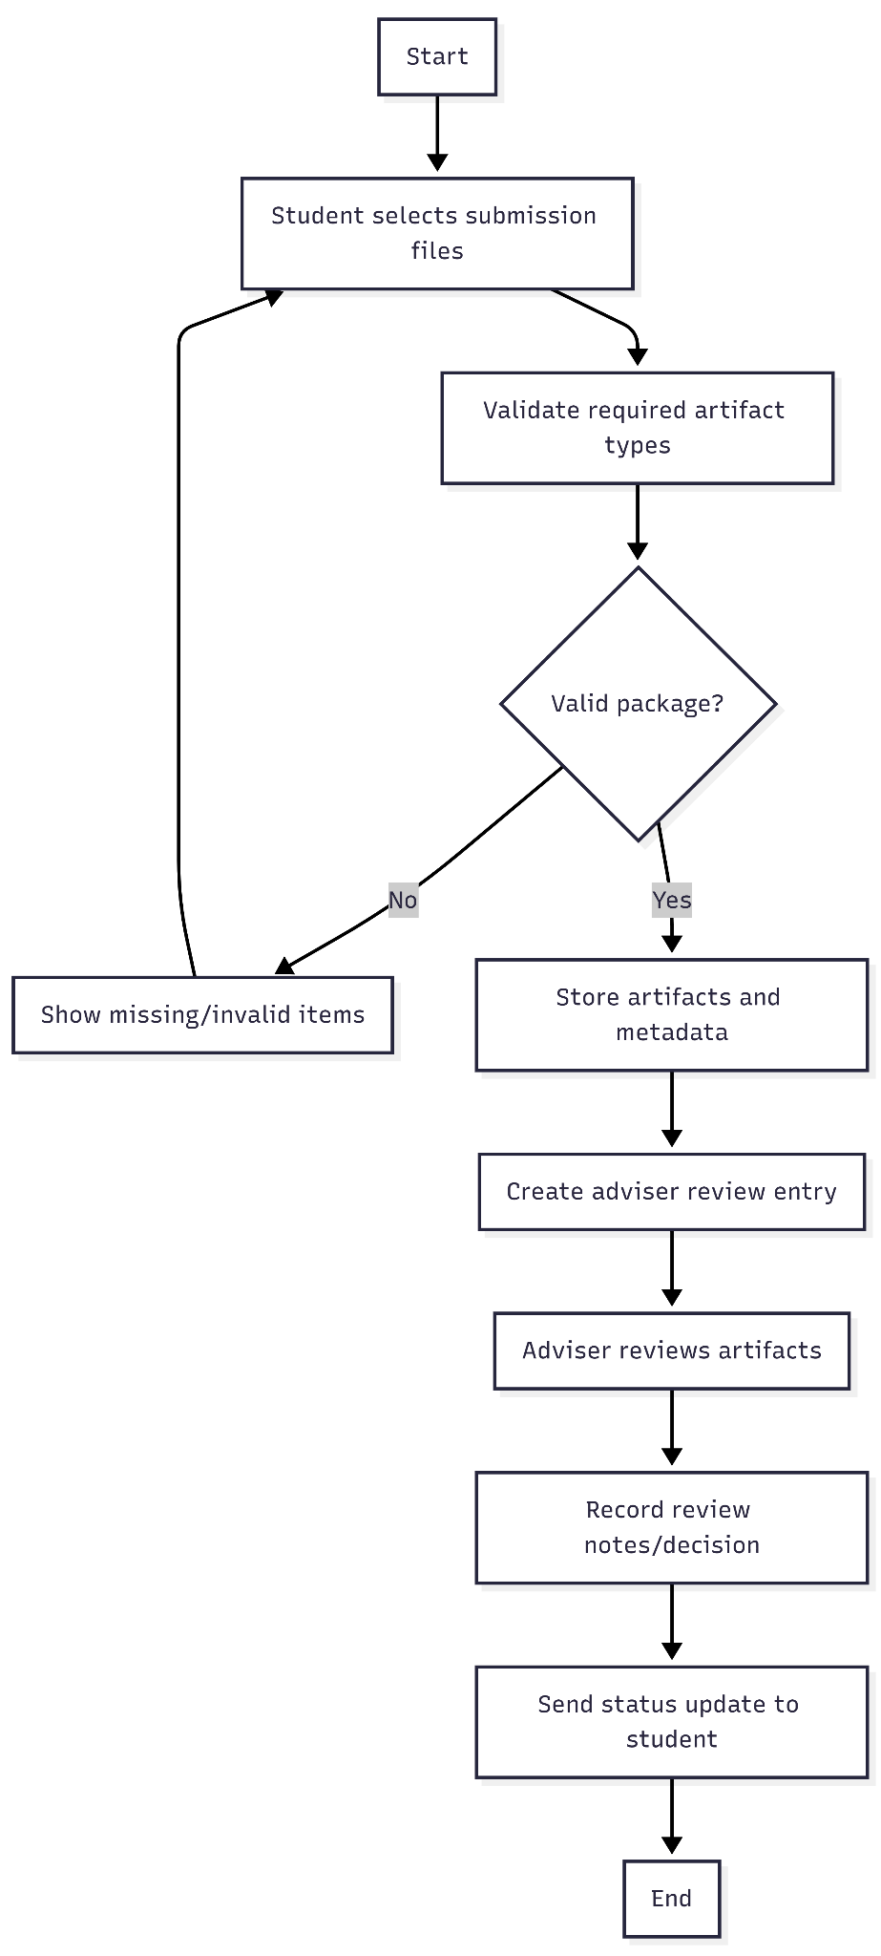
The diagram shows students submitting three artifact types to one system process, which stores them, routes them to adviser review, and returns status/receipt.
Functional Requirement 11: Flowchart Student Upload source code, design documents, and test results for adviser review.
Flow: package validation → storage → adviser review entry → adviser decision → status returned to student.
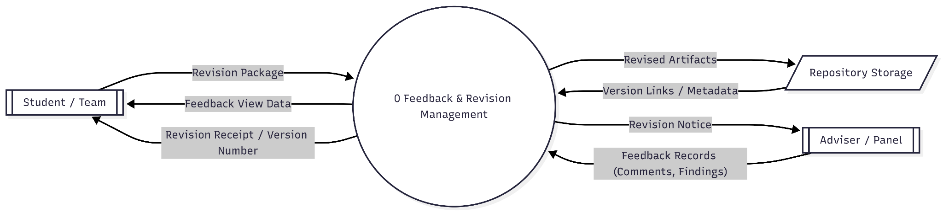
Functional Requirement 12: DFD Student View adviser/panel feedback and submit revised versions
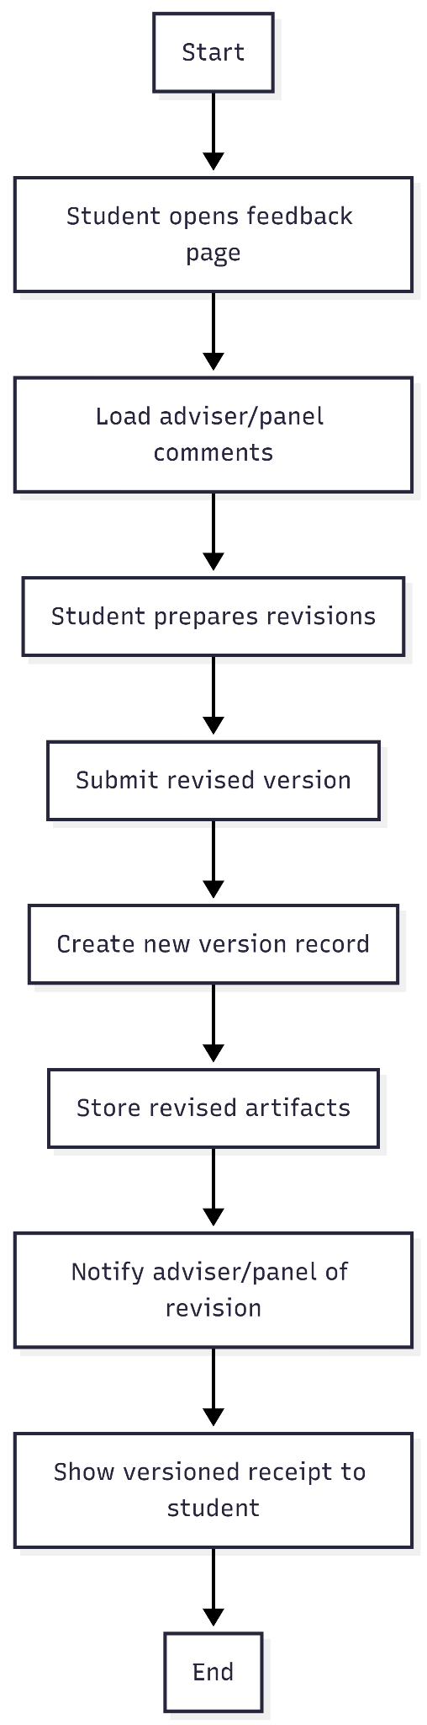
Feedback enters from adviser/panel, students view it, submit revised versions, and the system stores versioned outputs and notifies both sides.
Functional Requirement 12: Flowchart Student View adviser/panel feedback and submit revised versions
Flow: student reads feedback, revises work, submits a new version, system versions/stores it, and notifies reviewers.
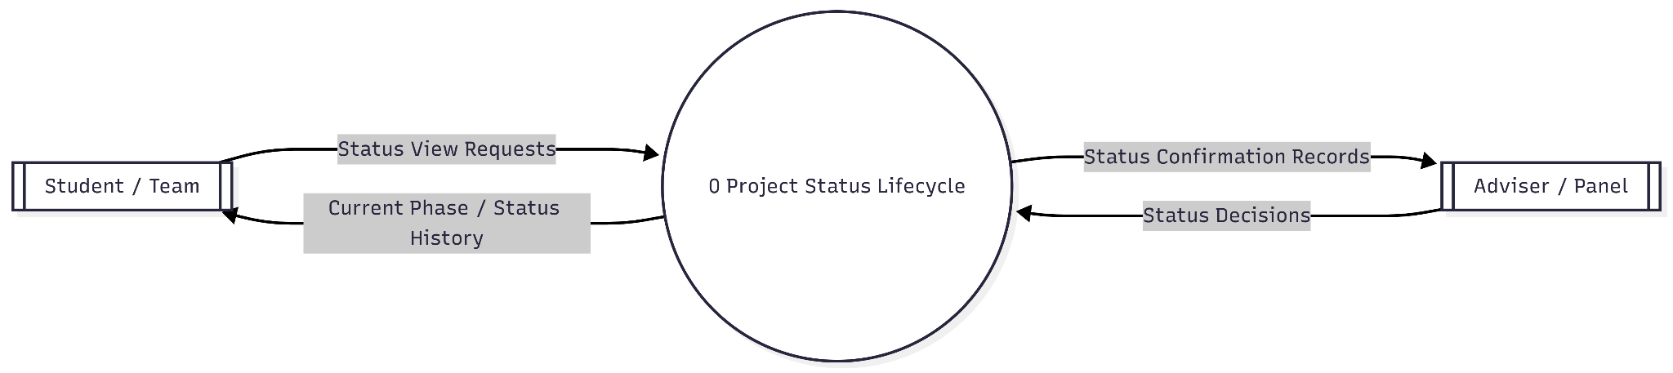
Functional Requirement 13: DFD Student Track project status: Proposed, Review, Approved for Defense, Defended
The Project Status Lifecycle system serves as a centralized coordination hub designed to bridge the communication gap between evaluators and student teams. It operates by ingesting "Status Decisions" from the Adviser or Panel, which are then processed to generate formal confirmation records for the reviewers while simultaneously updating the project's internal timeline. On the other side of the flow, the Student or Team can submit view requests to the system, which then retrieves and serves their current project phase and a comprehensive status history. By maintaining this continuous loop of input and feedback, the process ensures that project milestones are accurately tracked, archived, and accessible to all stakeholders in real-time.
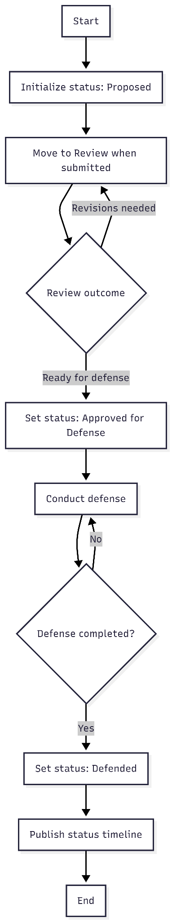
Functional Requirement 13: Flowchart Student Track project status: Proposed, Review, Approved for Defense, Defended
The system begins by managing chapter submissions, where it captures timestamps and enforces justification requirements for any late entries to ensure procedural compliance. Once submitted, the project enters a structured lifecycle that transitions from a "Proposed" state through iterative review cycles until it is officially approved for defense. The process culminates in the final defense and the publication of a comprehensive status timeline, providing a complete and transparent record of the project's evolution.
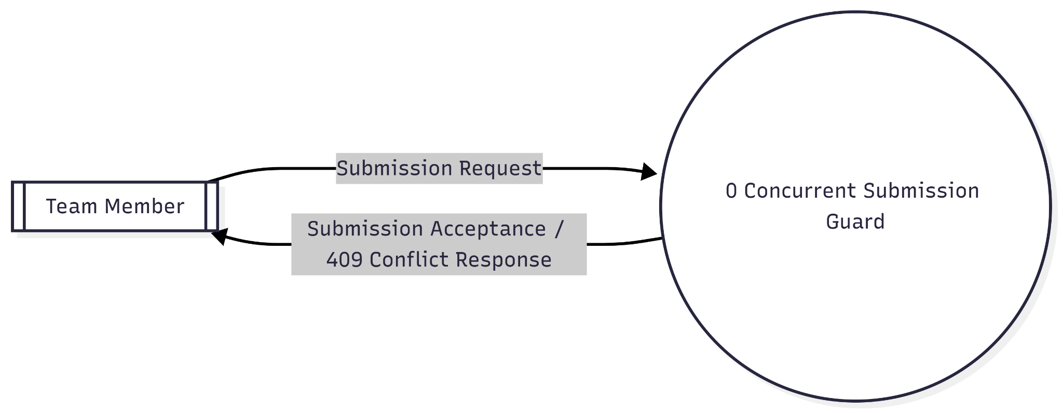
Functional Requirement 14: DFD Student Concurrency control to prevent duplicate submissions (HTTP 409 Conflict)
The process accepts only one active submission transaction and returns HTTP 409 to competing simultaneous requests.
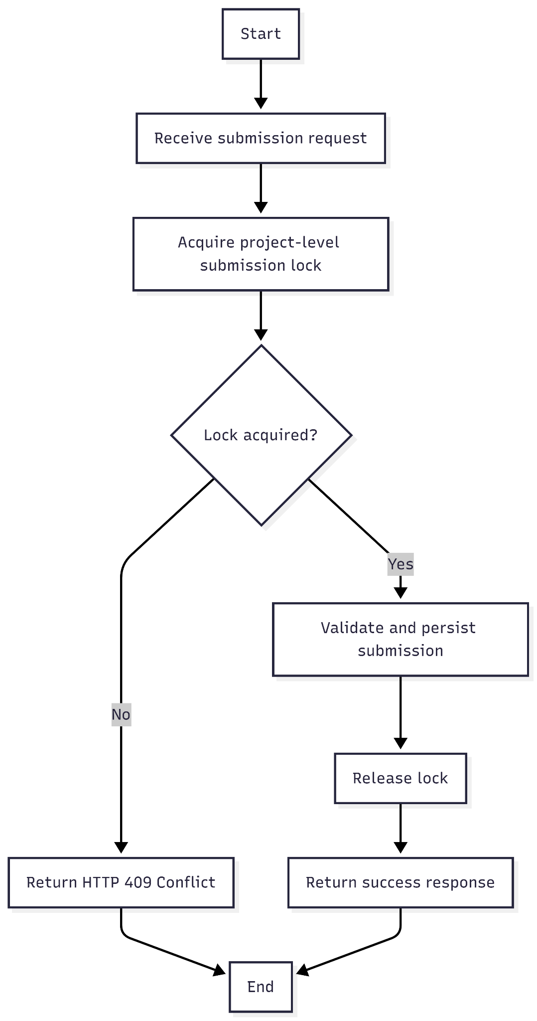
Functional Requirement 14: Flowchart Student Concurrency control to prevent duplicate submissions (HTTP 409 Conflict)
The workflow maintains data integrity by requiring each submission request to successfully acquire a project-level lock before the system validates and persists any information. If the lock is currently held by another process, the system issues an HTTP 409 Conflict response to prevent duplicate writes, ensuring the lock is only released after the successful completion of the initial request.
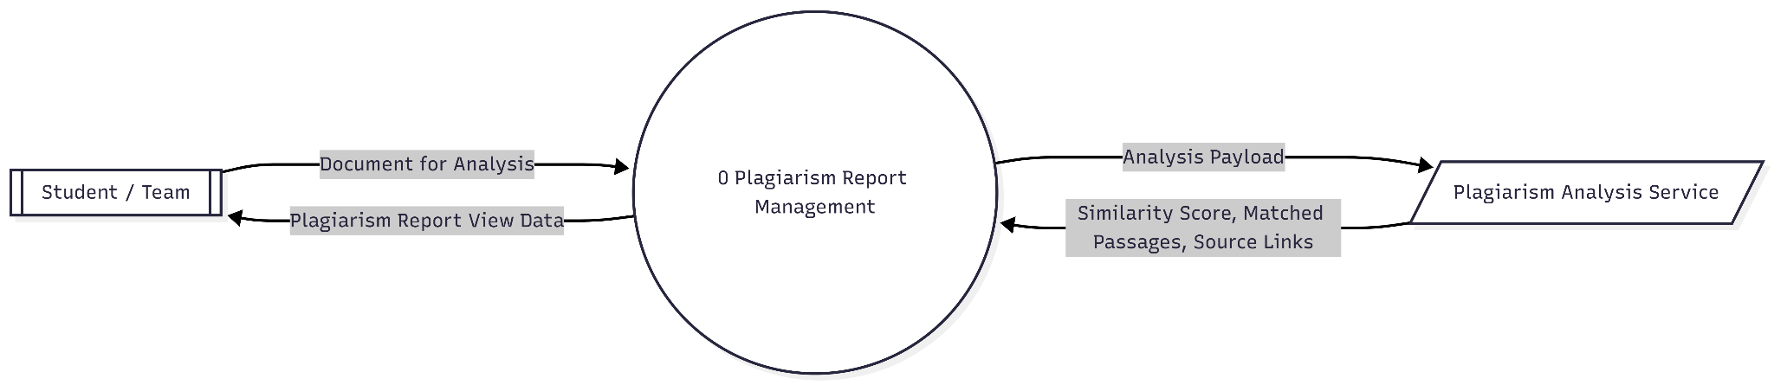
Functional Requirement 15: DFD Student Plagiarism Report with similarity scores, matched passages, source links
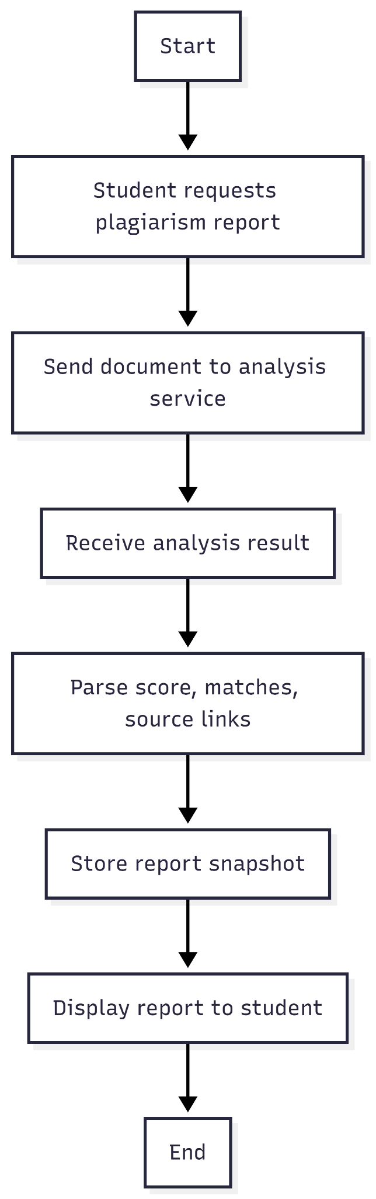
Student submits a document, system retrieves plagiarism analysis results, and returns a report containing the required score, passages, and links.

Functional Requirement 15: Flowchart Student Plagiarism Report with similarity scores, matched passages, source links
The process begins when a student triggers a request for a plagiarism report, prompting the system to transmit the document to an external analysis service. Once the analysis is complete, the system receives the raw results and parses them into specific data points, including similarity scores, exact matches, and direct source links. This parsed data is then captured as a stored report snapshot to maintain a permanent record before the final report is formatted and displayed to the student.
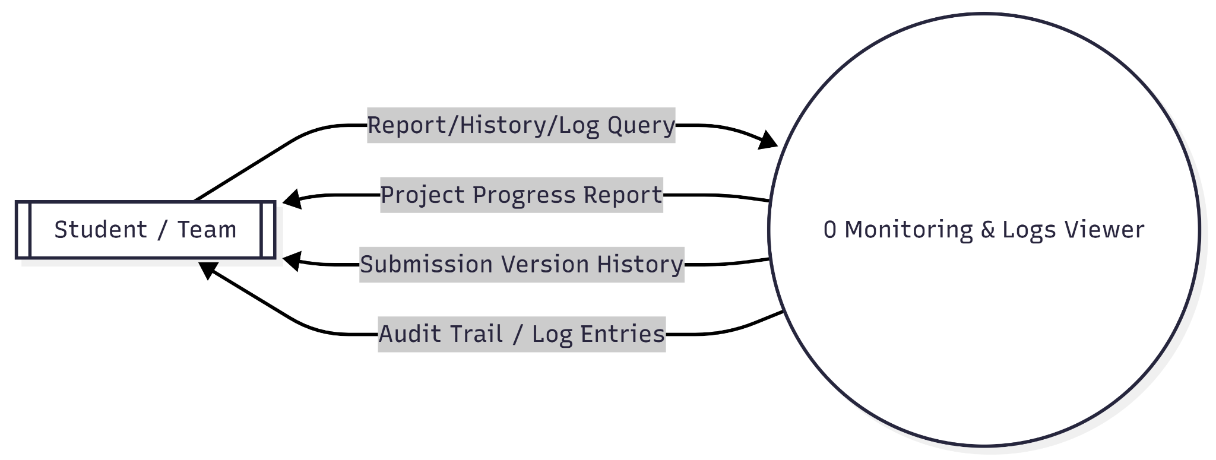
Functional Requirement 16: DFD Student View Project Progress Report, Submission History (versioning), Audit Trail/Logs
The process provides three monitoring views from a single request context: progress, version history, and full audit logs.
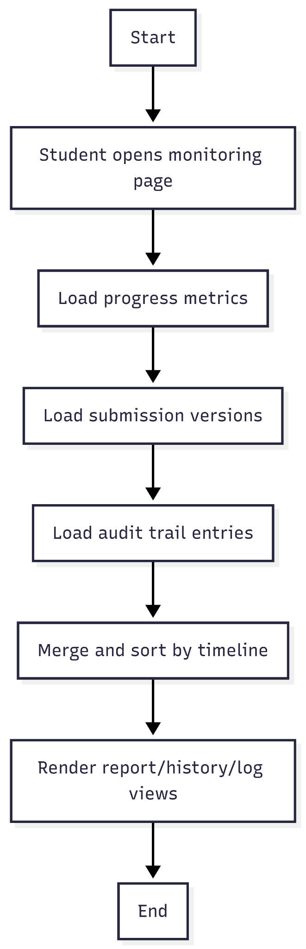
Functional Requirement 16: Flowchart Student View Project Progress Report, Submission History (versioning), Audit Trail/Logs
The system aggregates diverse data sources by concurrently loading progress metrics, submission versions, and audit trail entries whenever a student accesses the monitoring page. These datasets are then merged and sorted into a unified chronological timeline to render a comprehensive view of the project's history, reports, and activity logs.

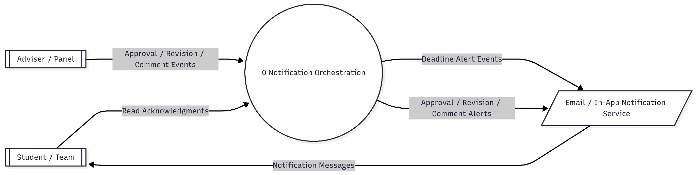
Functional Requirement 17: DFD Student Notify students of deadline alerts, approvals, revisions, and comments
The Notification Orchestration system serves as a unified communication engine that bridges the gap between administrative actions and student awareness by transforming discrete project events into actionable alerts. It begins by monitoring inputs from the Adviser / Panel—specifically approval, revision, or comment events—while simultaneously watching for automated deadline alert triggers. Once an event is detected, the system builds a standardized notification message, selects the appropriate delivery channel (such as email or in-app services), and dispatches the alert to the Student / Team. To ensure accountability and close the feedback loop, the system can capture read acknowledgments from the students, providing the administration with verification that critical updates have been seen.
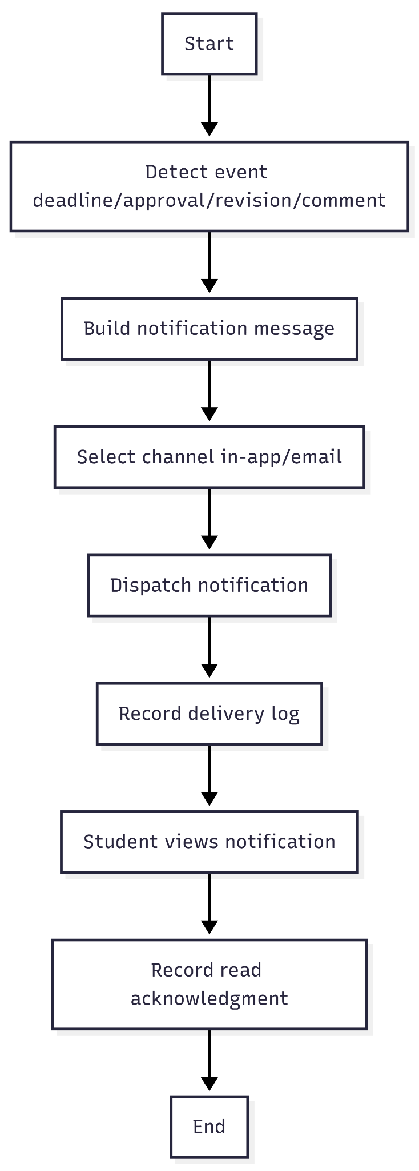
Functional Requirement 17: Flowchart Student Notify students of deadline alerts, approvals, revisions, and comments
The system maintains a centralized communication pipeline by detecting specific project events—such as deadlines, approvals, or revisions—and automatically composing a standardized notification message. Once a message is built, the system selects the appropriate delivery channel, such as in-app alerts or email, to dispatch the notification and creates a permanent record in the delivery log. This end-to-end flow concludes by tracking the student's interaction, specifically recording a read acknowledgment to ensure every critical update is both delivered and verified.
Adviser
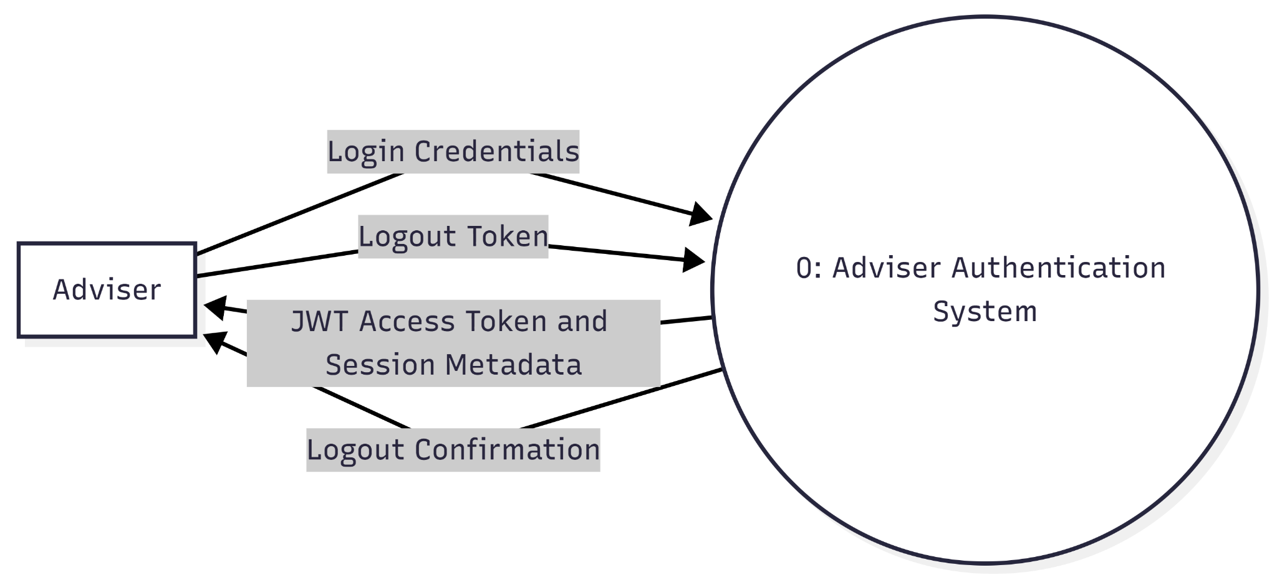
Functional Requirement 1: DFD Adviser Login and Logout (Secure)
This context-level DFD shows one external entity (Adviser) exchanging authentication data with one system process. The adviser sends credentials and receives JWT/session data. On logout, the adviser sends the active token and receives a confirmation response.

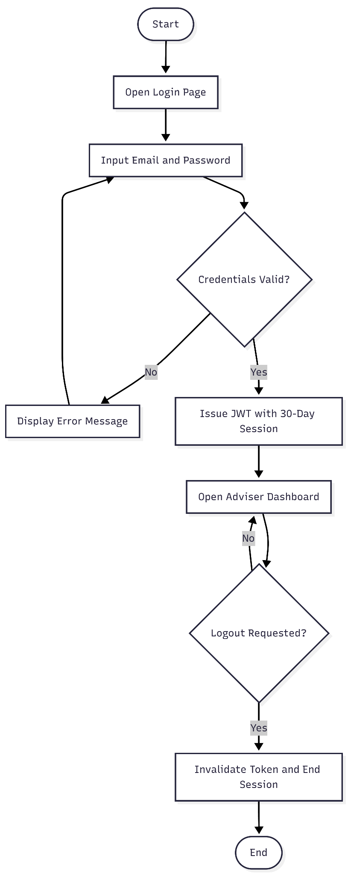
Functional Requirement 1: Flowchart Adviser Login and Logout (Secure)
The flow validates credentials, creates a 30-day JWT session on success, and keeps the adviser in dashboard state until logout is requested. Logout invalidates the token and ends the session.
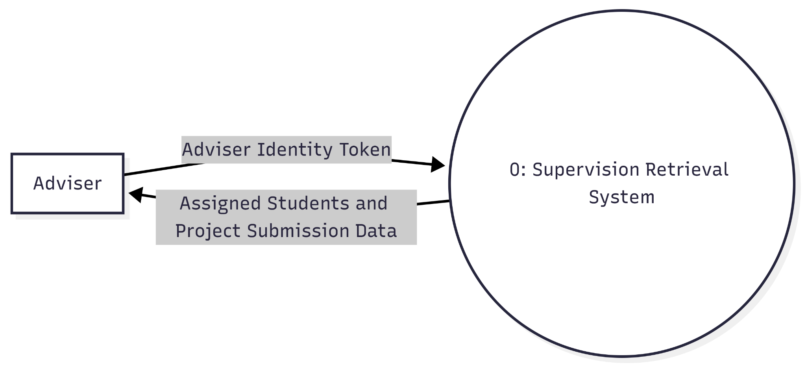
Functional Requirement 2: DFD Adviser View Assigned Students and Submitted Projects
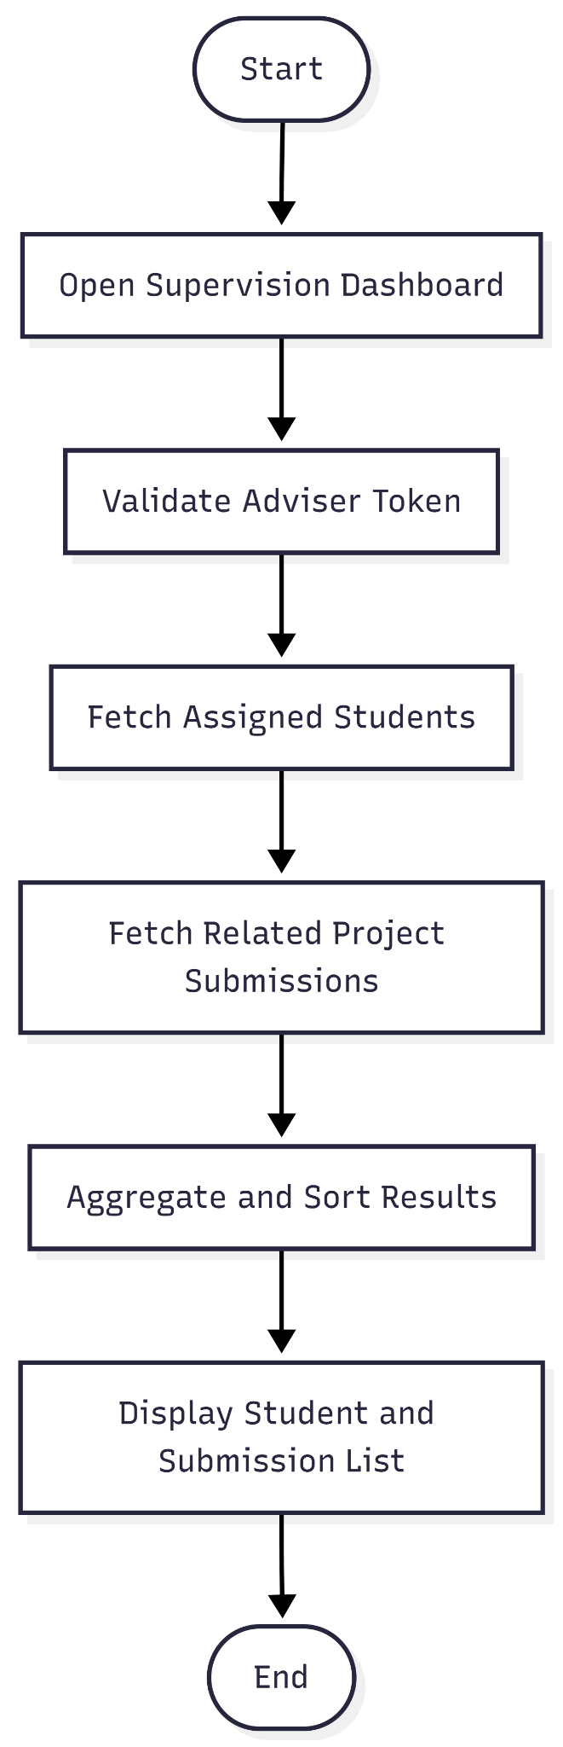
The adviser requests supervision data using an authenticated token. The system returns only assigned students and their project submissions relevant to that adviser.
Functional Requirement 2: Flowchart Adviser View Assigned Students and Submitted Projects
The process authenticates the adviser, retrieves assigned students, then retrieves and presents their related project submissions in one organized dashboard.
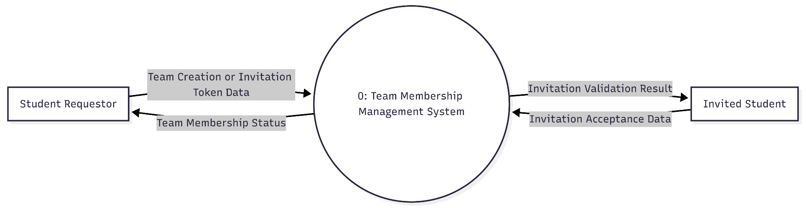
Functional Requirement 3: DFD Adviser Create Team or Join Team via Invitation
This DFD models team membership interactions at system boundary level. Students can either create a team or join via invitation. The system validates invitation data and returns membership outcomes.
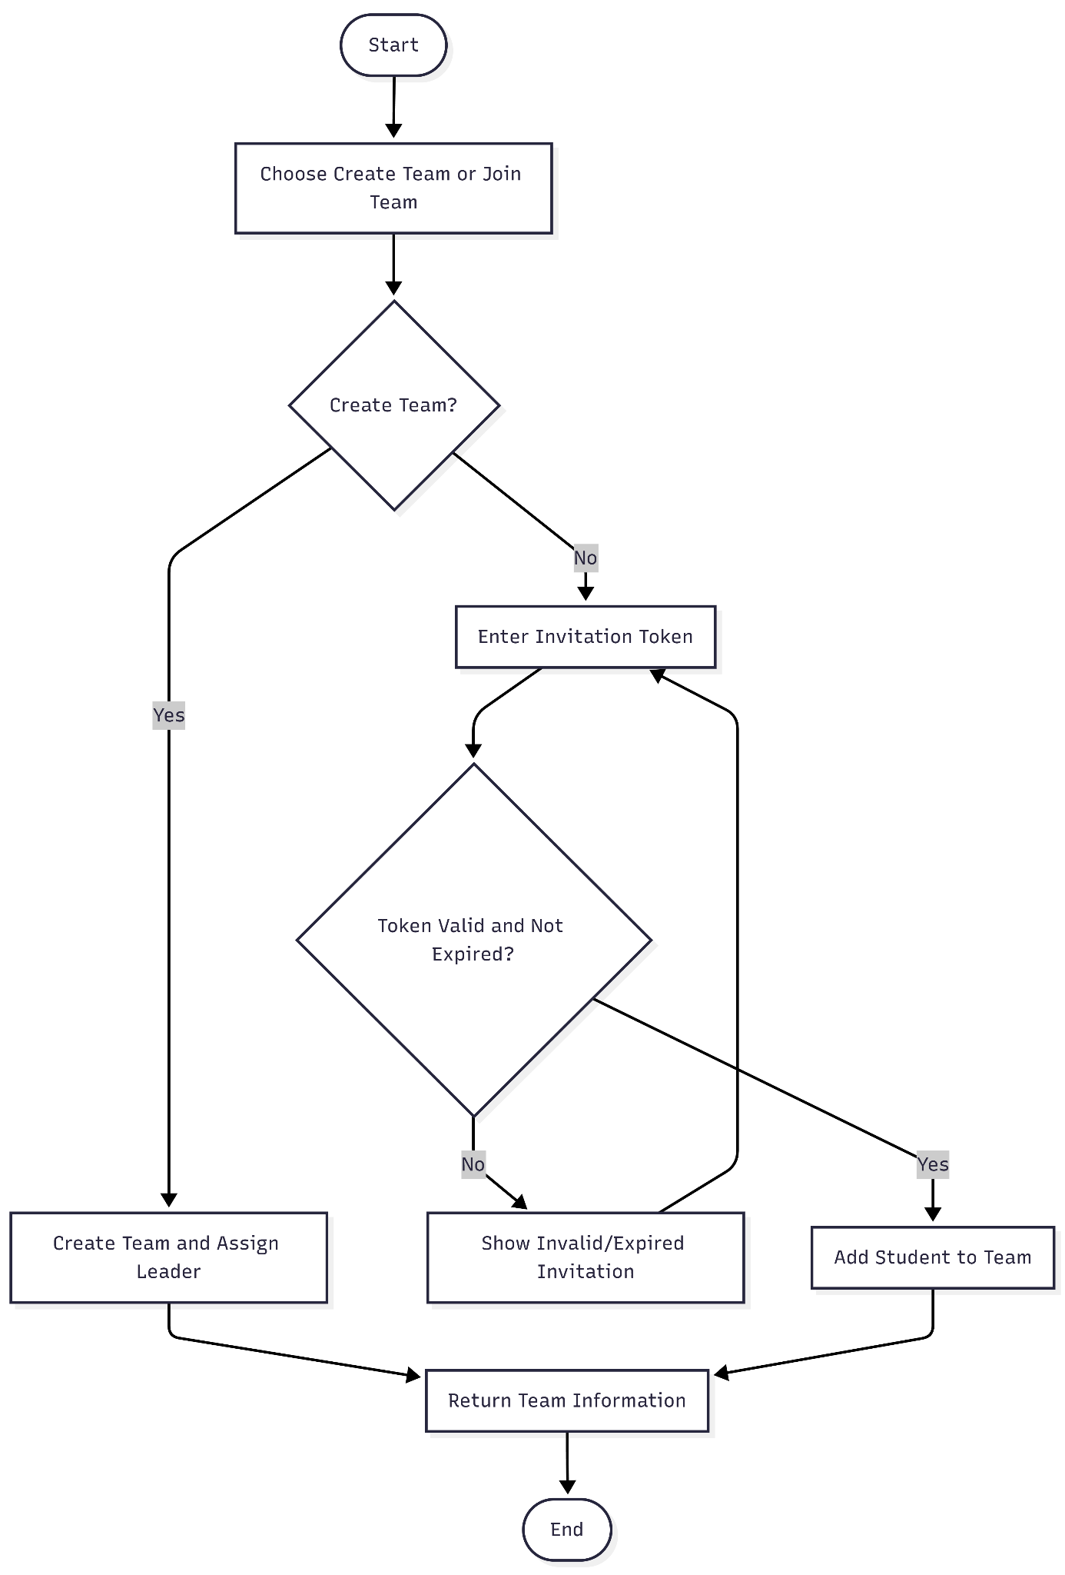
Functional Requirement 3: Flowchart Student Create Team or Join Team via Invitation
A student chooses either to create a team or join an existing team. Join requests are conditional on invitation token validity before membership is finalized.
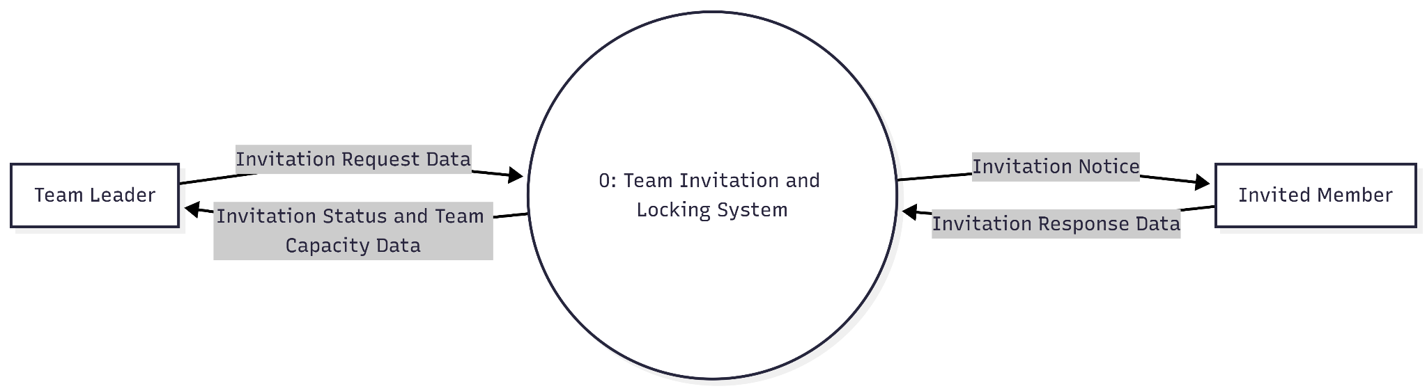
Functional Requirement 4: DFD Adviser Team Leader Invites up to 3 Members and Locks Team
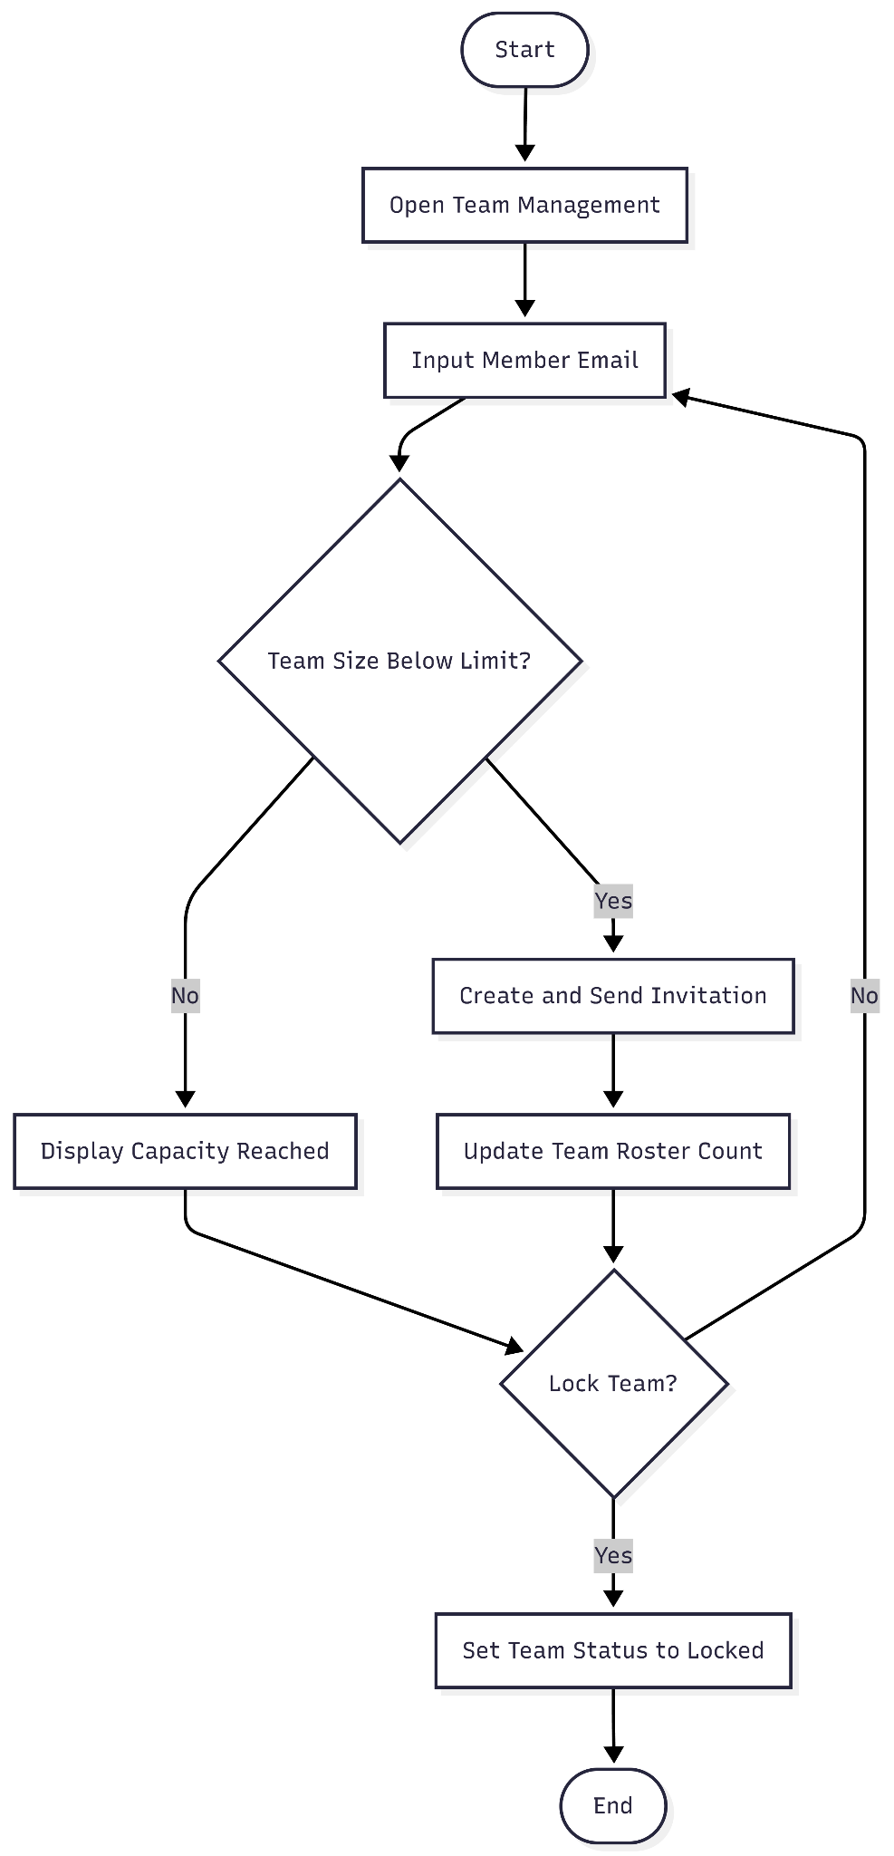
The Team Leader interacts with one system process to send invitations and manage team lock state. Invited members return acceptance data, and the system returns status and capacity feedback.
Functional Requirement 4: Flowchart Student Team Leader Invites up to 3 Members and Locks Team
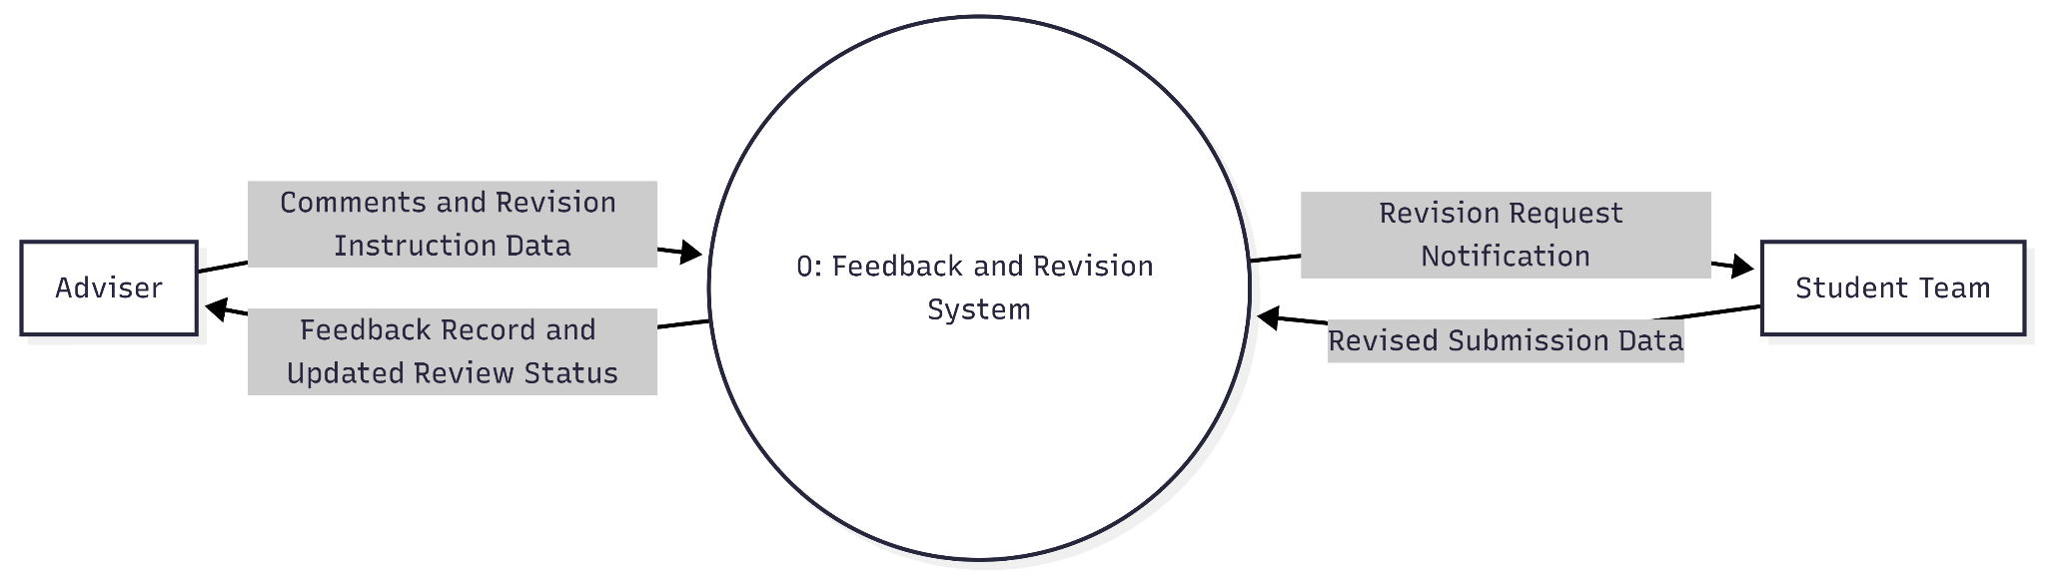
Functional Requirement 5: DFD Adviser Comments and Revision Requests
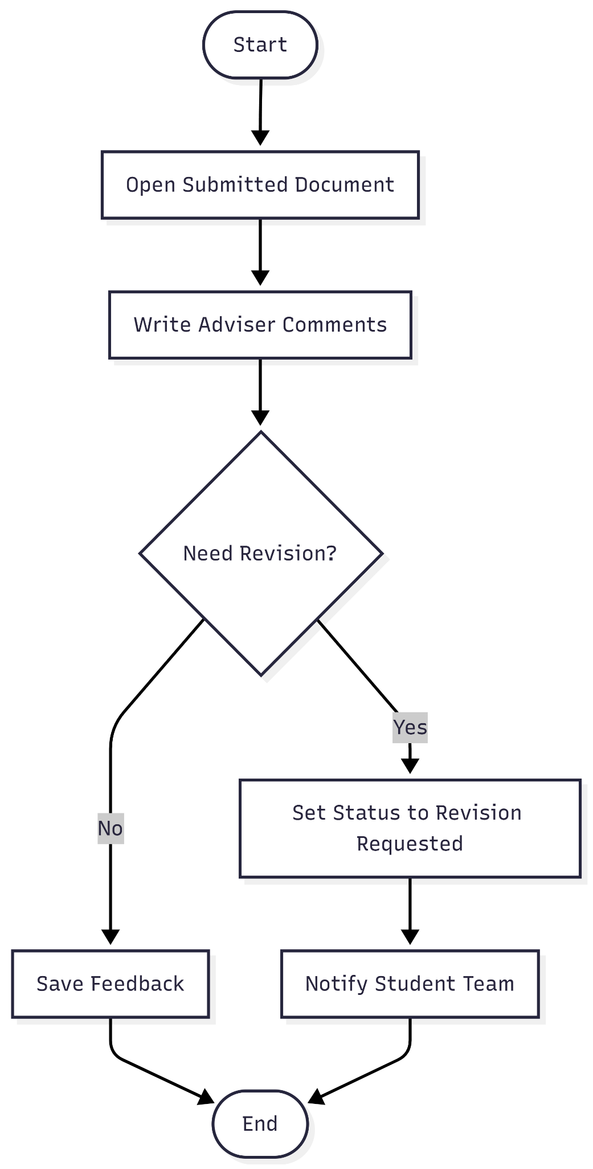
The adviser sends review comments and revision instructions to the system. The student team submits revisions, and the system maintains feedback status and notifies relevant users.
Functional Requirement 5: Flowchart Student Comments and Revision Requests
The adviser reviews a submission, records comments, and optionally marks it for revision. If revision is required, the system updates status and sends notification to the student team.
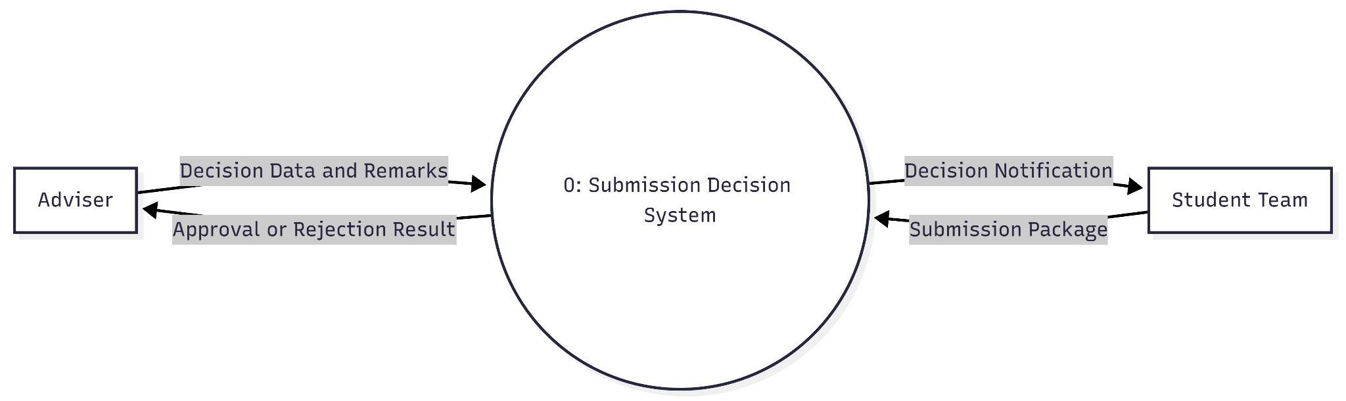
Functional Requirement 6: DFD Adviser Adviser Approve or Reject Submission
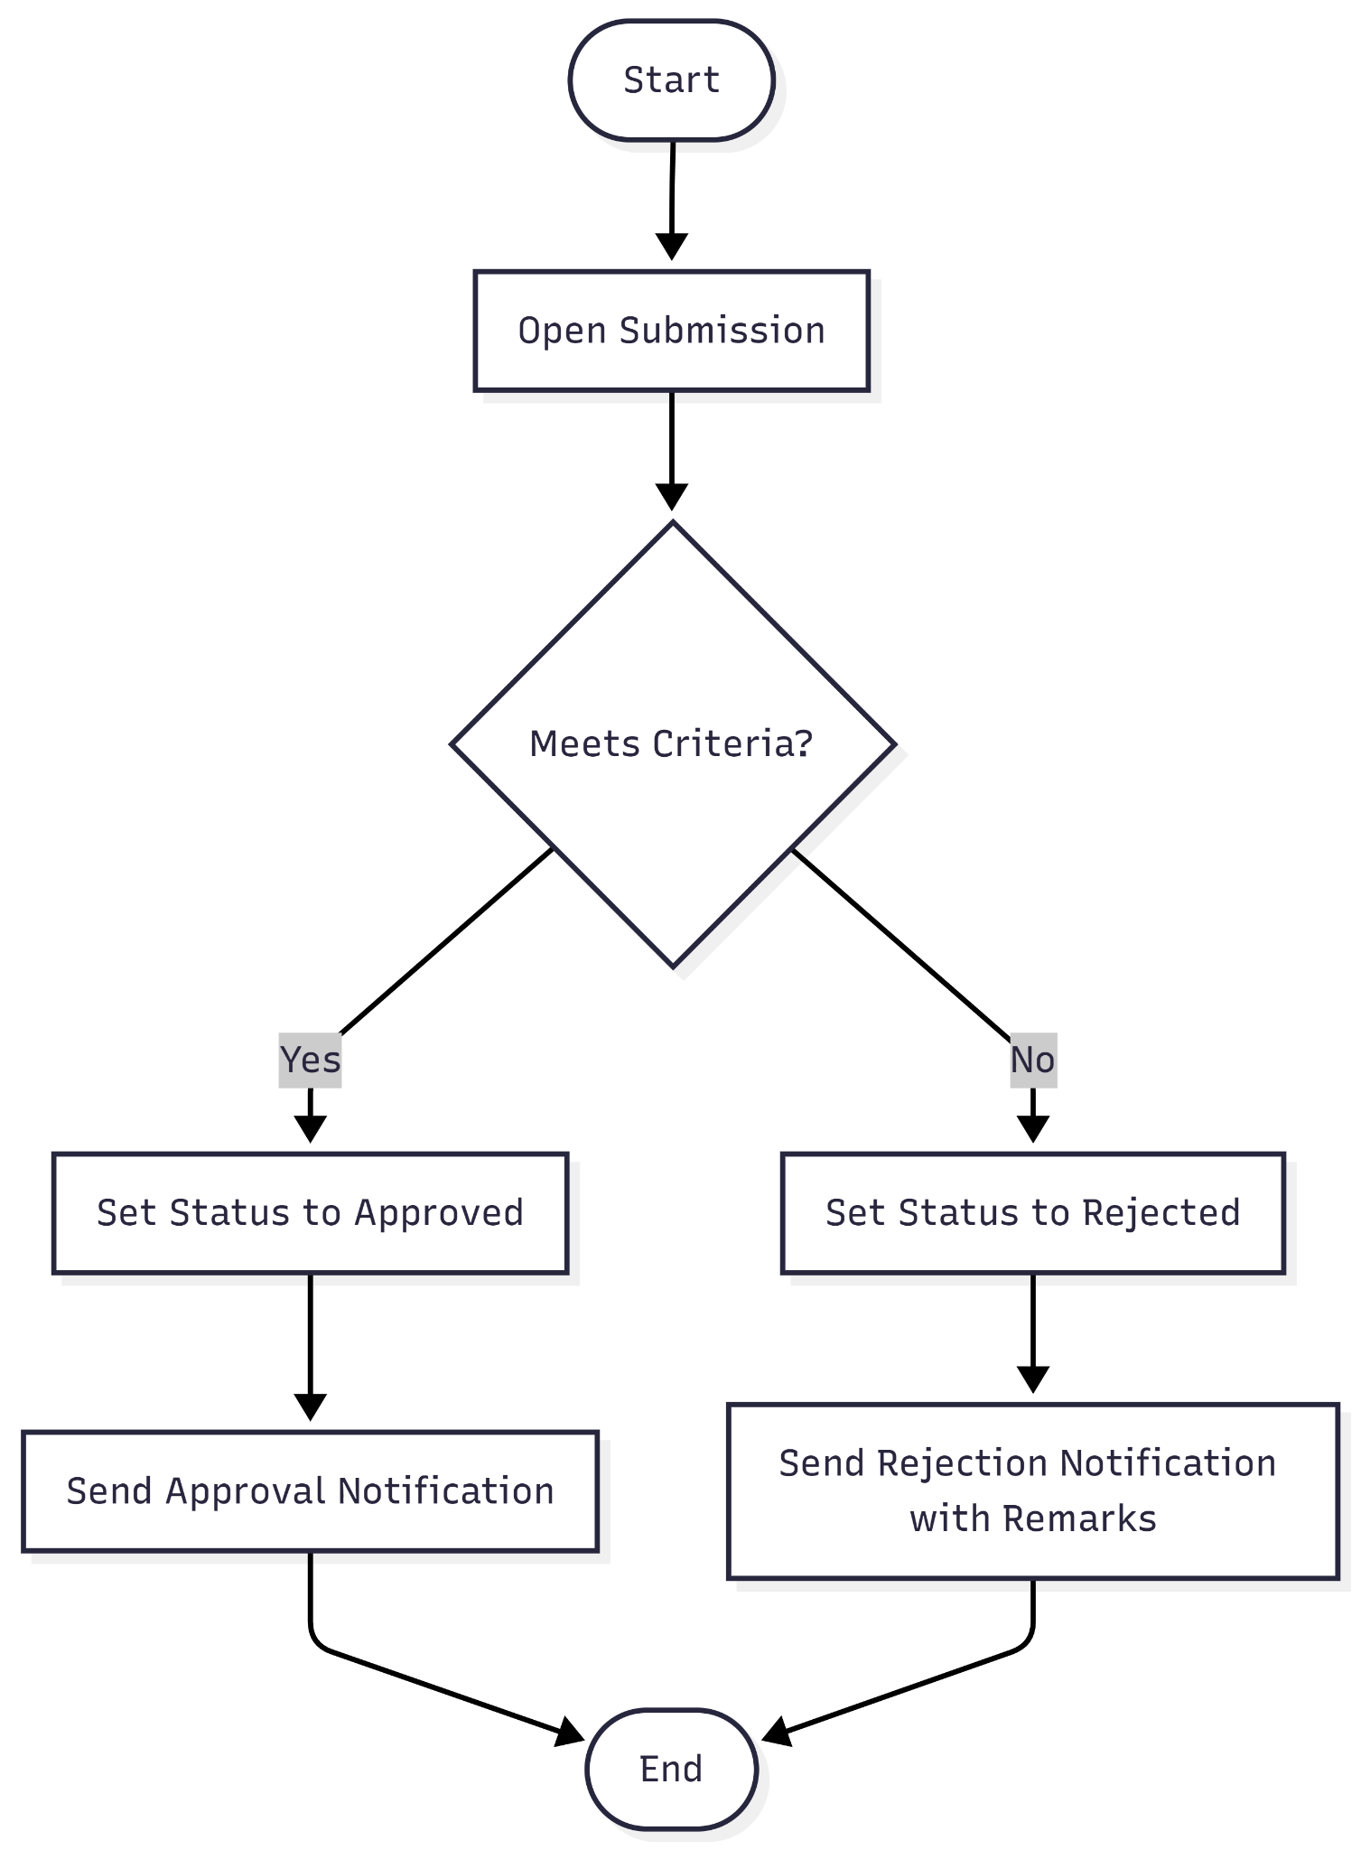
The student team supplies a submission package and the adviser supplies decision data. The system returns formal result records and communicates decision outcomes to both parties.
Functional Requirement 6: Flowchart Student Adviser Approve or Reject Submission
The adviser evaluates the submission against criteria, assigns either approved or rejected status, and the system sends corresponding notifications with decision context.
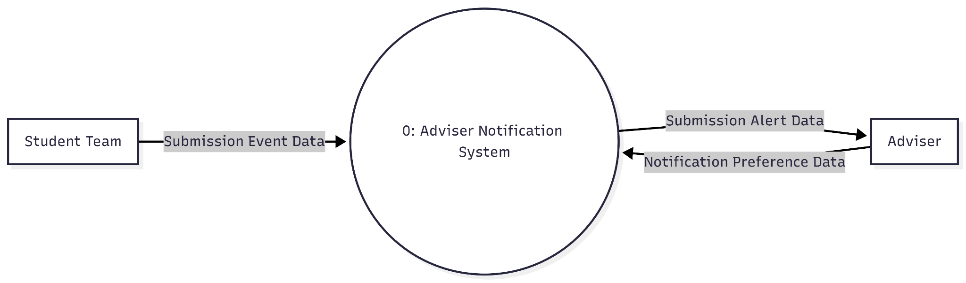
Functional Requirement 7: DFD Adviser Notify Adviser on Submission or Resubmission
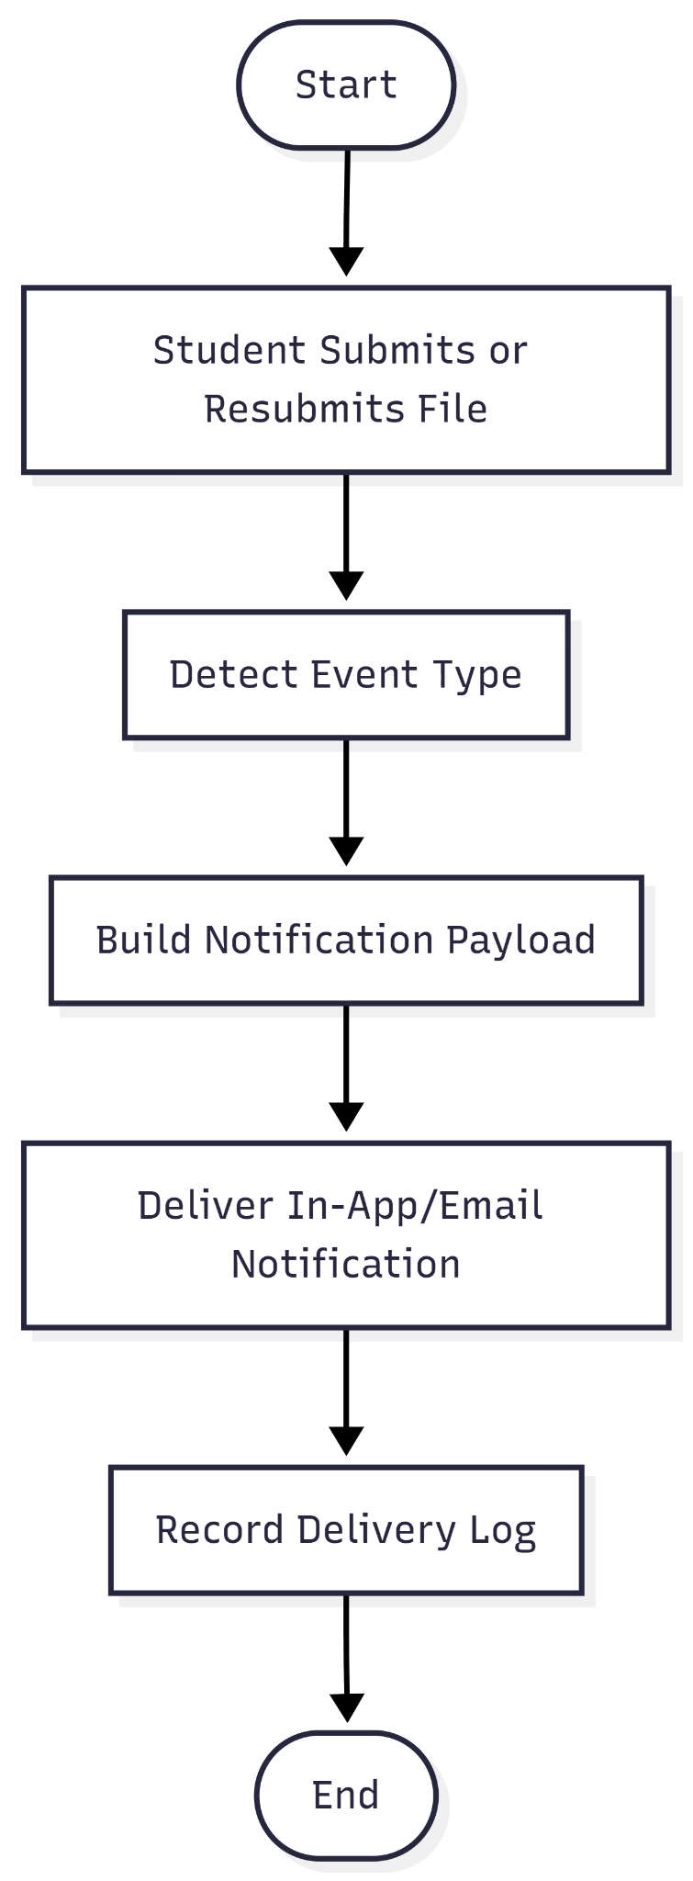
A student submission event enters the system, and adviser preference settings guide how alerts are delivered. The system sends event notifications back to the adviser.
Functional Requirement 7: Flowchart Adviser Notify Adviser on Submission or Resubmission
When a submit/resubmit event occurs, the system classifies the event, generates notification content, sends it via configured channels, and logs the delivery result.
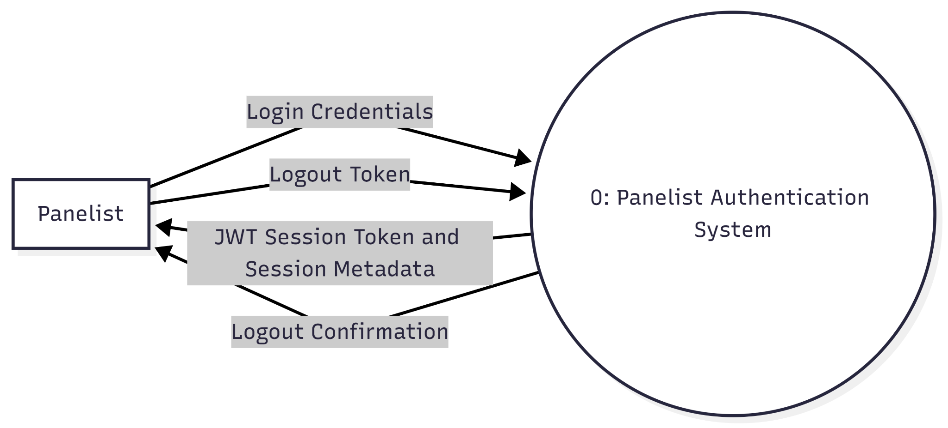
Functional Requirement 1: DFD Panelist Login/Logout
The authentication lifecycle begins when a Panelist submits their Login Credentials to the centralized Panelist Authentication System for identity verification, prompting the system to generate and return a JWT Session Token along with associated Session Metadata to establish a secure, authenticated state. This token serves as the primary credential for the duration of the user's activity until they initiate a logout by transmitting the active Logout Token back to the same system process. The system then invalidates the session and concludes the flow by sending a Logout Confirmation back to the Panelist, ensuring that the session is formally terminated and access is revoked.
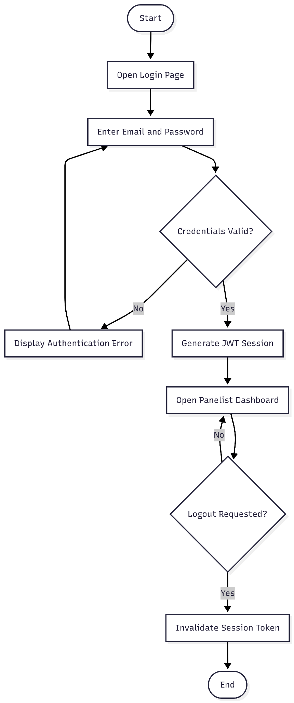
Functional Requirement 1: Flowchart Panelist Login/Logout
The system verifies credentials, issues a secure session, and keeps access active until logout. Logout invalidates the token and ends the session.

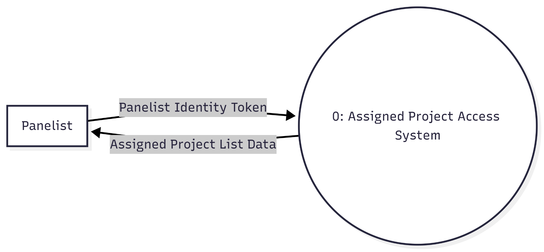
Functional Requirement 2: DFD Panelist View Assigned Capstone Projects
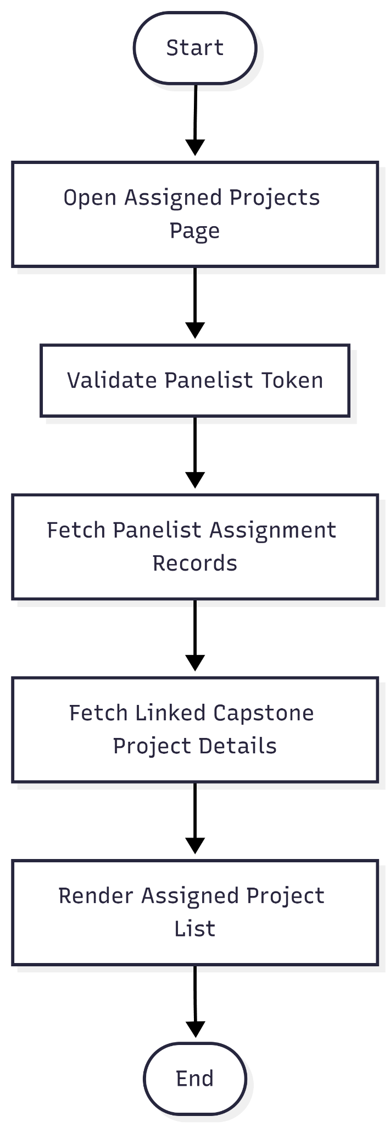
The panelist requests project access using authenticated identity data. The system returns only project records assigned to that panelist.
Functional Requirement 2: Flowchart Panelist View Assigned Capstone Projects

After token validation, the system loads assignment mappings and corresponding capstone metadata, then displays the scoped project list.
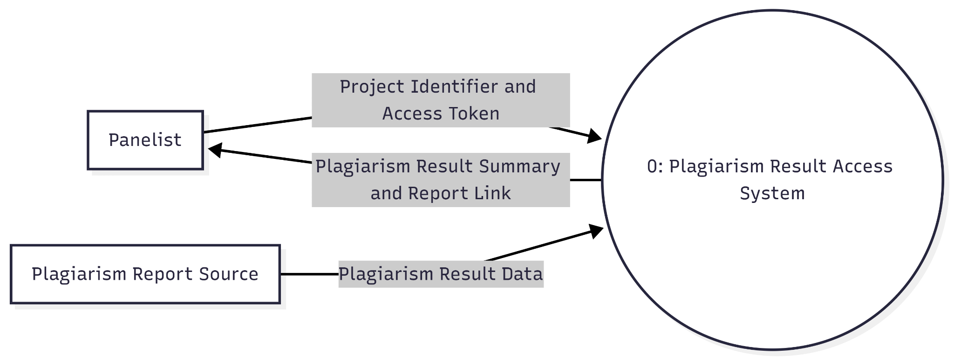
Functional Requirement 3: DFD Panelist Access Plagiarism Results
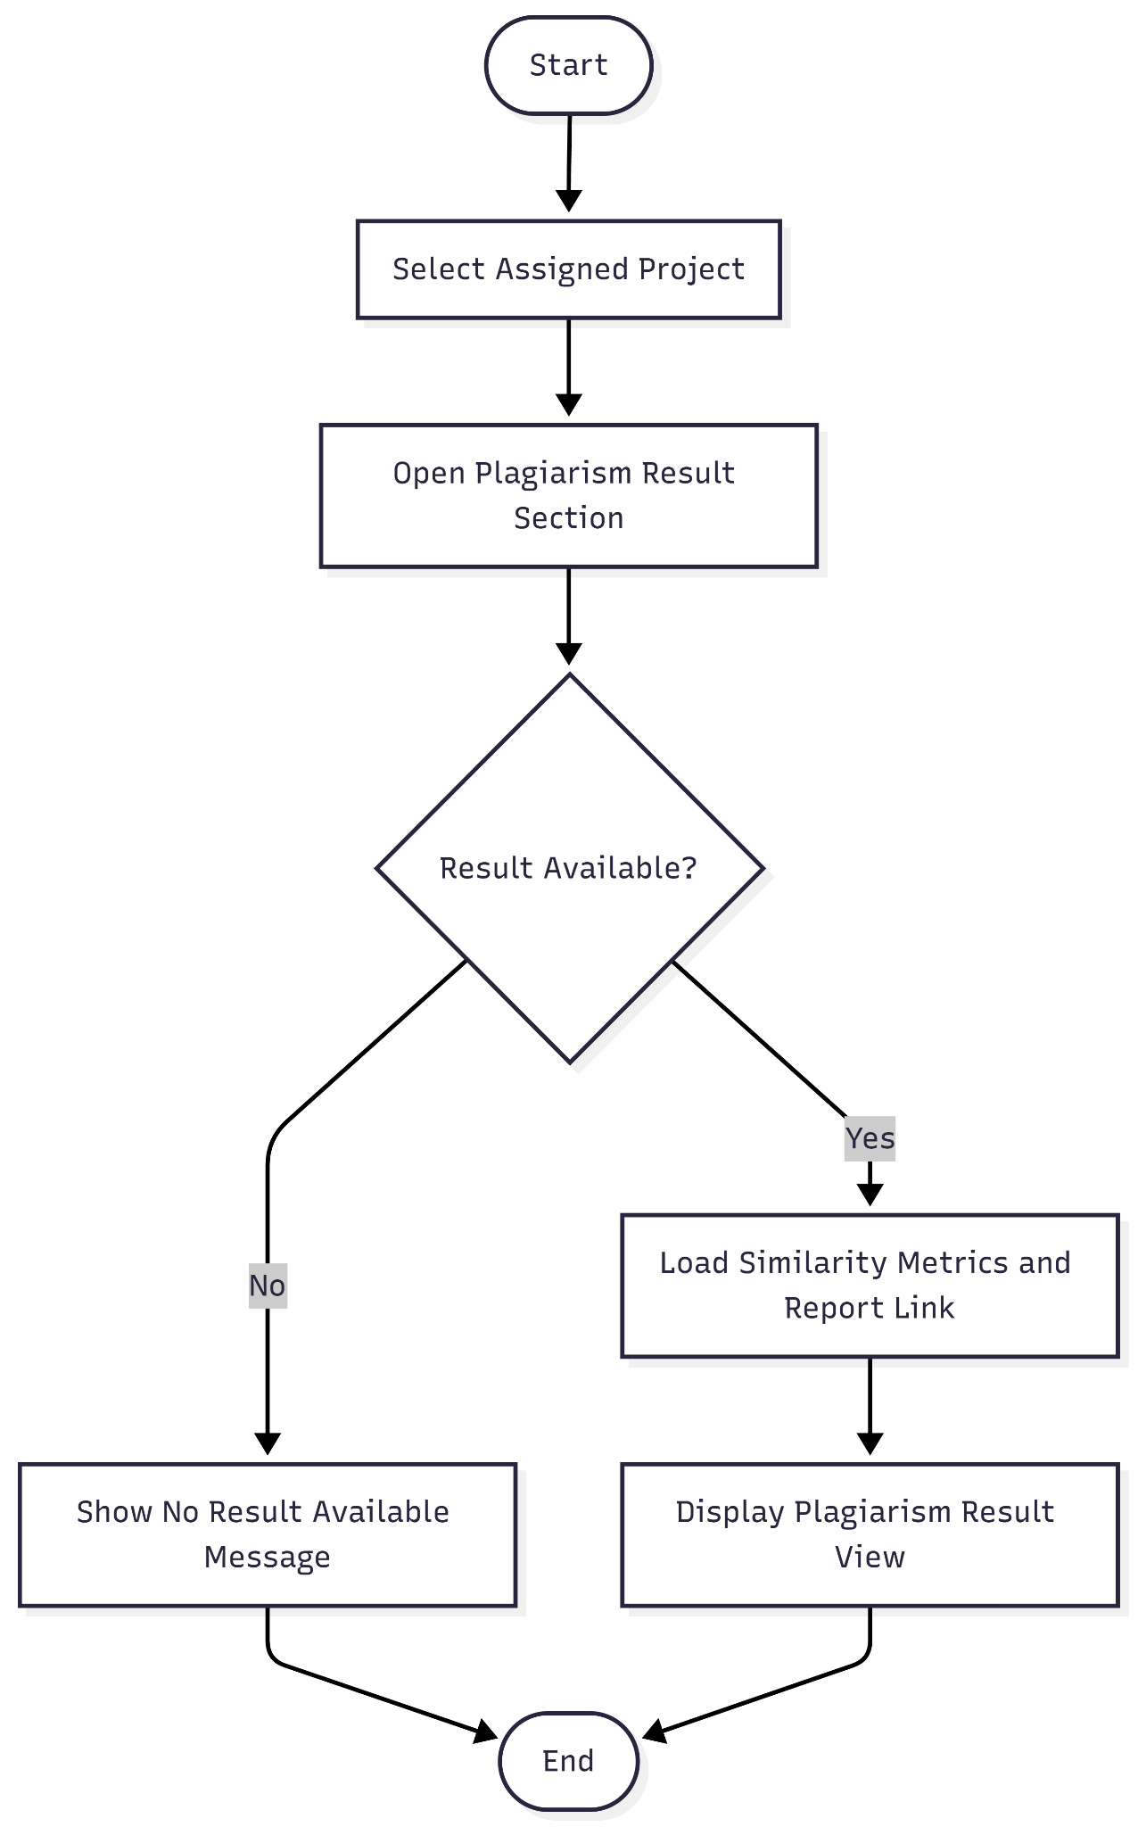
The panelist requests plagiarism data for a specific project. The system obtains plagiarism result data from the report source and returns readable results/report reference to the panelist.

Functional Requirement 3: Flowchart Panelist Access Plagiarism Results
The panelist opens a project and checks result availability. If present, the system shows plagiarism metrics and report reference; otherwise it shows an unavailable state.
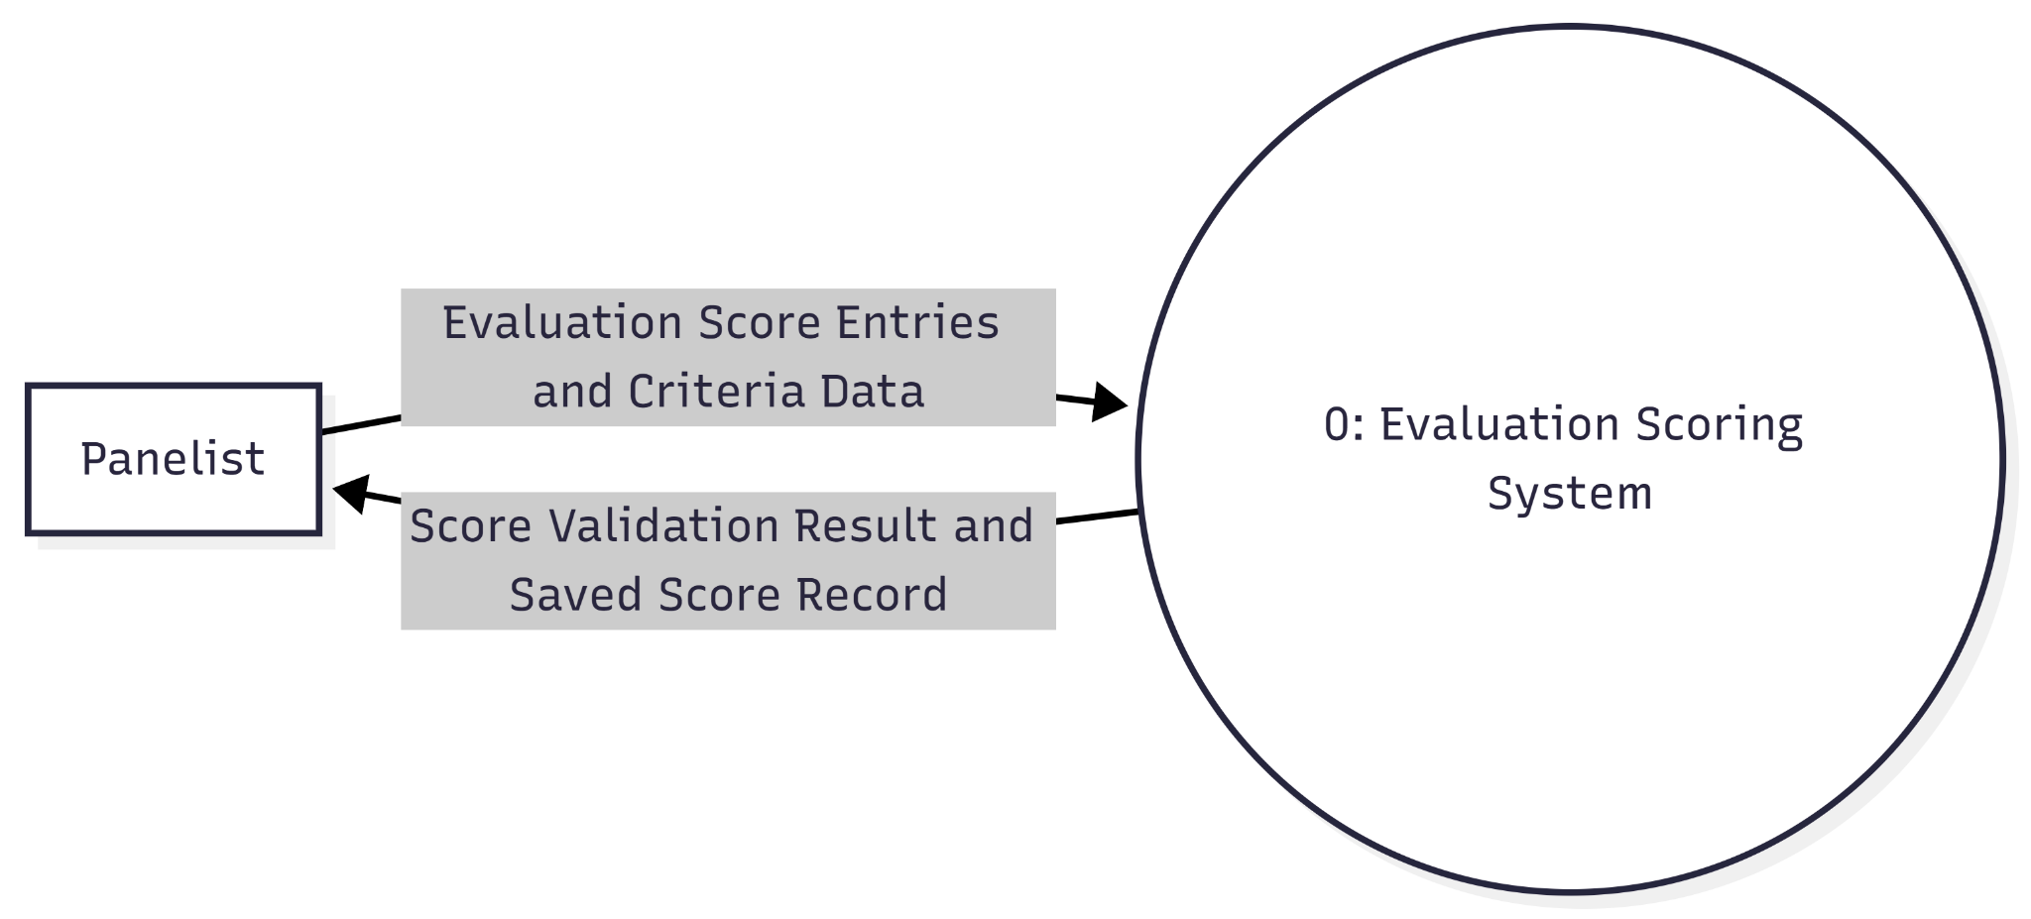
Functional Requirement 4: DFD Panelist Input Evaluation Scores by Criteria
The panelist submits criterion-based score data to a single scoring process. The system validates the input and returns save confirmation and computed score record status.

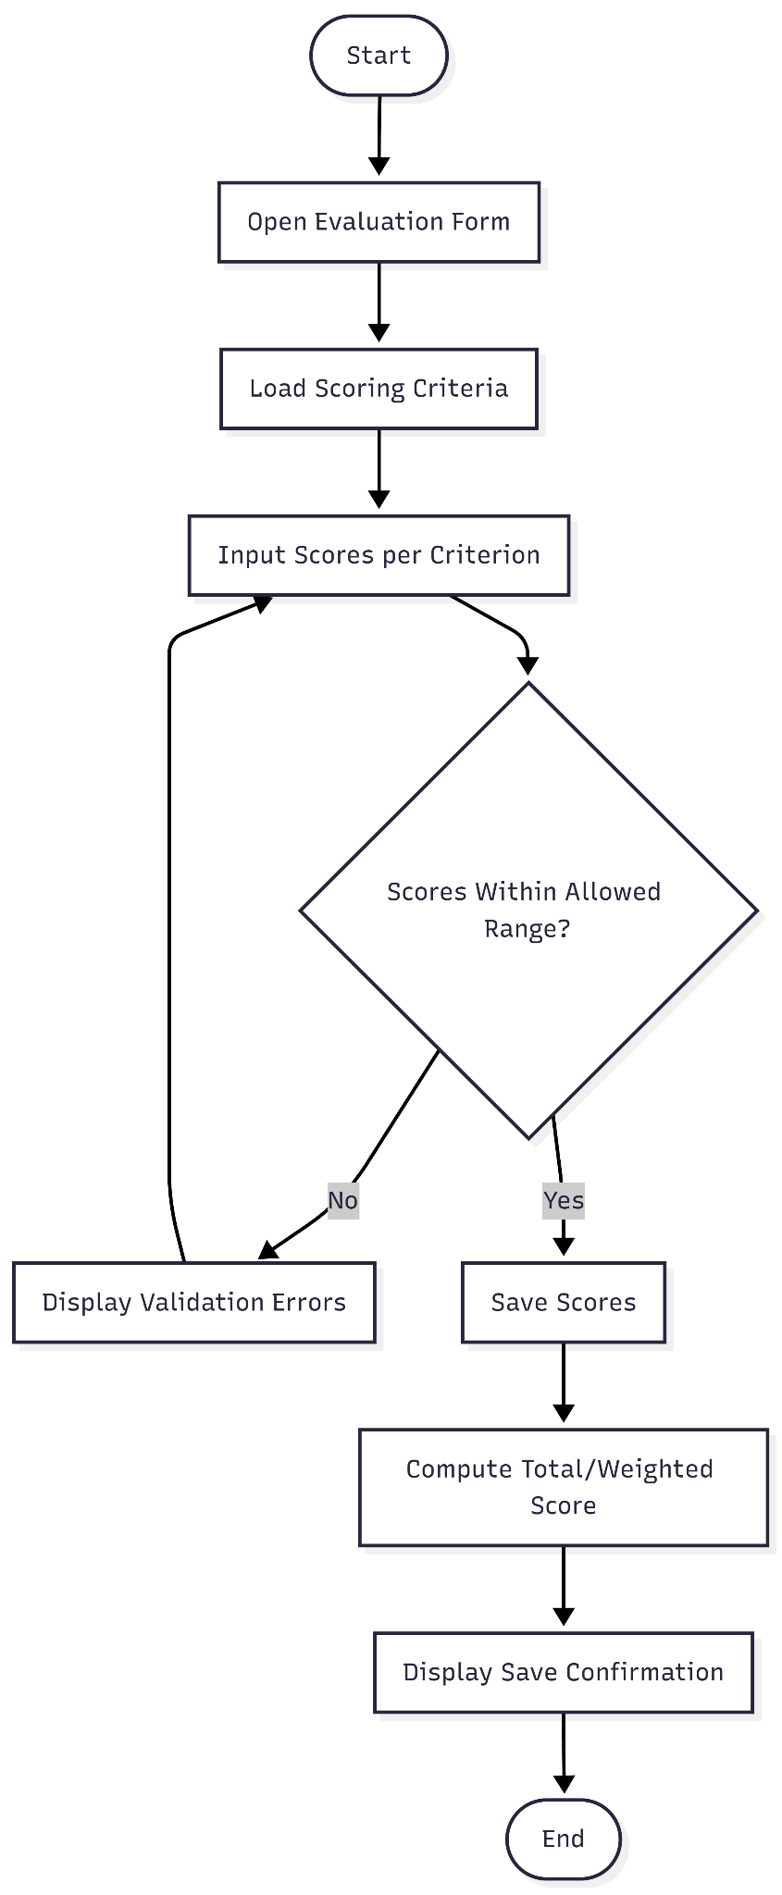
Functional Requirement 4: Flowchart Panelist Input Evaluation Scores by Criteria
The flow enforces criterion limits before persistence. Valid scores are saved and processed to produce total/weighted results for evaluation consistency
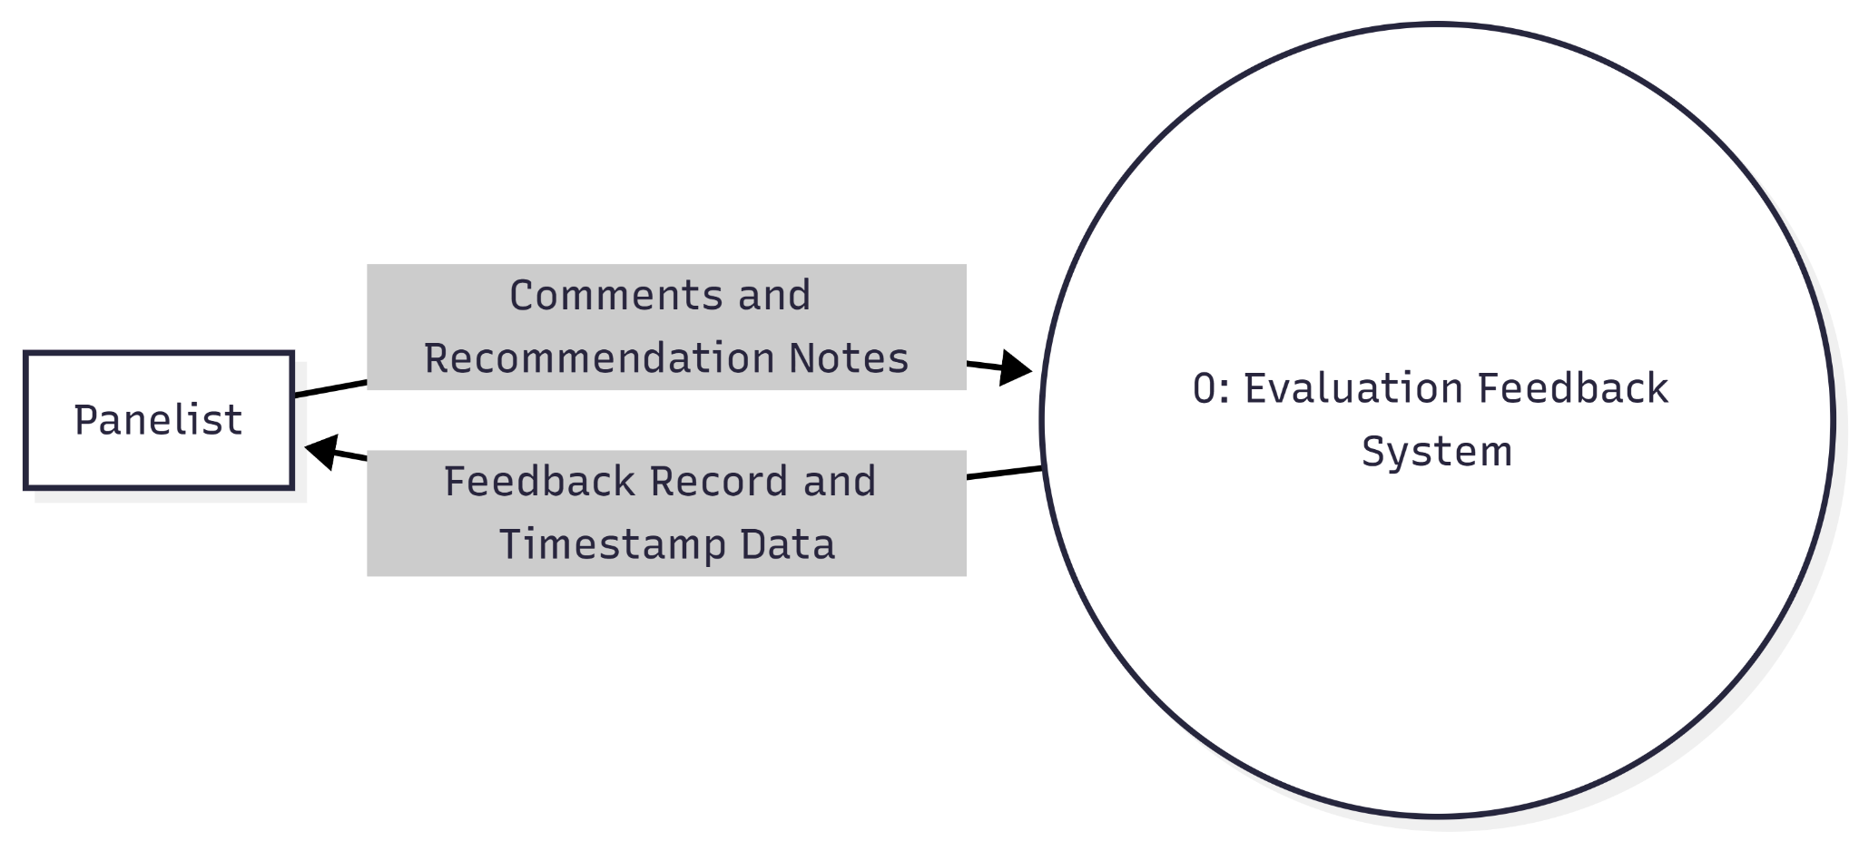
Functional Requirement 5: DFD Panelist Provide Comments and Recommendations
The panelist sends textual feedback data to one feedback process. The system stores the feedback and returns record status with tracking metadata.
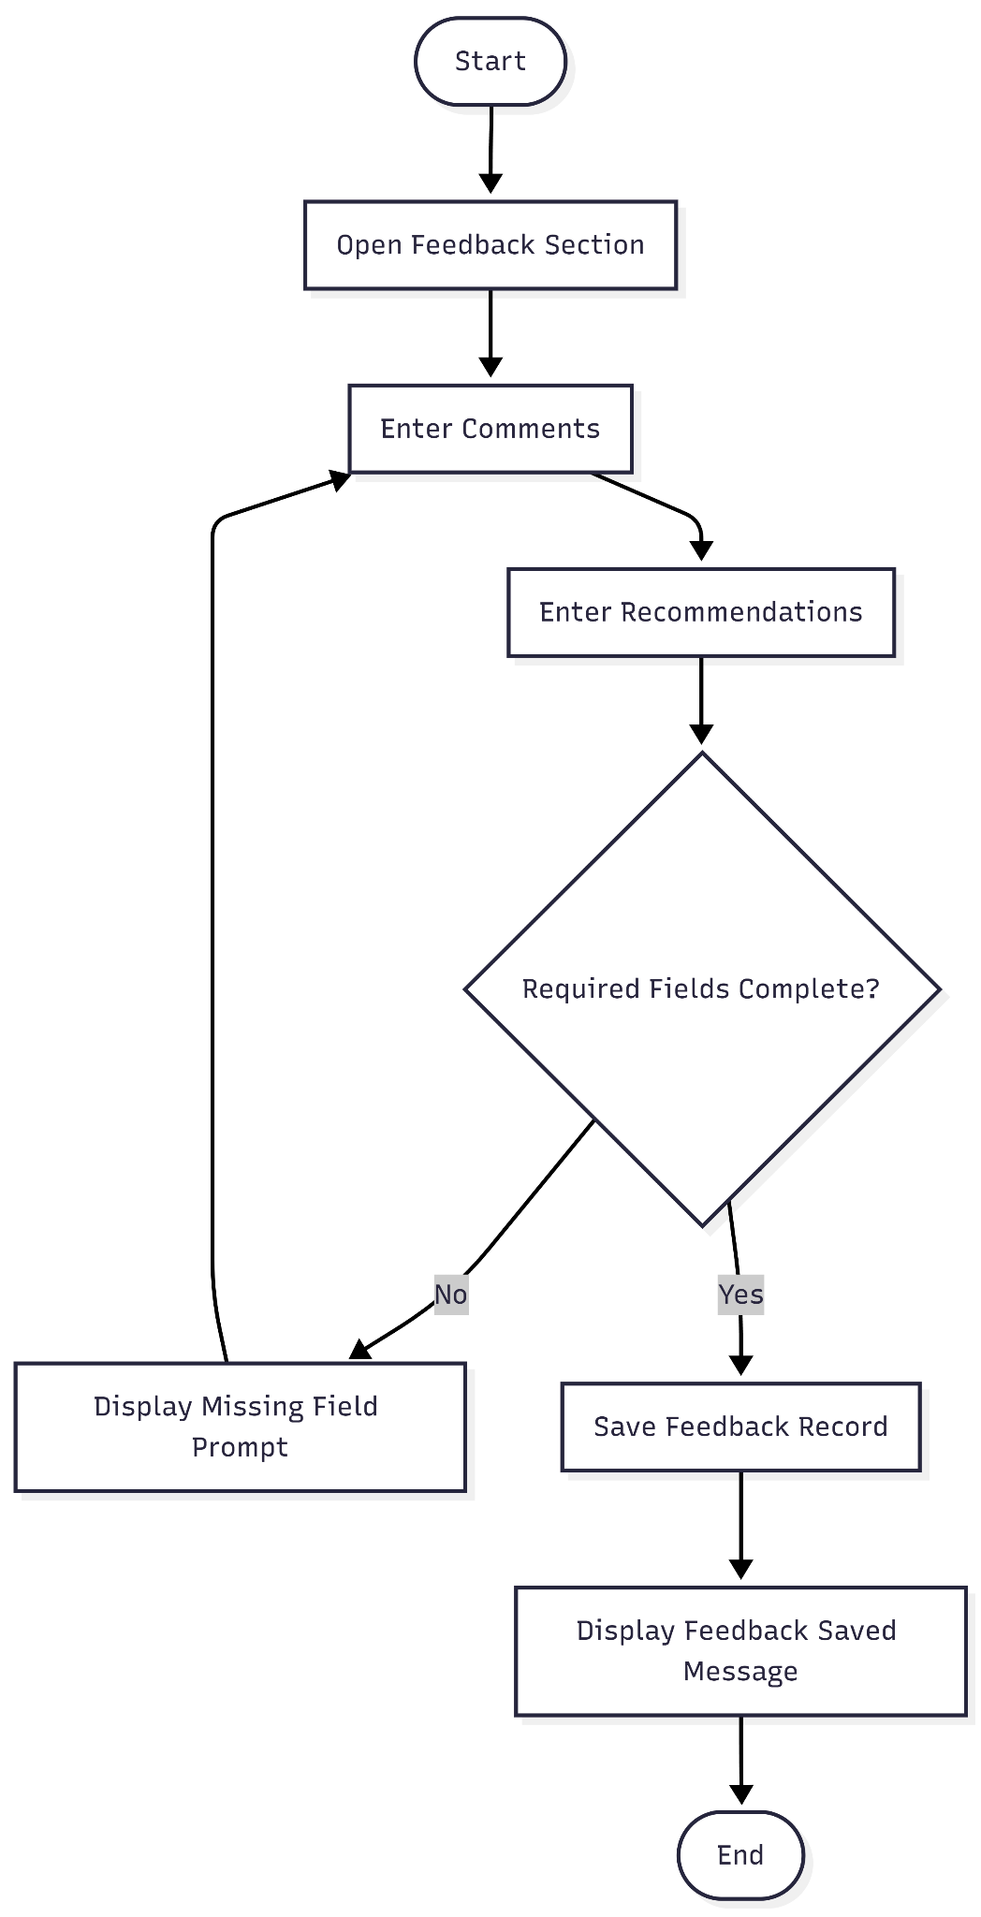
Functional Requirement 5: Flowchart Panelist Provide Comments and Recommendations
The panelist writes qualitative assessment notes. The system enforces completeness checks, saves the record, and confirms successful capture.
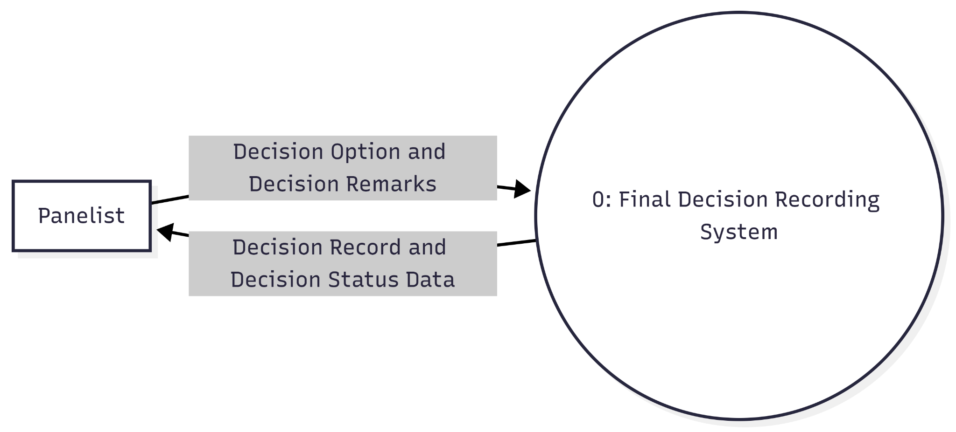
Functional Requirement 6: DFD Panelist Mark Final Decision (Passed / Passed with Revisions / Failed)
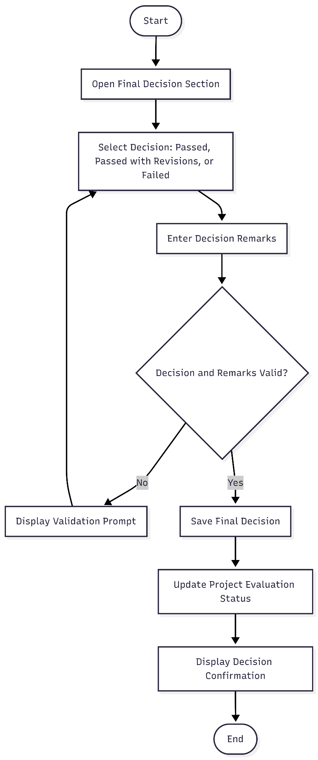
The panelist sends selected outcome data with remarks to one decision process. The system records the final decision status and returns confirmation data.
Functional Requirement 6: Flowchart Panelist Mark Final Decision (Passed / Passed with Revisions / Failed)
The panelist chooses one allowed decision outcome and submits supporting remarks. The system validates, records, and updates project evaluation status.
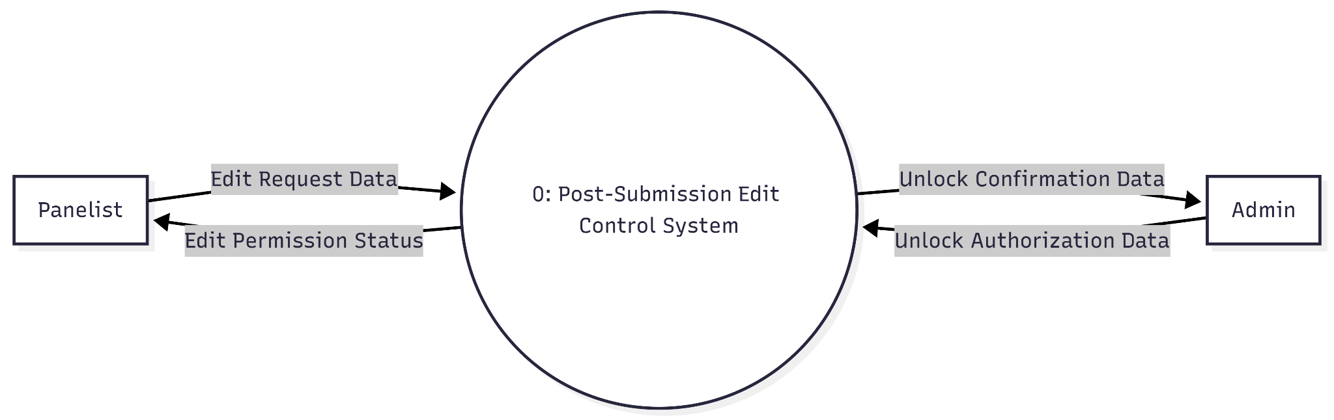
Functional Requirement 7: DFD Panelist Restrict Editing After Final Submission Unless Admin Unlocks
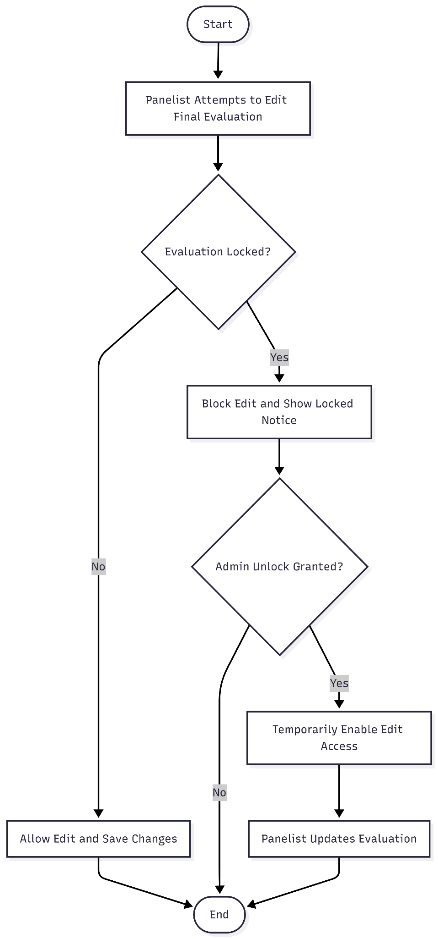
After final submission, panelist edit requests are evaluated by a single control process. Only admin-provided unlock authorization changes edit permission status.
Functional Requirement 7: Flowchart Panelist Restrict Editing After Final Submission Unless Admin Unlocks
The system enforces lock state immediately after final submission. Editing is blocked by default and becomes available only when an authorized admin unlock action is applied
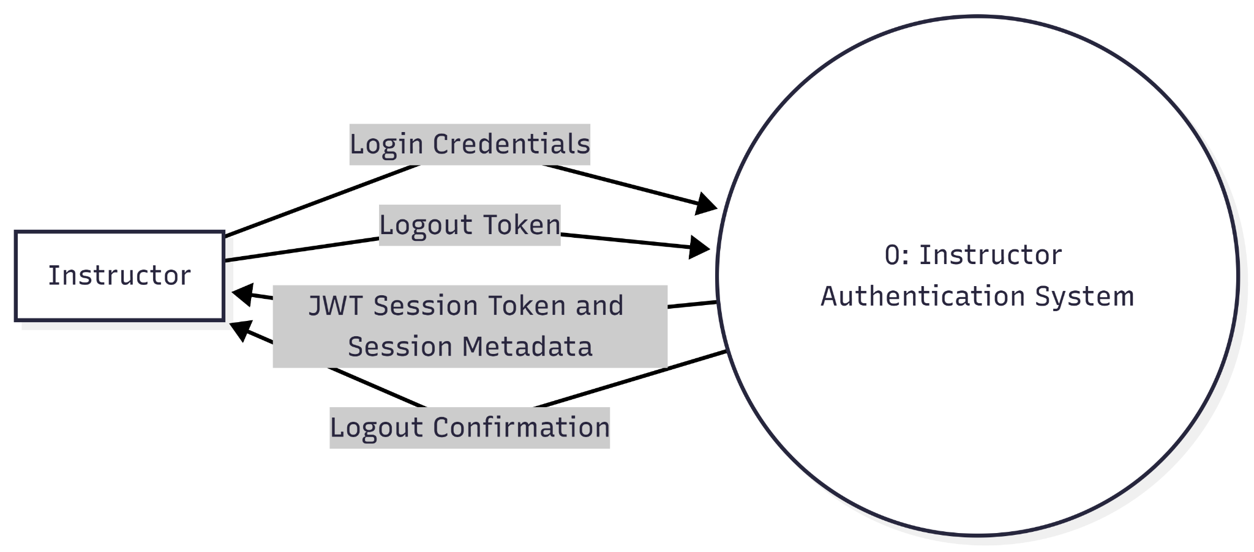
Functional Requirement 1: DFD Instructor Secure Instructor Login/Logout
The provided Level 0 Data Flow Diagram illustrates the seamless exchange between an Instructor and the Instructor Authentication System, starting with the transmission of Login Credentials to establish user identity. Once validated, the system transmits a JWT Session Token and Session Metadata back to the Instructor, enabling a secure, stateless session that carries the necessary permissions and context for application access. This process concludes with a logout sequence, where the Instructor provides a Logout Token to the system to invalidate the active session, receiving a final Logout Confirmation once the system successfully terminates the session's validity.
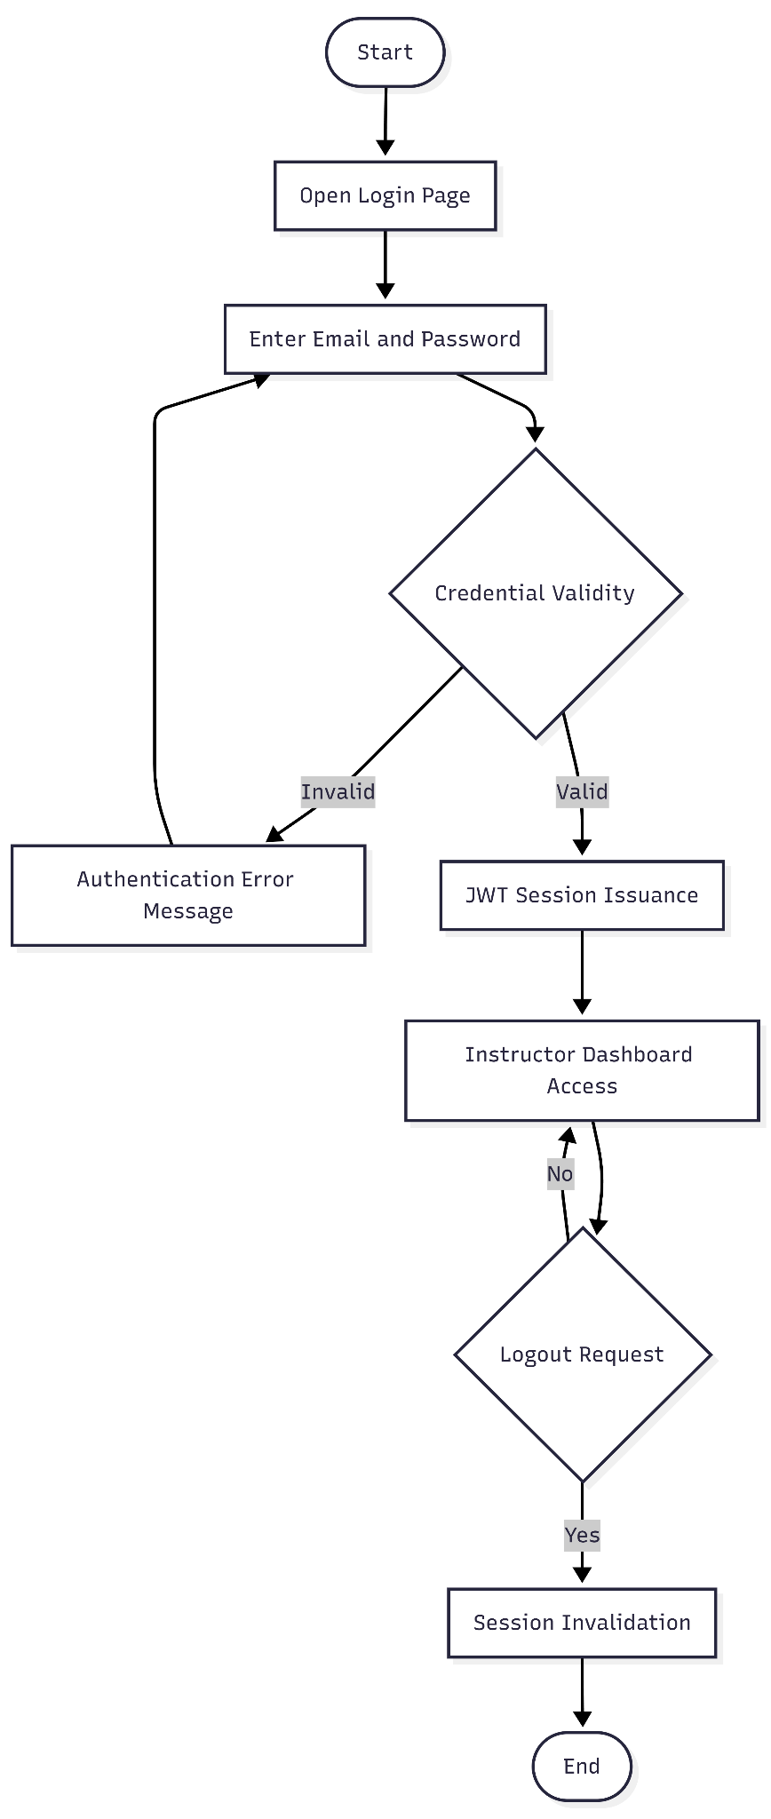
Functional Requirement 1: Flowchart Instructor Secure Instructor Login/Logout
The flow validates credentials, grants dashboard access with a secure token, and ends access only after explicit logout and session invalidation.

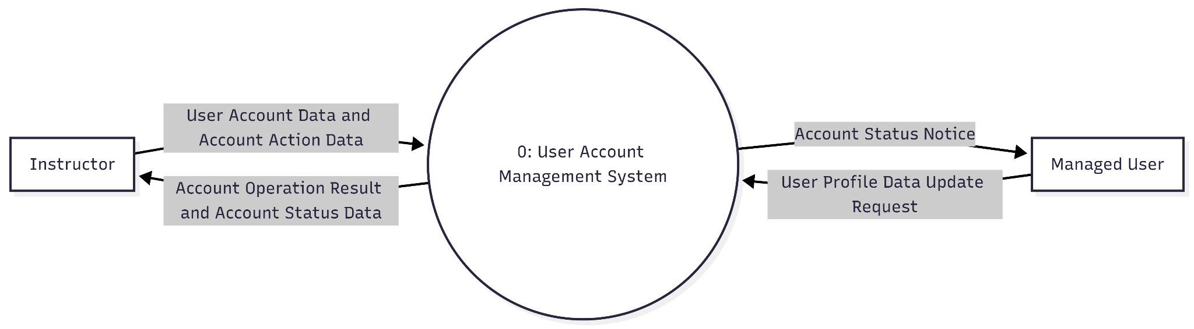
Functional Requirement 2: DFD Instructor Create, Edit, Deactivate, Delete User Accountst
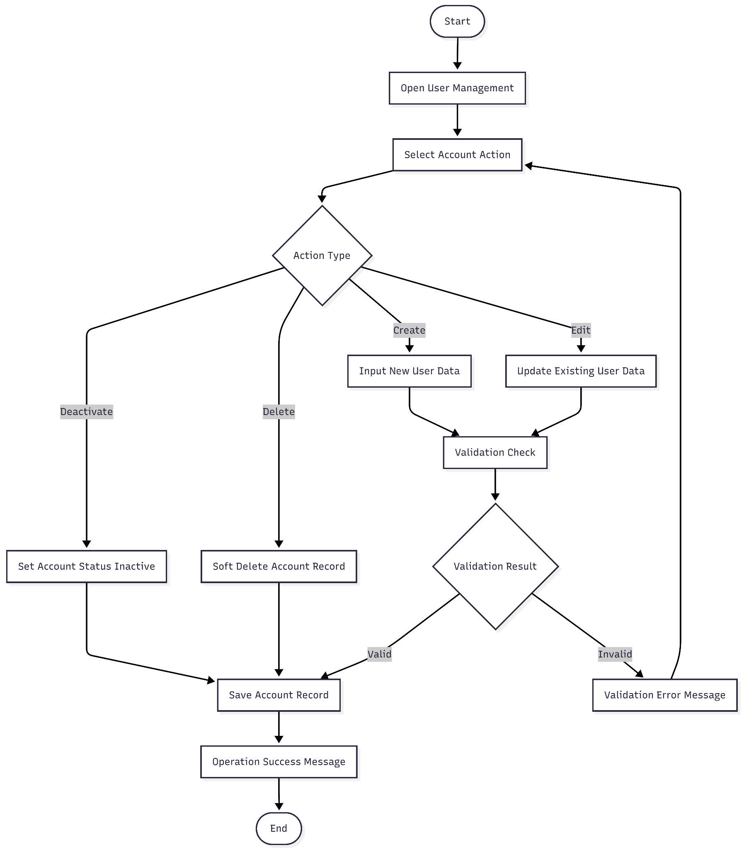
The instructor sends account action data (create/edit/deactivate/delete), while managed users may provide profile-related updates. The system processes these data packages and returns operation outcomes and status notifications.

Functional Requirement 2: Flowchart Instructor Create, Edit, Deactivate, Delete User Accounts
The instructor chooses an account action. Create/edit paths require validation; deactivate/delete update account state. The system stores changes and returns operation feedback.
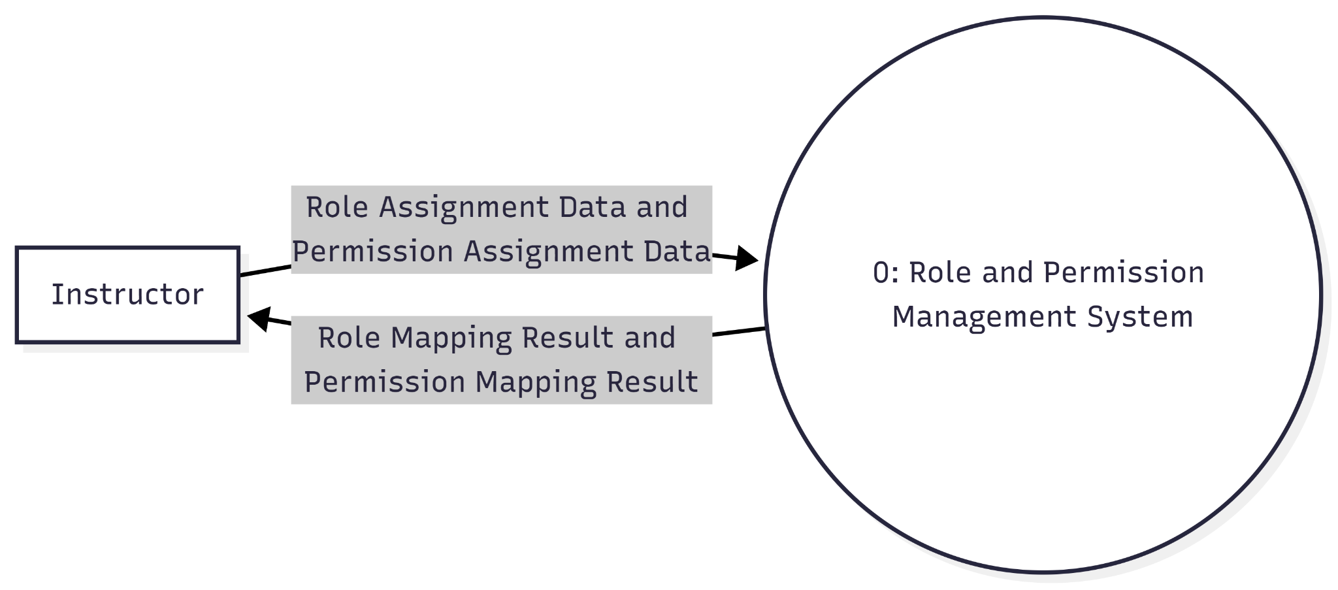
Functional Requirement 3: DFD Instructor Assign Roles and Permissions
The instructor provides role/permission assignment data to the central authorization process. The system applies mappings and returns assignment results.

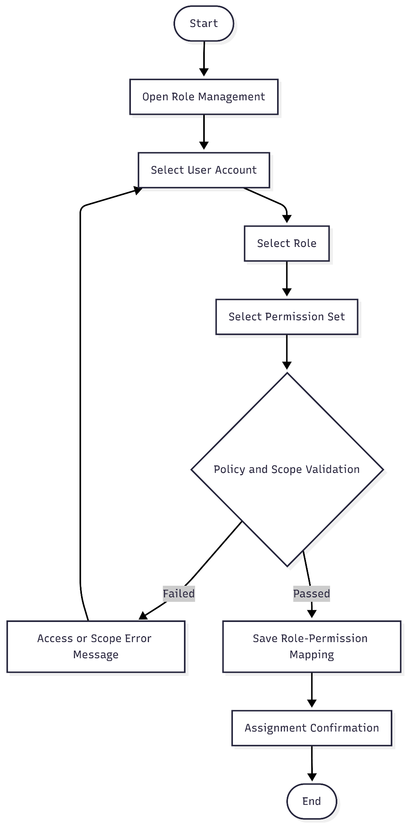
Functional Requirement 3: Flowchart Instructor Assign Roles and Permissions
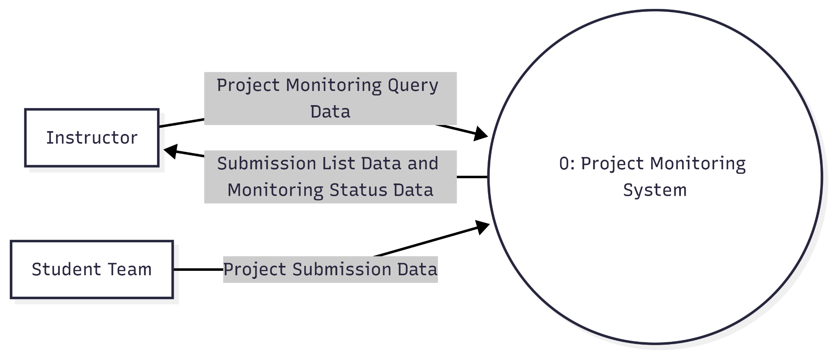
The instructor selects a target user, applies role and permission options, and submits. The system validates scope/policy constraints before persisting authorization mappings.
Functional Requirement 4: DFD Instructor View and Monitor All Submitted Projects
Student teams provide submission data to the system. The instructor requests monitoring data, and the system returns submission records with status indicators for oversight.
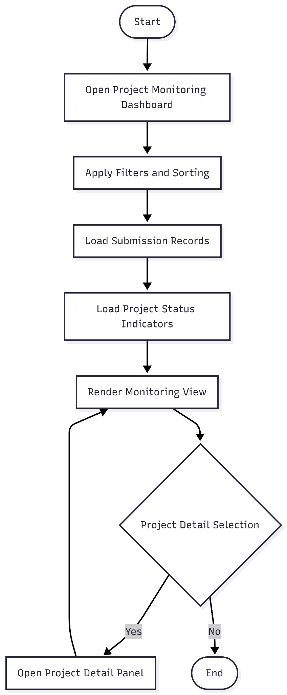
Functional Requirement 4: Flowchart Instructor View and Monitor All Submitted Projects
The instructor accesses a dashboard, filters submission records, and reviews status and details per project for continuous monitoring.
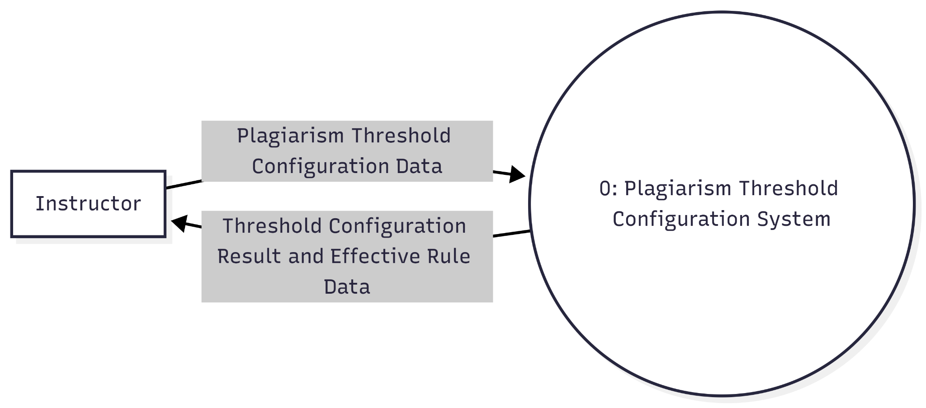
Functional Requirement 5: DFD Instructor Set Plagiarism Threshold Percentages
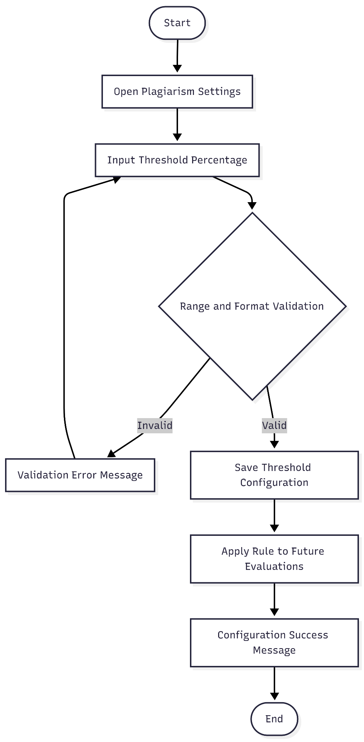
The instructor submits threshold configuration data (percentage rules). The system validates and stores the rule set, then returns confirmation and the effective threshold values.
Functional Requirement 5: Flowchart Instructor Set Plagiarism Threshold Percentages
The instructor sets a threshold value, the system validates bounds/format, stores the rule, and applies it to subsequent plagiarism evaluations.
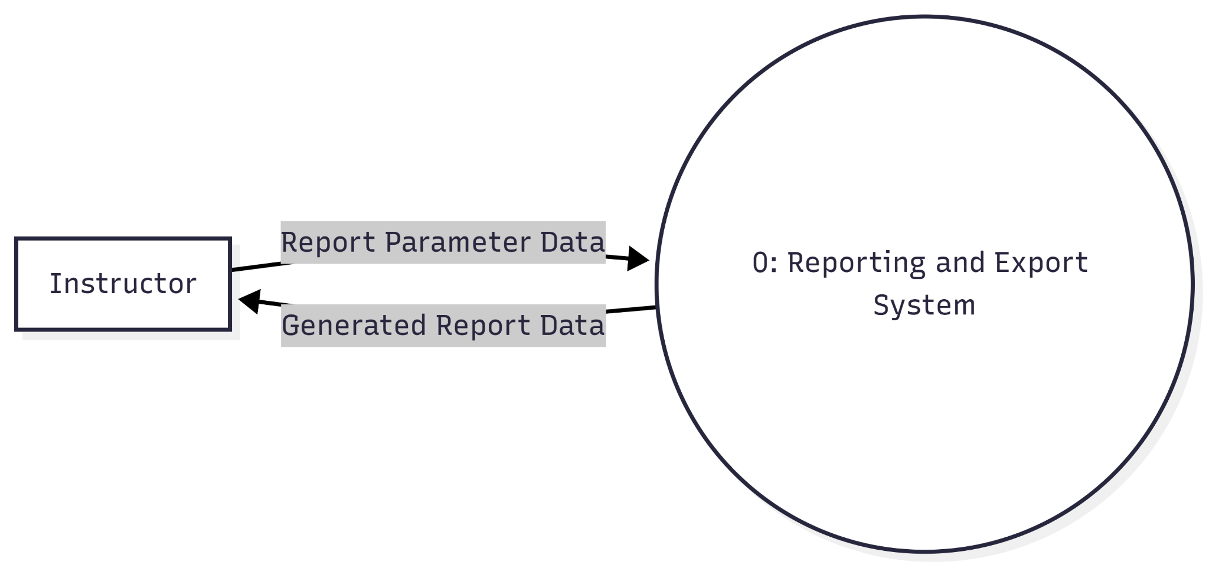
Functional Requirement 6: DFD Instructor Generate System Reports (Submissions, Evaluations, Plagiarism Results)
The provided Level 0 Data Flow Diagram depicts the interaction between an Instructor and the Reporting and Export System, where the instructor defines the scope of their request by providing Report Parameter Data including date ranges, report types, and specific filters. The system then processes these parameters to aggregate the relevant information and delivers the Generated Report Data back to the instructor for review or distribution. By facilitating this targeted data retrieval, the system enables the instructor to convert raw system information into structured, meaningful reports that support informed decision-making and administrative oversight.
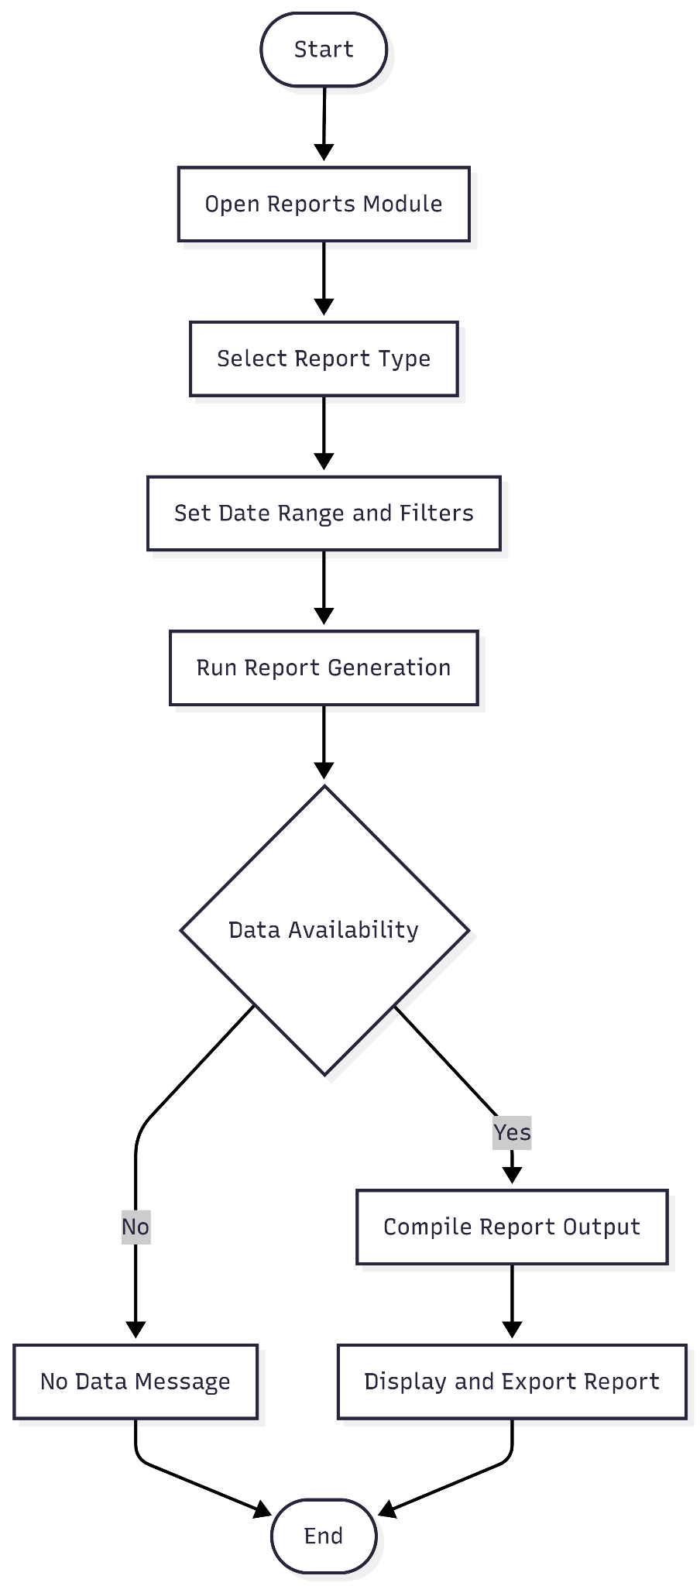
Functional Requirement 6: Flowchart Instructor Generate System Reports (Submissions, Evaluations, Plagiarism Results)
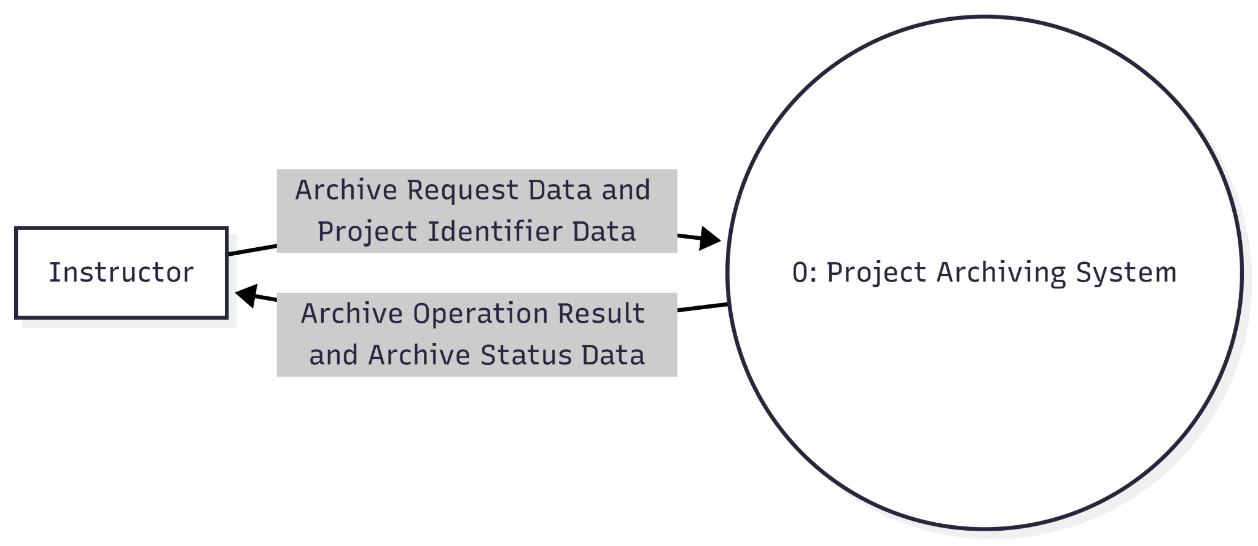
The instructor defines report parameters and runs generation. The system either returns a no-data state or provides a complete report for viewing/export.
Functional Requirement 7: DFD Instructor Archive Completed Projects
The instructor submits archive request data for completed projects. The system updates archival status and returns operation result and status information.
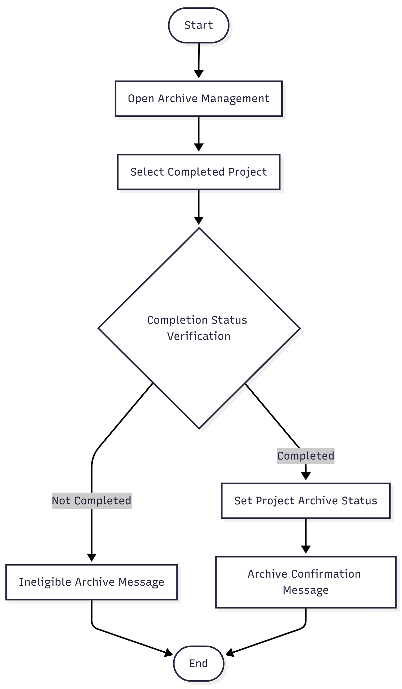
Functional Requirement 7: Flowchart Instructor Archive Completed Projects
The instructor selects a project for archival. The system verifies completion eligibility first, then marks the project archived and confirms the operation.

Phase 3: Development
Objective 3: Develop a capstone project management and archiving system based on the approved design.
This phase involves the concrete realization of the design, transitioning from architectural blueprints to a fully functional software environment by building both the core capstone management system and its integrated plagiarism detector. During this stage, the theoretical workflows, user role permissions, and database schemas established in the design phase are translated into executable MERN stack code. It encompasses the programming required to construct an interactive infrastructure for document submission, progress tracking, presigned MinIO document access, and final archiving, alongside the seamless embedding of the on-premise cms-plagiarism-api microservice to enforce academic integrity and originality directly within the platform's operational flow.

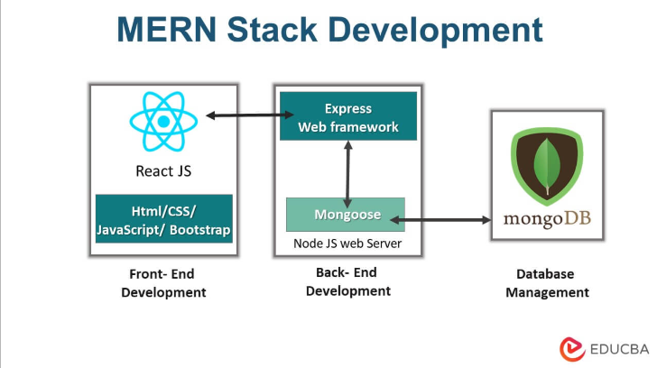
Figure 9.1. MERN Stack Development Diagram
Backend Development: Implementing server-side logic with Node.js and Express.js to support all project management functionalities. This includes developing RESTful API endpoints for user authentication, document submission handling, feedback exchange, progress tracking, and database operations. The backend architecture incorporates middleware for file processing, user session management, and role-based access control to ensure secure, efficient data flow throughout the system.
Frontend Development: Constructing user interface components with React.js to create intuitive, responsive interfaces for all user roles (students, advisers, panel, instructor). The frontend implementation includes dashboard views tailored to each role, document submission forms with drag-and-drop functionality, real-time notification systems for feedback updates, and interactive progress tracking visualizations. Component-based architecture ensures modularity and reusability across different interface sections.
On-Premise Microservice & Notification Integration: Systematically integrating the in-house Python FastAPI plagiarism microservice (cms-plagiarism-api) backed by Celery workers, Redis brokers, and ChromaDB HNSW vector stores. The Express 5 backend transmits extracted text payloads to FastAPI, executes two-tier winnowing and Sentence-Transformers analysis, and enforces S_hybrid = 0.65 * S_winnowing + 0.35 * S_semantic <= 25%. In the event of similarity threshold breaches, a multi-tiered dual-channel notification system dispatches real-time Socket.IO web socket alerts to connected client dashboards and queues asynchronous SMTP emails via BullMQ.
Phase 4: Testing
Software testing in this study follows a module-based approach, where testing is conducted after the completion of each functional module of the system, with additional testing performed once all modules are fully integrated. This approach is used to detect errors early, prevent defects from affecting other system components, and ensure that each module functions according to its design specifications. Technical testing is carried out using predefined test cases in a testing matrix, focusing on functionality and reliability. After individual modules pass testing, integration testing is performed to verify proper interaction among system components, with identified issues documented, corrected, and re-tested until the expected results are achieved.
Technical testing is executed using a predefined testing matrix and specialized tools, including Postman for API endpoint verification and MongoDB Compass for data integrity checks. Furthermore, a specialized Plagiarism Detection Test is conducted using a controlled corpus of original and manipulated texts to validate the accuracy of the similarity checking algorithm. Finally, the process culminates in software quality testing, where target end-users, including students and advisers evaluate the system in real-world scenarios to ensure workflow efficiency and usability before client use.
Objective 4: Test the developed system in terms of technical functionality, performance, and reliability through systematic testing procedures, including unit testing, integration testing, and user acceptance testing, to ensure that all system features operate correctly, comply with the design specifications, and can consistently perform under expected usage conditions.
Functionality Testing: Executing a comprehensive suite of test cases to verify all functionality requirements for each user type. Functionality testing was conducted to verify that all system features operate according to the functional requirements specified in the Software Requirements Specification (SRS). A comprehensive suite of test cases was developed and executed for each identified user role: Student, Adviser, Panel Member, and Instructor. These test cases were derived directly from system requirements and reflected the actual capstone workflow defined by the IT Department’s capstone manual.
Each test case specified the user role, system action, and expected result. Representatives from each user group executed the test cases under controlled conditions. Students tested features such as authentication with OTP verification, team formation, title submission with similarity checking using the Levenshtein Distance algorithm, document uploads with late submission handling, and concurrency conflict detection. Advisers validated access control restrictions, document evaluation workflows, and automated notification triggers. Panel members tested plagiarism review access, evaluation verdict recording, and result locking mechanisms. The instructor verified user management controls, plagiarism threshold configuration, and report generation and archiving processes.
A total of twelve (12) core system functionality test cases were executed across all user roles, covering authentication, submission control, evaluation, reporting, similarity checking, and role-based access management. Each test case was evaluated using a Pass or Fail criterion. A test was marked as Pass when the system output matched the expected behavior defined in the testing matrix. Any deviation from expected behavior was marked as Fail, documented, corrected, and retested. The overall functionality success rate was computed by dividing the total number of passed test cases by the total number of executed test cases and multiplying by one hundred. A success rate of at least ninety percent was considered acceptable, provided that no critical module failed.
Reliability Testing: Evaluates a software system’s ability to perform its intended functions consistently and accurately under specified conditions for a given period of time. It ensures that the system operates without failures, maintains stability during continuous use, and can recover properly from errors or unexpected situations.
Plagiarism Detection Testing: Validating the integrated checker against a controlled corpus of documents, including original texts, texts with known direct plagiarism, and paraphrased content. Accuracy will be measured by the system's success rate in identifying manipulated texts and calculating correct similarity percentages, thus evaluating the plagiarism/similarity detection accuracy.

SYSTEM FUNCTIONALITY TEST CASES

Role | Test Case ID | Action | Expected Result
Student | 1.1: Authentication | Registers, receives OTP, and logs in. | The system verifies 6-digit OTP (10-minute expiration) and grants a 30-day JWT token.
 | 1.2: Team Formation | Creates a team and invites members. | Team Leader can invite up to 3 members via email and lock the finalized roster.
 | 1.3: Title Submission | Submits project title and description. | The system automatically executes a Title Similarity Check using the Levenshtein Distance algorithm.
 | 1.4: Late Upload | Uploads chapter documents (max 25MB) via Google Drive past the deadline. | The system accepts the file but automatically requires a late justification note.
 | 1.5: Concurrency | Two teammates trigger a submission simultaneously. | System blocks the duplicate submission attempt and returns an HTTP 409 Conflict error.
Adviser | 2.1: Access Control | Logs in and navigates to the dashboard. | The system restricts viewing to assigned students and their corresponding projects.
 | 2.2: Evaluation | Reviews a submitted capstone document. | Advisers can successfully add comments, request revisions, or approve/reject.
 | 2.3: Notifications | The student submits a revised chapter. | The system accurately triggers a notification alerting the assigned adviser.
Panel | 3.1: Plagiarism Review | Accesses an assigned project for review. | The system allows viewing of the project and access to the plagiarism similarity results.
 | 3.2: Evaluation Verdict | Input scores, comments, and a final decision. | System records evaluation and marks status as Passed, Passed with Revisions, or Failed.
 | 3.3: Results Locking | Attempts to edit evaluation after final submission. | System restricts further editing unless explicitly unlocked by the Admin.
Instructor | 4.1: User Management | Accesses the user management dashboard.. | Can create, edit, deactivate, or delete accounts, and assign roles/permissions.
 | 4.2: Plagiarism Threshold | Sets a new acceptable plagiarism percentage. | System updates and saves the new threshold to use against future document scans.
 | 4.3: Reports & Archive | Requests a system report and archives a project. | Generates reports within 10 seconds and successfully transfers completed projects to the archive.

System Reliability Testing
The reliability of the developed system was evaluated using objective, system-generated performance metrics appropriate for a cloud-hosted environment. Reliability, in this study, refers to the system’s ability to perform its intended functions consistently and accurately under specified operational conditions over a defined period of time.
Phase 5: Evaluation
The system will be evaluated through a survey-based evaluation. Selected participants will be asked to use the system by performing actual tasks document submission, viewing submission history, checking archived projects, reviewing submissions, and monitoring progress. After using the system, the respondents will answer the evaluation questionnaire based on their experience. The purpose of the evaluation is to measure the system’s usability and user satisfaction and identify areas for improvement based on end-user feedback.
Evaluation Instrument
The evaluation instrument will be a structured questionnaire using a 5-point Likert Scale:
- 5 – Strongly Agree
- 4 – Agree
- 3 – Neutral
- 2 – Disagree
- 1 – Strongly Disagree
The questionnaire will assess usability and overall user satisfaction.

SYSTEM USABILITY AND USER SATISFACTION SURVEY
Dear Respondent,
Thank you very much for using Project Workspace: Capstone Management System with Plagiarism Checker. This capstone project is a system that aims to digitize the manual process of handling capstone project documents, which will improve the sustainability of our university, and lessen the workload of students, advisers, panels, and capstone instructors in the overall capstone project research workflow.
In this regard, we would like to seek your cooperation by accomplishing this survey form to help us evaluate the quality and assess the level of acceptability of the application to you as our target user. Your feedback will be used to further improve its features to serve you better. Rest assured that the data gathered through this survey will be treated with utmost confidentiality in accordance with the provisions of RA 10173 of the Data Privacy Act of 2012.
Again, thank you very much for being our participant in this survey.
PART 1: RESPONDENT’S PROFILE
Name(Optional): _____________________________________________
Role: Student ___ Panel ___ Adviser ___ Instructor ___
PART 2: SOFTWARE QUALITY EVALUATION
A. Directions: Please evaluate the software quality of the Project Workspace - Capstone Management System with Plagiarism Checker based on the characteristics of the ISO 25010 Software Quality for end users. Choose the appropriate rating using the 5-point scale with its corresponding verbal descriptions. (5 as Excellent and 1 as Poor).
Instructions:
Please rate each statement using the scale below:
5 – Excellent 4 – Very Good 3 –Good 2 – Fair 1 – Poor
Usability: Degree to which a system can be used by specified users to achieve specified goals with effectiveness, efficiency, and satisfaction in a specified context of use.
A.Usability | 5 | 4 | 3 | 2 | 1
1. The system is easy to use.
2. The system is user-friendly.
3. I can easily learn how to navigate in the system.
4. The system functions are easy to understand.
5. Navigation within the system is clear and simple.
B. User Satisfaction
1. I am satisfied with the system overall.
2. The system meets my needs and expectations.
3. The system makes my tasks easier and faster.
4. I feel confident using the system.
5. The system provides accurate and reliable results.

PART 3. FEEDBACK AND SUGGESTIONS
Please provide further comments about your experience in using Project Workspace: Capstone Management System with Plagiarism Checker. Kindly identify its strong points to be enhanced and its weak points that need to be addressed for improvements.
________________________________________________________________________________________________________________________________________________________________________________________________________________________________________________________________________________________________________________________
Do you have any thoughts on other features/functions that can be added to Project Workspace: Capstone Management System with Plagiarism Checker? Kindly share any suggestions with us so we can better improve it.
________________________________________________________________________________________________________________________________________________________________________________________________________________________________________________________________________________________________________________________
Respondent’s Signature: ___________________
Date of Evaluation: _______________________

The respondents of the study were selected using a proportionate sampling approach, with twenty percent (20%) of the total population chosen to ensure adequate representation while maintaining feasibility of data collection. As of the Second Semester of SY 2025–2026, there are three hundred fifty-seven (357) enrolled students from BSIT Levels 3 and 4 and BSEMC-DAT Levels 3 and 4. Applying the 20% sampling rate resulted in seventy-one (71) student respondents, which is considered sufficient to represent the target population while minimizing response burden.
In addition to student respondents, faculty members were selected based on their roles and relevance to the study. Five (5) academic advisers and five (5) capstone panel members were included, representing key academic stakeholders involved in student supervision and evaluation. This selection was justified given that there are twenty-three (23) faculty members in the college as of the current academic term, ensuring proportional representation of evaluators and advisers. Furthermore, two (2) instructors and eight (8) faculty members who have completed their master’s degrees were included to provide expert validation and informed assessment, particularly in evaluating the academic and technical aspects of the system.
The 20% sampling proportion is deemed adequate for descriptive and developmental research, as it allows for reliable representation of the population while ensuring manageability of data collection and analysis within the study’s timeframe.
The interpretation of results will focus on the calculated Weighted Mean scores for the ISO 25010 characteristics.. This is necessary to formally and quantitatively assess if the developed system successfully meets the study's objectives and to validate the consistency of perceived quality across different user roles. Interpretation will be done by comparing the Weighted Mean to the predefined Verbal Interpretation Scale for a qualitative rating to determine if there is a statistically significant difference in perception between user groups.
The survey responses will be analyzed using the following statistical tools:

1. Weighted Mean : Will be used to calculate the average score for each quality characteristic and overall system quality based on the responses from the target users.
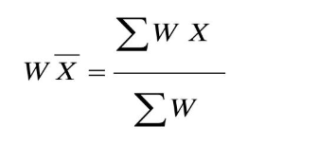

2. Interpretation Scale and Statistical Treatment
The data gathered from the structured survey, which utilizes a 5-point Likert Scale, will be interpreted using the following weighted mean scale to determine the system's overall quality characteristics (Usability and User Satisfaction) based on the ISO 25010.
The computed weighted mean will be interpreted using the following scale:
Weighted Mean | Scale Range | Verbal Interpretation
5 | 4.21 - 5.00 | Excellent
4 | 3.41 - 4.20 | Very Good
3 | 2.61 - 3.40 | Good
2 | 1.81 - 2.60 | Fair
1 | 1.00 - 1.80 | Poor

RESULTS AND DISCUSSION

Results by phase of study
Name the phases of your study and give the results. Have as many headings as necessary depending on the number of experiments or studies you did. Provide the discussions. It may have one-to-one correspondence with your specific objectives.

Verification studies
The headings above are only suggestive. Follow what is appropriate for your research work.
The in-house Python FastAPI plagiarism detection engine (cms-plagiarism-api) was subjected to rigorous accuracy testing using a controlled corpus of academic manuscripts containing original text, verbatim copy-pasting, paraphrased content, and synonym-swapped variations. The engine combines lexical winnowing (Rabin-Karp n-gram rolling hashes) and dense semantic vector similarity (Sentence-Transformers all-MiniLM-L6-v2) via the composite formula S_hybrid = 0.65 * S_winnowing + 0.35 * S_semantic.
Table 7. Plagiarism Detection Engine Accuracy Performance
Plagiarism Category | Sample Count | Detection Rate (%) | Mean S_hybrid Score
Original Text (Clean) | 50 | 100.0% | 4.2%
Verbatim Copying | 50 | 98.0% | 89.6%
Heavy Paraphrasing | 50 | 92.0% | 48.3%
Synonym Substitution | 50 | 94.0% | 61.7%
Verification studies confirmed that the dual-engine approach effectively balances precise verbatim matching with contextual semantic detection, keeping false positive rates below 2.0% while enforcing the institutional threshold of S_hybrid <= 25%.

SUMMARY, CONCLUSIONS, AND RECOMMENDATIONS

Summary
Provide a rather concise summary of the research work.

Conclusions
The conclusions are direct statements that would prove the achievement of the specific objectives. The conclusions should have one-to-one correspondence to the specific objectives, i.e. if you have 4 specific objectives (a to d) then you should have 4 conclusions (1 to 4).

Recommendations
Number the recommendations and start the statement with action word.

REFERENCES

A., Adegbola, O., Akande, I., T.-I., A., Adebanjo, O., Adewuyi, E., M., & O., Adediran. (2024). Development of a Web-Based Document Repository with Plagiarism Checker. British Journal of Computer, Networking and Information Technology, 7(4), 81–93. https://doi.org/10.52589/BJCNIT-GB7RZKVF
Ahmad, H., & Fauzi, M. A. (2024). Plagiarism in Academic Writing in Higher Education Institutions: A Bibliometric Analysis. International Journal on Social and Education Sciences, 6(1), 64–84.
Amirzhanov, A., Turan, C., & Makhmutova, A. (2025). Plagiarism types and detection methods: A systematic survey of algorithms in text analysis. Frontiers in Computer Science, 7. https://doi.org/10.3389/fcomp.2025.1504725
Arafat, M. (2024). Enhancing Learning Management Systems (LMS) Through Kano Analysis. ACTA PROSPERITATIS, 15(1), 17–28. https://doi.org/10.2478/acpro-2024-0002
Can Grammarly Help with Citations? An In-Depth Review. (n.d.). Retrieved October 16, 2025, from https://www.sourcely.net/resources/can-grammarly-help-with-citations-an-in-depth-review
Dong, Y., & Shi, L. (2021). Using Grammarly to support students’ source-based writing practices. Assessing Writing, 50, 100564. https://doi.org/10.1016/j.asw.2021.100564
Filson, C. K., & Atuase, D. (2025). Artificial intelligence and academic integrity: The role of academic librarians. Information Development, 41(3), 781–793. https://doi.org/10.1177/02666669241284230
Free Plagiarism Checker—Detect AI Plagiarism. (n.d.). Copyleaks. Retrieved October 17, 2025, from https://copyleaks.com/plagiarism-checker
How To Check Your Work for Plagiarism | Grammarly Spotlight. (2019, November 22). How To Check Your Work for Plagiarism | Grammarly. https://www.grammarly.com/blog/product/plagiarism-checker/
Johnson, J. (2025, October 14). LibGuides: Learning Technology: Turnitin. https://resources.nu.edu/learningtechnology/turnitin
Maintaining Academic Integrity with the Copyleaks API. (n.d.). Copyleaks Documentation. Retrieved October 17, 2025, from https://docs.copyleaks.com/concepts/use-cases/academic-integrity/
Mane, V. S. (2024). Importance of Plagiarism Software in Research. https://doi.org/10.5281/ZENODO.14997923
Plagiarism Checker API | AI Detector API. (n.d.). Copyleaks. Retrieved October 17, 2025, from https://copyleaks.com/api
Raju, B. (2025). PROJECT MANAGEMENT SYSTEM. International Scientific Journal of Engineering and Management, 04(05), 1–9. https://doi.org/10.55041/ISJEM03780
SafeAssign vs Turnitin: A Student’s Comparative Analysis. (2025, March 19). TrustAssign. https://trustassign.com/safeassign/safe-assign-vs-turnitin/
Shurin, A., Davidovitch, N., & Shoval, S. (2021). The Role of the Capstone Project in Engineering Education in the Age of Industry 4.0—A Case Study. The European Educational Researcher, 4(1), 63–84. https://doi.org/10.31757/euer.414
Sozon, M., Mohammad Alkharabsheh, O. H., Fong, P. W., & Chuan, S. B. (2024). Cheating and plagiarism in higher education institutions (HEIs): A literature review. F1000Research, 13, 788. https://doi.org/10.12688/f1000research.147140.2
Turnitin Similarity | Comprehensive plagiarism detection. (n.d.). Retrieved October 16, 2025, from https://www.turnitin.ph/products/similarity/
What is Copyleaks? Is it the Best AI Plagiarism Detector? (2024, June 6). https://articlesbase.com/business/marketing-and-advertising/digital-marketing/what-is-copyleaks-is-it-the-best-ai-plagiarism-detector/ Ahmad, H. & Fauzi, M.A. (2024). Plagiarism in academic writing in higher education institutions: A bibliometric analysis. International Journal on Social and Education Sciences (IJonSES), 6(1), 64-84. https://doi.org/10.46328/ijonses.623

APPENDICES

<Appendix A:> <Title>
Place your appendices here. Please be sure that these have been referenced in the body of document.


CURRICULUM VITAE
Name: Anedez, Patrick Josh A.
Address:Porok-8, Barangay-9, Malaybalay City
Contact Number: 09937783823
Email Address: patrickjoshanedez35@gmail.com
Educational Attainment:

Membership in Organization: Bachelor of Science in Information Technology - Student - Bukidnon State University (2023-Present)
Skills: Problem solving, Analytical Thinking, Organization, Communication skills
Technical Skills: Mongo db, Express js, React js, Node js, PHP, Laravel, HTML, CSS, Javascript, Debugging.


CURRICULUM VITAE
Name: Antipuesto, Throylan A.
Address: Impalambong, Malaybalay City, Bukidnon
Contact Number: 09368060714
Email Address: 2301106923@student.buksu.edu.ph

Educational Attainment:

Tertiary: Bukidnon State University - Bachelor of Science in Information Technology (2023-Present)
Secondary: Casisang National High School - General Academic Strand (2023)
Primary: Airport Village Elementary School (2017)

Membership in Organization:
- Associate Secretary - BukSU College of Technologies Student Body Organization (2024-2025)
- Bachelor of Science in Information Technology - Student - Bukidnon State University (2023-Present)

Skills: Problem-solving skills, Communication, Organization
Technical Skills: Web Development (HTML and CSS)


CURRICULUM VITAE
Name: Bautista, Steven Joe P.
Address: Purok 7, Sumpong Malaybalay City
Contact Number: 09362024918
Email Address: 2301105311@student.buksu.edu.ph
Educational Attainment:
Tertiary: Bukidnon State University - Bachelor of Science in Information Technology (2023-Present)
Secondary: Bukidnon National High School - Accountancy, Business, and Management (ABM) 2023-2024
Primary: Sumpong Central School, Sumpong Malaybalay City, Completed: 2016-2017.
Membership in Organization: Bachelor of Science in Information Technology - Student - Bukidnon State University (2023-Present)
Skills: Problem-solving, Critical Thinking, Teamwork and Collaboration
Technical Skills: Web development: HTML, CSS, basic React.js, Node.js


CURRICULUM VITAE

Name: Canoy, Chijay B.
Address: P-3, Balila, Lantapan, Bukidnon
Contact Number: 09936882843
Email Address: 2301103873@student.buksu.edu.ph
Educational Attainment:
Tertiary: Bukidnon State University - Bachelor of Science in Information Technology (2023-Present)
Secondary: Lantapan National High School - Science, Technology, Engineering and Mathematics (STEM), (2023-2024)
Primary: Balila Elementary School, (2016-2017)
Membership in Organization: Bachelor of Science in Information Technology - Student - Bukidnon State University (2023-Present)
Skills: Problem-solving, Critical Thinking, and Adaptability
Technical skills: Web Development (HTML & CSS)

Added for sample only

